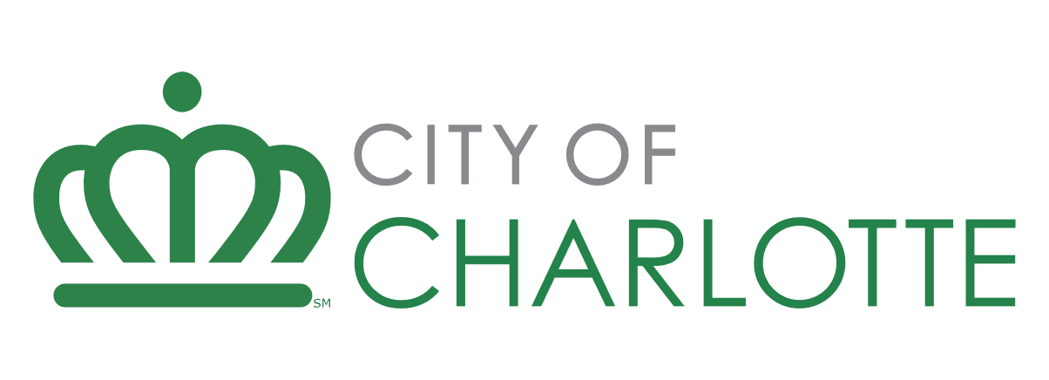

Developer Application – Housing Funding Requests

Request for Proposal/Qualifications: Winter FY24 Housing Development Fund
Due date: January 26, 2023
Developer Name: Developer Response Here
Project Name: Developer Response Here
Instructions: This document establishes a uniform approach for developers when responding to city funding opportunities for affordable housing. To ensure a smooth and efficient evaluation process, kindly adhere to the following guidelines:
Response Format: Provide your answers in short paragraphs, bulleted lists, or concise sentences. For any graphic, photo, or illustration needed, refer to it as Attachment X - Description.pdf and include it in your submission.
Completeness of Response: Fully respond to each question. If a question does not pertain to your development request, please state how the question is not applicable. I.E. “As this is a homeownership project, no property management will take place”.
Do Not Refer to External Text: Please avoid referencing external text documents in your response. Provide all relevant text in this document and attach photos, graphics, or renderings to your submission in pdf format.
Formatting: Maintain the original formatting and page breaks in your submission. This structure helps staff evaluate your response with greater accuracy. Ensure developer answers are in blue highlight.
Following these instructions can help streamline the evaluation process for your affordable housing funding opportunity proposal.

Applicant Information
- Primary Contact Name & Title: Developer response here.
- Primary Contact Phone #: Developer response here.
- Primary Contact Email: Developer response here.
- Legal Name of Business: Developer response here.
- Director or President: Developer response here.
- Type of Organization: Developer response here.
- Incorporation Date: Developer response here.
- Federal Tax ID/ Social Security Number: Developer response here.
- Estimated Current Fiscal Year Budget: Developer response here.
- Current number of staff: Developer response here.
- What is your Company/organization’s mission statement?
Developer response here.
- If the development will be held by an entity other than the applicant, provide the name of the organization here (i.e., subsidy or holding company)
Developer response here.
- Describe Applicant’s expertise in developing and operating affordable housing developments to include:
  - Developer company overview,
  - Development team experience and property management
  - Experience with similar developments
  - If the developer has not received multifamily housing development funding from the city in the last five years, provide at least three references that can speak directly to the applicant’s development experience. Provide as Attachment 1 – Developer References.pdf
Developer response here.
11. Are any principals, partners, employees, or others related to this transaction also employees of, or closely related to a)employees of the City of Charlotte, HUD or other relationship that may be a conflict of interest?
b) members of, or closely related to Members of, the Charlotte City Council?
c) beneficiaries of the program for which funds are requested, either as clients or as paid providers of goods or services?
If any are yes, provide a detailed explanation below. If all are no, respond no.
Developer response here.

Project Information

- Provide a detailed project description.
Developer response here.
- Provide a neighborhood narrative description and describe how the development supports/ will support the surrounding community.
Developer response here.
- Describe the development’s proximity to important amenities such as medical, grocery, and public transportation.
Developer response here.
- Provide a rationale for how you arrived a the real estate tax value used in your proforma.
Developer response here.
- Describe any supportive services that will be provided at the development. If none, respond N/A.
Developer response here.
- Has full debt restructuring under the Market to Market process (or any similar HUD program) begun or been completed within the last 5 years?
Developer response here.
- Has this development received City of Charlotte financing in the last five years?
Developer response here.
- What is the status of the development? What other financing is in place? What is the status of site control, and is there any current construction/renovation activity?
Developer response here.
- Explain why city financing is needed and include any other sources of gap funding received or this project is pursuing.
Developer response here.
- What are the proposed loan structure and terms for the city-provided funding?
Developer response here.

- Describe any UDO Affordable Housing bonuses this development will seek.
Developer response here.

Property Management

- Name of proposed property management firm.
Developer response here.
- Provide a list of up to five properties currently managed by this firm.
Developer response here.
- List properties managed by the proposed management that have been in default in the last ten years.
Developer response here.
- Provide a detailed property management plan.
Developer response here.
- Provide a detailed outreach and marketing plan for the development.
Developer response here.

Legal & Environmental

- Provide the legal land description.
Developer response here.
- Describe any historically significant conditions requiring Historic Review. If none, respond N/A.
Developer response here.
- Description of any environmentally significant site condition(s). If none, respond N/A.
Developer response here.
- Disclose any outstanding judgments or litigation. Provide an explanation for each item. If none, respond N/A.
Developer response here.

Previous Experience

- List previous city funding received. Add rows as needed.
Development/ Project Name | Funding Amount | Development/ Project Status
Sample Project | $1,000,000 | Financing Closed, Under Construction

