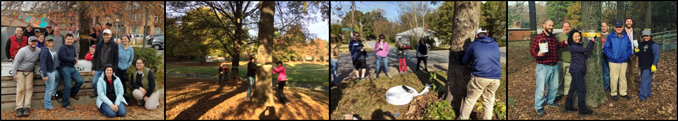
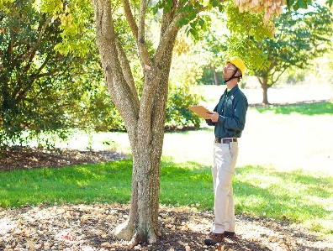
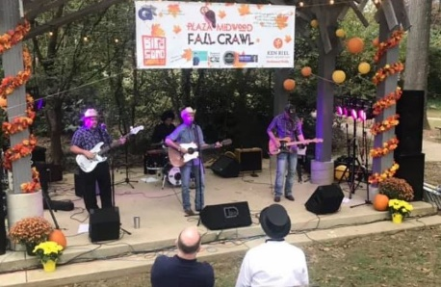
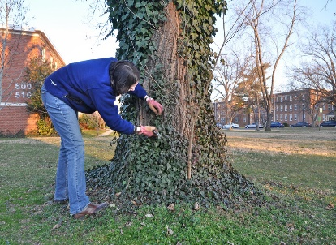

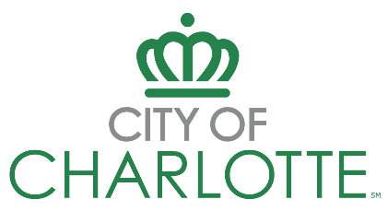
Tree Care Grant
Programs & Guidelines

Apply by January 5th, 2026 - Applications will not be accepted if submitted after the deadline.
Overview

Charlotte takes pride in having one of the most expansive tree canopies in the country. We couldn’t achieve this without the hard work of Charlotte residents like you! In order to celebrate the rich biodiversity found in our urban forests, educate the public on how to take action to maintain our canopy, and protect our forest for years to come, Landscape Management and Housing & Neighborhood services are proud to present this year’s Tree Care Grant.

Eligible organizations citywide can apply for matching grants of up to $3,000 for tree care initiatives including canopy opportunity assessment, small tree pruning, ivy and invasive plant removal, bark scale treatment, and education and tree focused community events. Please see Appendix A for a complete list of eligible projects.
Program Eligibility – Who Can Apply?

Eligible Organizations

Neighborhood associations within Charlotte’s city limits when all of the following apply to the organization:
- Active, established for at least six months
- Registered on city neighborhood organization contact list.
- Created and managed by residents within the neighborhood
- Open for membership to everyone in the neighborhood
- 75% of association members live in the neighborhood.
- Has a duly elected board and established by-laws or governing documents
- Holds regular meetings and maintains records via agendas and meeting minutes

Other Neighborhood Based Groups, including book clubs, gardening clubs, sports leagues, and civic clubs are eligible for Neighborhood Matching Grants when all of the following apply:
- Active and established for at least six months
- 80% of the group members live in the neighborhood
- Holds regular meetings and maintains records via agendas and meeting minutes
- Proposed project promotes the greater good of the neighborhood
- Has a signed letter of agreement or other documentation shows a collaborative partnership with or support from the neighborhood association
Ineligible Organizations
The City recognizes that there are many groups that contribute to neighborhood quality of life. Ineligible organizations are encouraged to partner with organizations that meet the eligibility criteria. Please note that the eligible organization MUST be the lead entity in project planning and implementation. Organizations that discriminate on the basis of race, nationality, ethnicity, religion, creed, or disability are ineligible to apply.

Ineligible Purchases
Grantees may not use funds for personal use items, entrance fees, raffle items, annual plants, pine straw, grass, operating expenses, alcoholic beverages, and for projects already funded through the Neighborhood Matching Grants program.

Match Requirements – How Can Organizations Meet Their Match?

Organizations are required to match awarded funds 1:1; meaning for every dollar granted, a matching amount must be provided through one or more of the methods below:

- A minimum of 50% of must be matched through volunteer time (valued at $34.79 per hour)
- A minimum of 25% of the required match must be contributed by the applying organization

Match Types | Documentation – forms are available at charlottenc.gov/treecaregrant
Cash  Contribution | - Document planned cash contributions from the applying organization, individuals or supporting community partners (businesses, non-profits, etc.)  - Contribution Template (see Appendix C)
In-kind Contribution | - Goods and/or services received for free or at reduced cost  - Contribution Template (see Appendix C)
Volunteer Time | - Volunteer Time must be pledged using the ‘Volunteer Pledge Sheet’ found in the appendix below  - Volunteer time is calculated at $34.79 per person per hour  - Up to 20 hours of related pre-application activities may be counted towards your match, completed Volunteer Sign-In Sheets are required (see Appendix C)

Volunteer activities may include, but are not limited to:

- Removal of ivy and invasive plants
- Mulching
- Promotion of the tree care opportunity to residents (door to door canvassing, public meetings)
- Neighborhood clean ups and/or street adoption
- Community events (documentary film screenings, educational workshops, and other community building events such as pancake breakfasts, ice cream socials, holiday gatherings, etc.)
- Implementation of other neighborhood improvement projects (hours can’t overlap with those committed as part of an active Neighborhood Matching Grant).

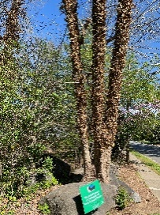
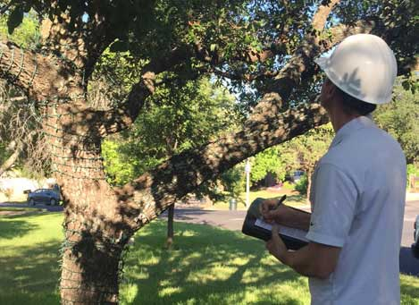
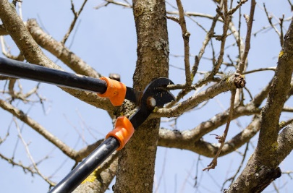

Application Process – How Can We Apply?
  1 | Review Program Materials – review the guidelines and attend a required pre-application workshop in person or via Zoom prior to the application deadline. The meeting schedule can be found on the City’s neighborhood trainings page, or by calling 704-432-4802.
2 | Begin Application- prepare by reviewing the application questions and tips provided at the end of this document. Complete the required budget and volunteer pledge worksheets which can be found on the Keep Charlotte Beautiful website, or by calling 704-432-4802.
3 | Create Account – Access the grant portal. Previous applicants may use existing Tree Care grant or NMG credentials. New users will need to create an account.
4 | Complete Application – Submit the application by 11:59 p.m. on January 5th. Applicants who are unable to complete the application online may call 704-432-4802 to request support or to learn of alternative application options.

Process & Timeline

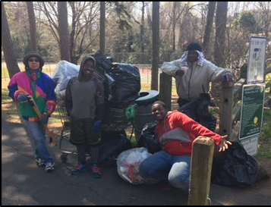
The application deadline is January 5th, 2026 by 11:59 p.m.

Applicants will receive a confirmation email upon application submittal. Applications are reviewed and scored based on the criteria below. After a review, applicants will be notified of their status: approved, denied, or approved with contingencies.

Approved applicants will be invited to the contract signing and orientation meeting on January 28th. Projects may begin only after the contract is executed.

Scoring Criteria | Max  Points
Application requirements  - Submitted a letter of support from applying organization (10) | 10
Project budget  - Completed budget worksheet provided with clear estimate of project expenses and match contributions (15)  - Submitted quotes from vendor(s) or supplier(s) with sales tax included (15) | 30
Value and documentation of match  - Match meets or exceeds the minimum 1:1 requirement (15)  - Match is well documented with Volunteer Pledge documentation and in-kind or cash contribution letters (if applicable) (15) | 30
Project Design  - Project is well planned and ready for implementation (15)  - Includes a clear plan for marketing, promotion and neighborhood outreach (15) | 30
Total Possible Points (60+ is passing) | 100

Terms and Conditions

Contracts
Within 30 days following notice of approval, successful applicants will enter into a contract with the City of Charlotte. Contractual agreements reflect the project goals, budget, and match commitments that are included as part of the approved application. Projects may begin only after the contract is executed.

- Approval is withdrawn if the contract is not executed within 6 months.
- Fraud, misuse of funds, failure to meet match commitments or other non-compliance constitutes a grant default. Defaulted organizations may be ineligible for future grants for up to two (2) years.
- A grant may be abandoned upon request, reimbursement of expended grant funds may be required.
- Organizations may have one (1) Tree Care Grant and one (1) Neighborhood Matching Grant open concurrently.
Disbursement of Funds
Grant funds are not awarded in advance; funds are released on an ‘as needed’ basis after applicants submit invoices and/or receipts for approved items to staff.

The City contracts solely with the recipient neighborhood organization; therefore, any discrepancies that may result from the hiring of contractors, consultants or private vendors must be resolved by the grantee.

- Checks are made payable to the organization, not to vendors. Organizations are responsible for releasing payments to their vendors. Please allow (30) days for invoice processing from the day a complete reimbursement request is received by program staff.
- Organizations are encouraged to use reliable vendors with valid credentials to avoid challenges.
- Contact Jonathan Hill, jonathan.hill@charlottenc.gov or 704-432-4802, for questions related to grant reimbursement requests.

Mentorship & Neighborhood Matching Grants

Many new and reoccurring applicants protect neighborhood trees & get to know more neighbors each year through successful implementation of Tree Care initiative grants. To be connected to past grantees who can provide advice, tips and tricks for finding success in your tree care project please contact Jonathan at jonathan.hill@charlottenc.gov, or 704-432-4802.

For larger projects or projects that fall outside of the scope of the tree care grant, eligible neighborhoods are encouraged to apply to the Neighborhood Matching Grants (NMG) program, which can provide matching grants of up to $25,000 towards tree care projects. To learn about NMG opportunities, visit charlottenc.gov/nmg.

Appendix A: Available Tree Care Projects

Project Opportunity | Purpose | Eligible Expenses | Requirements
Tree Canopy Opportunity Survey | - An opportunity survey will identify risks and areas for improvement in the tree canopy, allowing the neighborhood to take action to keep the canopy strong and healthy. Neighborhoods lying within Neighborhood Matching Grant eligible areas may use that grant to fund projects recommended by the survey. | - Professional tree canopy assessment by a certified arborist | - Tree canopy must be assessed by a certified arborist
Invasive Plant & Vine Removal | - Trees and vines rely on the same supply of water and nutrients. Because vines and invasive plants can be more aggressive, there’s a chance the tree isn’t getting its fair share of nutrition.  - Vines can weigh a tree branch down, putting it at a higher risk of breaking in a storm.  - Over time, a vine invasion weakens a tree, making it a target for opportunistic pests. | - Professional vine removal, including ivy, wisteria, and kudzu  - Professional invasive plant removal, including bamboo, privet, and tree of heaven.  - Tools and supplies related to vine and invasive plant removal. Reference sheet available upon request  - Volunteer training to review proper vine and invasive plant removal techniques | - License may be required for certain herbicides
Tree Pruning | - Pruning trees early in their lives ensures better structure and long-lasting tree health. | - Tools and supplies related to tree pruning. Reference sheet available upon request | - Pruning must be conducted by volunteers
Community Education Event | - An informed community is a strong community. Providing educational opportunities, such as workshops, documentary screenings, and expert panels is a great way to engage the neighborhood in tree care. | - Fees for equipment rental, including projectors, audio equipment, tables, and chairs  - Food and non-alcoholic beverages for the educational event(s)  - Equipment for canopy related events (arbor day celebrations, heritage tree celebrations, etc.  - Speaker fees | - Food and beverage purchases not to exceed $500
Project Opportunity | Purpose | Eligible Expenses | Requirements
Bark scale Treatment | - Crepe Myrtle Bark Scale (CMBS) is a damaging insect that sucks nutrients out of crape myrtle trees.  - First identified near Lake Norman in 2016, CMBS has now spread to other parts of Charlotte.  - Knowing how to identify and control CMBS can help slow its spread and reduce its impact in your neighborhood. | - Professional assessment/identification and treatment plan by a certified arborist or landscape contractor  - Tools and materials for chemical control (as recommended by a professional using a science based approach - a targeted application based on the insect’s life cycle) | - Volunteers must review tree treatment guidelines before application
Mulch | - Mulch prevents erosion around trees, reduces competition by suppressing weeds, moderates the temperature of trees, and helps trees to conserve water.  - Mulch should be replenished around trees as needed and should be no more than 4 inches deep | - Tools and equipment needed to disburse mulch, including rental vehicles (trucks, skid steers, etc).  - Neighborhoods are strongly encouraged to utilize the County for free or discounted mulch. | - Mulch distribution should be conducted by neighborhood volunteers.
Appendix A: Available Tree Care Projects, cont.

Appendix B: Grant Application Guide

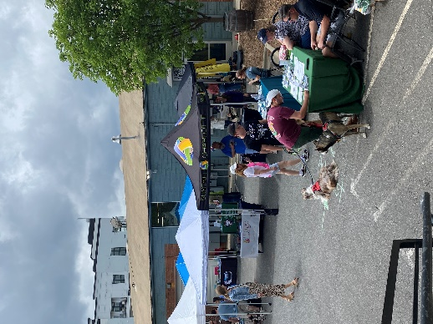
Grant Application Questions

Part I: Organizational Information

- Organization Name
- Verifying documentation: Please upload a copy of your Bylaws (or Articles of Incorporation) indicating you are an active, neighborhood-based or business association
- How did you hear about this grant opportunity?
- NMG Eligibility; is your organization located within the general Neighborhood Matching Grants Program’s eligible geography? By answering this question, staff will be able to provide potential resources about other grant opportunities.
- Board Retreat: Indicate if your organization participated in a Board Retreat within the past year. If yes, upload your Vision to Action Idea Development Workbook to use your $1,500 credit (project must be one that was prioritized at the retreat).
- Has your organization previously received a City of Charlotte Tree Banding or Tree Care Grant?
Part II: Tree Care Project Information

- Describe (in 500 words or less) the project you will use the requested funds for.
- Have you attended a Tree Care Information Session in the past year?
- Please list the streets you plan to focus on through your project (Please upload a map, if available)
- What is the final goal of your project?
- How will you measure the success of your project?
- Amount of grant funding requested (limit is $3,000)
- Upload your budget worksheet
- Upload your Vendor Quote(s)
- Upload your Tree Care Volunteer Pledge Sheets
- Upload a letter of support from your organization pledging support for the application and Tree Care project
- Upload a completed Contribution Template or letter of support for each cash or in-kind contribution that is on your budget (if applicable)

Application Pointers

- The application will auto save every 30 seconds. You can also save the application at the bottom of the screen and log back in later to complete and submit it.
- Technical assistance, computer and internet access are available; please contact Jonathan Hill, 704-432-4802 or email jonathan.hill@charlottenc.gov.

Appendix C: Grant Forms

Tree Care Grant Budget Template
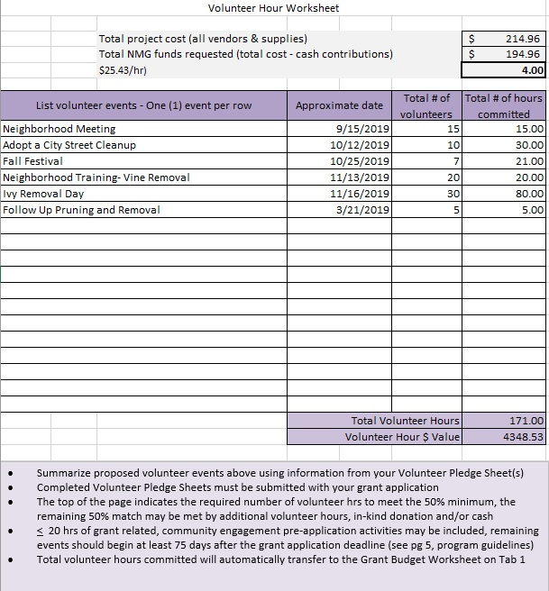
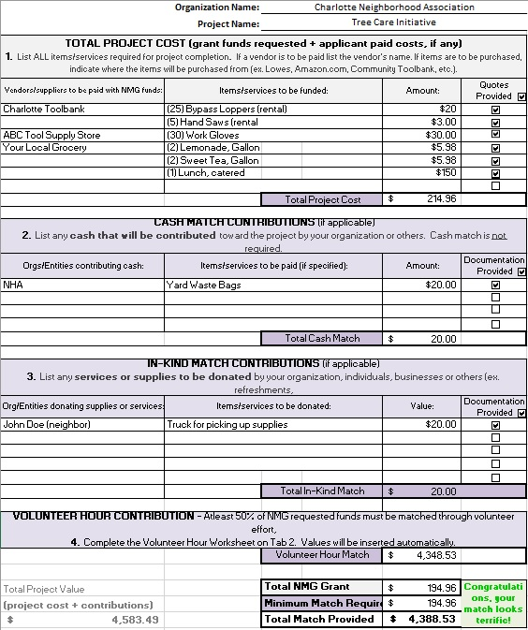
Appendix B: Sample Budget Worksheet
Tips:
- Make sure your MATCH TOTAL is equal to or exceeds the TREE CARE-GRANT REQUEST
- Make sure your Volunteer time is AT LEAST 50% of the TREE CARE-Grant Request
- You should have a quote for any purchases you want to make or vendor(s) you plan to hire
- You should have Contribution letters for all in-kind or cash donations listed
- Volunteer time is valued at $34.79 per volunteer per hour

Tab 1: Grant Budget Worksheet
Tab 2: Volunteer Labor Worksheet

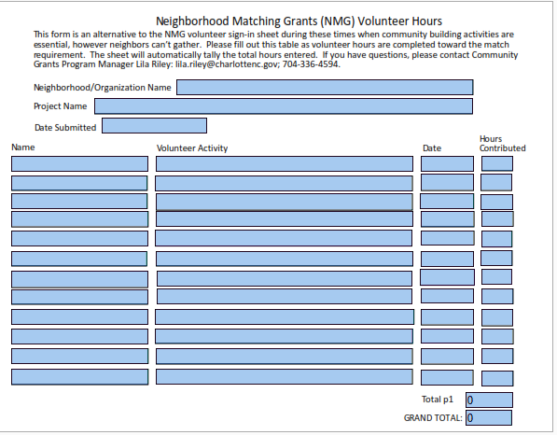
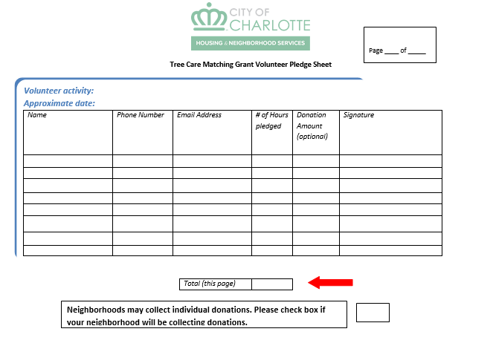

Recommended template for documenting cash and/or supplies
