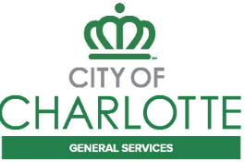
Engineering Services
PLAN SUBMITTAL COVERSHEET

DATE Today’s date
PROJECT NAME Sample Project Name
PROJECT LOCATION From Road to Street
PLAN COMPLETION Preliminary/ R/W / Construction

SUBMITTAL INCLUDES:

COMPLETE PLANS PACKAGE
MILESTONE CHECKLIST
CURRENT COST ESTMATE
DRAFT SPECIAL PROVISIONS (R/W)
SPECIAL PROVISIONS (Construction)

CONSULTANT Name
CONSULTANT PM Name
CONSULTANT QA/QC ENGINEER Name, PE

