Extend Audit Period

Audit management
There are four buttons on the contract audits that you can use to maintain your contract audits.
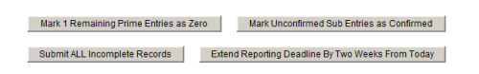
Mark Remaining Prime Entries as Zero – Indicates the prime contractor has not made any subcontractor payments or the remaining incomplete audit lines are $0. Click the button to complete the audit lines with $0.
Mark Unconfirmed Sub Entries as Confirmed – Indicates one or more subcontractors have not confirmed their payments. This button confirms all incomplete audit lines. If a subcontractor has completed work, edit the subcontractor record to indicate that the final payment was received. The subcontractor will not be included in future audits.
Submit All Incomplete Records – Allows you to bulk enter subcontractor payments. You can only use this function the first time a subcontractor payment is recorded. Payment edits must be done individually.
Extend Reporting Deadline by Two Weeks From Today – Extends the reporting deadline by two weeks. The prime contractor can enter payments and the subcontractors can confirm payments. The reporting time period varies depending on your organization’s preference and is usually 15 to 90 days.

Extending a reporting deadline
When audit data becomes available for reporting, both prime contractors and subcontractors have a set amount of time to respond before the audit closes. The time period varies depending on your organization’s preference and is usually 15 to 90 days. There are times when vendors will miss the reporting deadline or need to correct amounts they reported in previous months. Depending on your access rights, you can extend the reporting deadline in two week intervals to allow vendors to report their payments.
To extend the reporting period for one audit period
1. If necessary, locate and open the contract.
2. On the Contract Management page, click the Compliance Audit List tab.
3. Click the View Audit hyperlink for the time period you want to extend.
4. Click Extend Reporting Deadline By Two Weeks From Today.
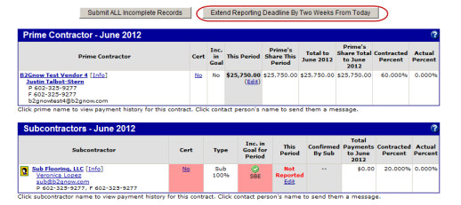
5. Click OK.
To extend the reporting period for all audits on the contract
1. If necessary, locate and open the contract.
2. On the Contract Management page, click the Compliance Audit List tab.
3. Click Extend Reporting Deadline By Two Weeks From Today.
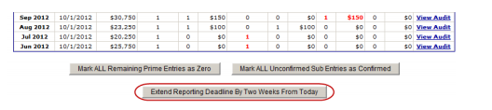
4. Click OK.

