Contract Search
(Pending Lock-In/Value Change)

Search and Export of Contracts
Step One
From the Navigation window click on Search >> Contracts
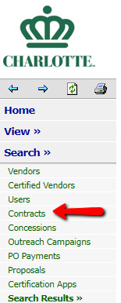

Step Two
Input the following search parameters
- Diversity Goal: 0% to 100%
- Contract Status: Open
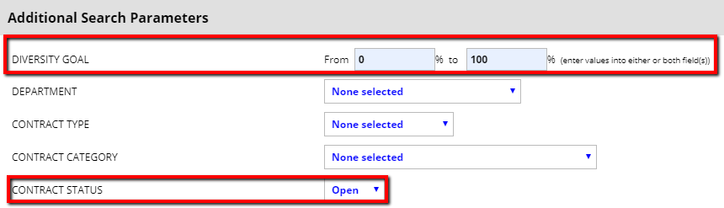
Step Three
Click on Search All Matches
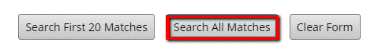
Step Four
While the results will appear, you will need to click export to add additional search parameters.
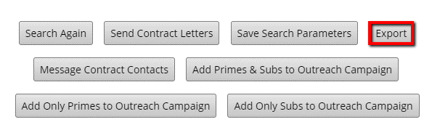
Step Five
Many search parameters will already be selected. To identify contracts by Department as well as Lock-In Data and Pending Change Orders you must select the following parameters.
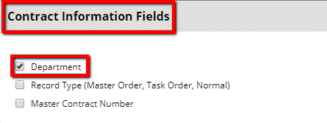

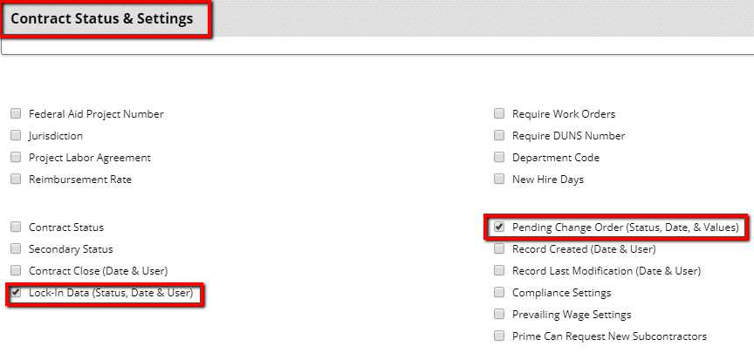
Step Six
Export Records! You also can save these export parameters for future use, by clicking and following the prompts.
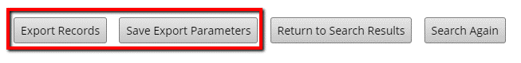
Step Seven
The excel sheet will populate the results. You can sort and filter by the Lock In and or New Value Pending.
- Identify contracts that have not been locked in by viewing those listed as “No”
- Identify contracts that have a New Value Pending by viewing those listed as “Yes”
