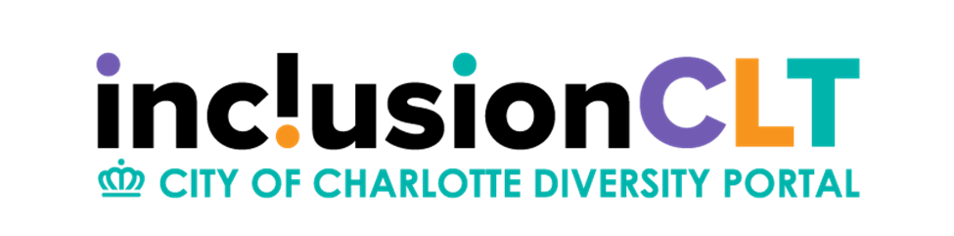

Contract Lock in Process

To understand the contract “lock-in” process be sure to follow these steps:
- From the dashboard click on “Contracts” or from the left-hand navigation panel click on “View” then “contracts”.
- From the Transaction: Contracts page sort the contracts by “New Contract” under Actions. Be mindful that if the check box is checked you will only see contracts that are assigned to you. Uncheck it to see all.

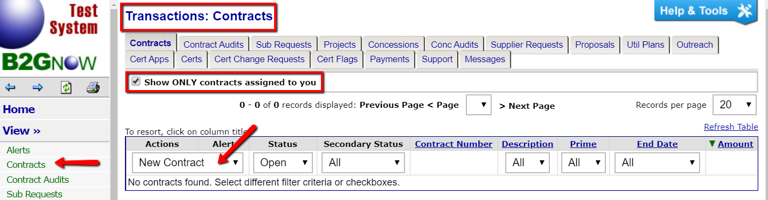

- To begin the lock-in process click “View” to the left of the contract you wish to lock-in.

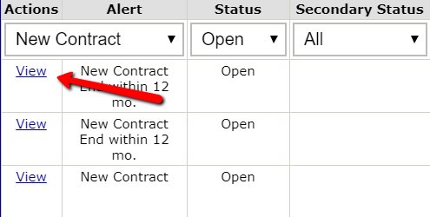

- From the Main page for the contract click “Review”. This opens the contract compose page.

- Review the information that came in via the interface, add any additional information that may be necessary, scroll to the bottom of the page, click “Review” and on the following page, scroll to the bottom and click “Save”.

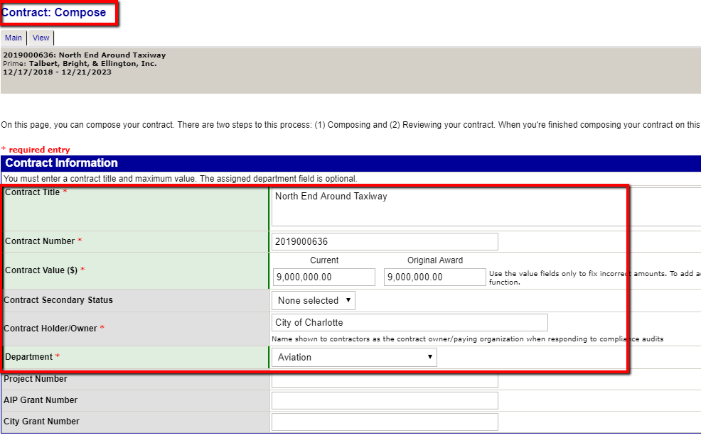

- Review and update the accurate Organizational Contacts from the drop-down menu. If additional contacts are applicable, they can be recorded here.

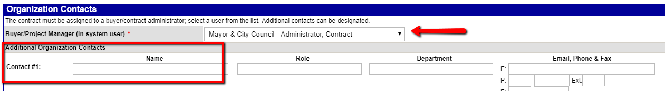

- To add Contract Goals to the contract, select “Click here to select goal types”

- The following screen will appear where you can select and add the applicable goal type(s) from the drop down, click on “Assign Goal” – you can add additional goal types and click return once complete.

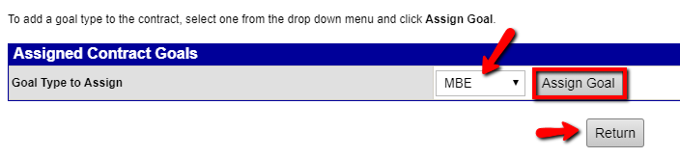

- Now that the Goal Type has been identified, enter in the applicable percentages.

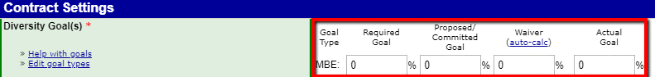

- If additional goals and/or funding information is known this can be reported here.

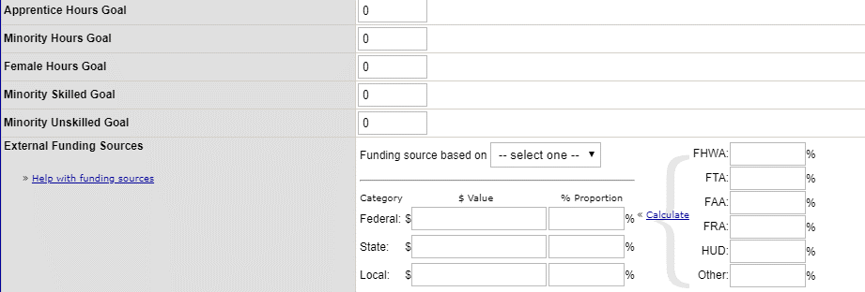

- Review and update the Contract Type and Category. Many of the settings are already defaulted to the selections City of Charlotte has identified.

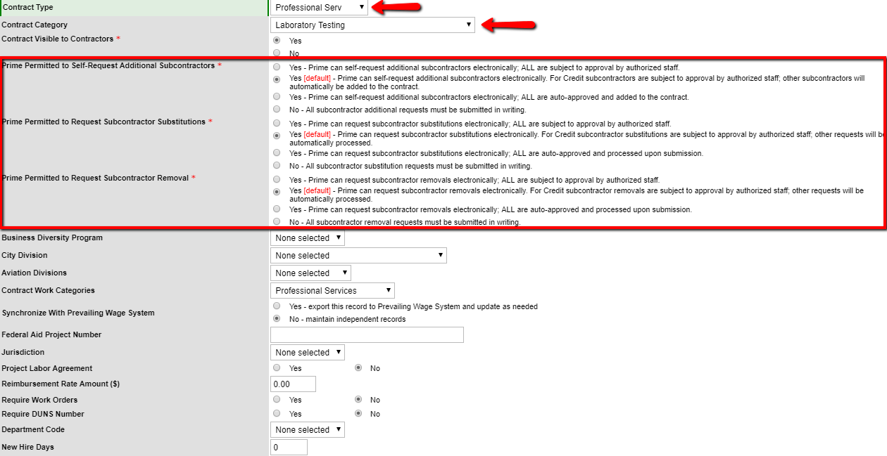

- Review the default audit settings

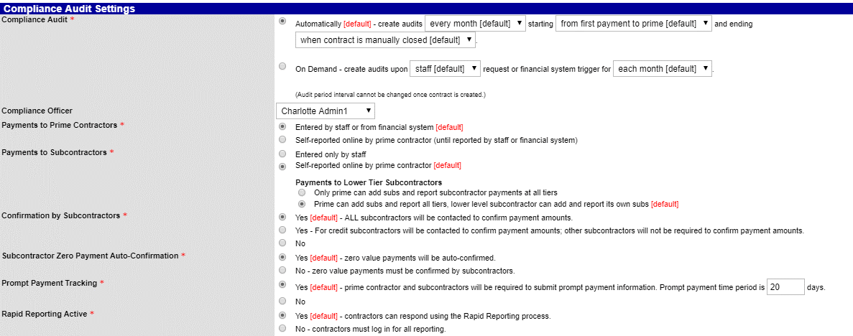

- The option to add commodity codes as well as Contract Documentation can be done as well. Once complete, click Review.

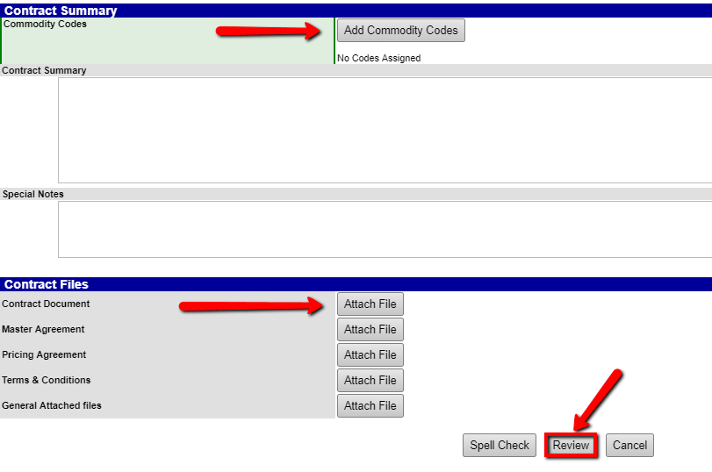

- A summary of the contract will appear. You will have an opportunity to Edit if needed or click Save to complete the Contract Lock-In.

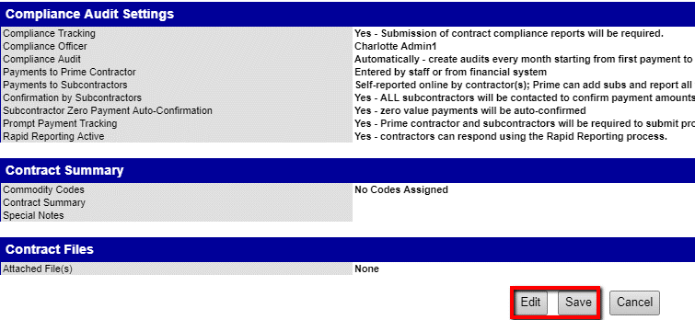

The contract is now saved and ready to have payments matched as well as subcontractors added to the contract.

