Metropolitan Transit Commission

March 27, 2019

METROPOLITAN TRANSIT COMMISSION
Wednesday, March 27, 2019 5:30pm
Charlotte Mecklenburg Government Center Room 267
AGENDA

I. Call to Order ...................................................................................................... Mayor Vi Lyles

II. Approval of the February 27, 2019 Summary (p.5-24) ..................................... Mayor Vi Lyles

- Report from the Chair of the Transit Service Advisory Committee (TSAC) .... Sam Grundman

- Report from the Chair of the Citizens Transit Advisory Group (CTAG)...................No Report

- Public Comments

- Action Items
  - None

- Information Items
  - FY2020 Budget & FY2020-24 CIP Overview (p.26-42) John Lewis/Blanche Sherman
  - Regional Transit Plan Update (p.44) .................................John Muth / Michelle Nance VIII. Chief Executive Officer’s Report (p.46-49) ........................................................ John Lewis, Jr IX. Other Business ................................................................................................... Mayor Vi Lyles
- Adjourn

Metropolitan Transit Commission March 27, 2019 Agenda

METROPOLITAN TRANSIT COMMISSION MEETING SUMMARY
February 27, 2019
(Approved on March 27, 2019) Presiding: Mayor Paul Bailey (Vice Chairman, Matthews)
Present:

Mayor Vi Lyles (City of Charlotte)
Danny Pleasant (Asst. City Manager, Charlotte) Bill Thunberg (Mooresville Representative) Larry Faison (City Manager, Monroe)
Mayor John Aneralla (Huntersville) Mayor Woody Washam (Cornelius) Mayor Jack Edwards (Pineville)

CATS Chief Executive Officer: John Lewis, Jr
Councilmember Linda Paxton (Stallings) Councilmember Jerry Morse (Indian Trail) Mayor Walker Reid III, (City of Gastonia) Mayor William Dusch (City of Concord) Commissioner Susan Hardin (Mecklenburg County)

  - Call to Order
The regular meeting of the Metropolitan Transit Commission was called to order at 5:30 p.m. by Vice Chairman Mayor Paul Bailey (Matthews).

  - Review of Meeting Summary
The meeting summary of January 23, 2019 was approved as written.

  - Transit Services Advisory Committee (TSAC) Chair’s Report
Sam Grudman - Chairman TSAC received some public comment about some frustrations with communications on detours leading up to the NBA All-Star. We're going to be heading up that more at our next TSAC meeting. Hopefully, we'll get some lessons learned for future events.
TSAC also heard the presentation of CATS staff recommendations for the 2030 plan. And the committee also heard about how CATS calculate and adjusts for on-time performance.

  - Citizens Transit Advisory Group (CTAG) Chair’s Report
Edward Tillman – Co-Chairman gave the CTAG’s Report. At our last meeting, the focus was getting a preliminary review of the operating budget for fiscal year 2020 to 2024. And there was a lot of discussion around some of the accomplishments that CATS had as far as trying to get some of the times on the bus schedules down to about 30 minutes, which there were some success with that. But much of the conversation was around them looking at the fiscal year 2020 budget.

  - Public Comments
    - Mayor Charlie Martin (City of Belmont) - The City of Belmont is a part of Gaston County of the Metrolina Region and we perceive the vision for the light rail. That would be a big help. The shared vision of the future taking cars off the road because there's a lot of cars on the road right now, especially when we deal with certain times of day. This would allow ridership to be able to get in and out of Charlotte a lot easier. Also, the workers can get to downtown, Amazon and the airport, as well. The big, big change is being able to get to the airport and Amazon. Also, it's going to cut down on air pollution as well. I think if we can go

ahead and be positive on this and be able to go ahead and extend this light rail as far as Gastonia, for that matter, I think it will take a lot of cars off the road and it will sure save a lot in the money in the long run for everybody.

    - Meg Fencil (Program Director, Sustain Charlotte) - Sustain Charlotte is committed to supporting the mission of CATS and the MTC to improve the quality of life of everyone in the Greater Charlotte Region by providing outstanding community wide public transportation services.
We share CATS' goal to increase transit ridership. In this regard, we commend CATS for working towards delivering and expand the transit network by 2030 and understand the need to define new rapid transit alignments as soon as possible in order to pursue funding and construction in a timely manner.
We're excited about the plans for BRT on the north corridor, Silver Line service extending from Matthews into Gaston County with service to the airport, and continuing improvement to the bus network, we're restructuring capital improvements and increase frequency.
It's clear that there is no easy or inexpensive option for bringing the future Silver Line through the uptown area. We encourage the MTC to carry both the north end and Trade Street tunnel options into the next phase of engineering for additional evaluation for several reasons. Although, there would be a higher upfront capital cost and some risk associated with building tunnel on Trade Street, there are also significant long-term benefits including more direct connectivity between the heart of uptown and the airport, Matthews, and Belmont.
Greater potential for attracting transit ridership because the more central location shortens access to the Silver Line across the four quadrants of downtown. And shorter travel times will be possible due to higher operating speeds to and through the heart of uptown. Direct service would connect riders to not only the future Charlotte Gateway station, but also to the existing Charlotte Transportation Center. Operating costs will be lower over the long-term and there would be less potential for serious and fatal collisions with pedestrians, cyclists, and motorists, which aligns with Charlotte's new vision zero initiative.
In closing, regardless of what decision you make, we strongly encourage you to allocate funds to do the engineering now rather than waiting. Our rapidly growing region desperately needs this plan to be completed. As we all know, it will never be cheaper to do the design and construction than it is now.

  - Presentation of Resolutions (Resolutions, as written and read, are attached to this summary)
- City of Gastonia Resolution – Read by Mayor Walker Reid III
- Gaston-Cleveland-Lincoln MPO Resolution – Read by Mayor Walker Reid III
- Town of Stallings Resolution – Read by Council Member Lynda Paxton. Also reaffirmed by Council Member Jerry Morse, Town of Indian Trail
- Town of Pineville Resolution – Read by Mayor Jack Edwards
MAYOR LYLES (City of Charlotte): I appreciate the support for this plan because we want to not only build a great city, and all of us want that for our city, but we want to build a great region, and this is the first step. Thanks, everyone, for the resolution of support and we're going to try to make a difference. And I really appreciate everyone being a part of it.

  - Action Items

Adoption of LYNX System Plan Jason Lawrence
Jason Lawrence, CATS Transit Planner presented the following. I will be giving you the highlights of the presentation that you saw at the January meeting. I will say that we certainly did a lot of outreach through this effort from communities from uptown Charlotte to the City of Belmont and all the way to the town of Mooresville and all points in-between.
We have staff recommendations, but that staff is made up of a lot other -- not just CATS staff, and certainly city staff, town staff, and throughout the community. A lot of engagement to get to this point today.
At the January meeting I presented these recommendations to you and tonight I will hit just the highlights that is in front of you tonight as an action to adopt those recommendations. And the summary for North corridor, we are recommending a phased approach to transportation -- a public transportation strategy with some improvements in the very near term at the bus stop, at the express and village rider and implementing express lanes service and the lanes on I-77. In the median term to implementing bus rapid transit service along the I-77 corridor with its stations inside the fixed use developments, additional park and rides, and the potential to investigate additional express lane direct connects, and, most importantly, that all-day service, that what we certainly heard about this effort of service throughout the days, nights, and weekends.
Long-term, we still believe that the commuter rail line, LYNX Red Line operating more than normal. The O line tracks are the preferred option for rapid transit and what we've heard from the community through each of the towns and we do believe that continued negotiation with Norfolk Southern should continue to one-day develop that project.
For the west, we are recommending this being the extension of the LYNX Silver Line to be included with the whole project as that adoption to all, this board dated in 2016 from 277 in uptown Charlotte to the town of Matthews, that be extended along 11th Street over to the Charlotte Gateway Station over to Wilkinson Boulevard with initial terminus at the City of Belmont across the Catawba River into the county of Gaston. We're also recommending enhanced bus services along West Boulevard and Freedom Drive with some bus capital improvements and then in part of the regional transit study to continue to evaluate rapid transit from the City of Belmont to downtown Gastonia.
As you heard tonight, the interest from counties outside of Mecklenburg in Gaston as well as Union County are recommending that in the next design phase for the Silver Line that we continue to look across the river on Wilkinson Boulevard through uptown into Southeast Charlotte, but also look at an extension for potential park and ride into the town of Stallings.
Also, we recommended last month was to investigate rapid transit from the terminus of the LYNX Blue Line station in South Charlotte at I-485 and to look across I-485 into the town of Pineville and also to the community of Ballantyne and develop a potential rapid transit options that could include Light Rail extensions but also some near-term mobility options for both communities.
We have been busy since the last time we spoke. These are the meetings that we have held since you heard the last presentation. We've been talking about housing agencies and engagement with Charlotte-Mecklenburg schools, the airport, there would be a close partnership between CATS and the airport as we advance the LYNX Silver Line. We've been to each of the towns of Cornelius, Huntersville, and Davidson to present the staff recommendations. We are beginning the process of -- and getting the staff recommendations into the comprehensive transportation plan. We met with Charlotte Regional and Transportation Planning organization committee and the full board this month. We've had meetings along West Boulevard to talk about those improvements for bus service through there and other stakeholders including Sustain Charlotte and Transit Services Advisory Committee, and just most recently we spoke to the Latin American Council of Charlotte (LACC) to discuss additional outreach that will hope to continue if these plans are going forward.

Resolution: Mayor Vi Lyles (City of Charlotte) motioned to approve the Adoption of LYNX System Update Staff Recommendations; Mayor Woody Washam (Cornelius) seconded the motion, which passed unanimously.

  - Information Items
- Town of Stallings Small Area Plan Lynne Hair Lynne Hair - Planning Director, Town of Stallings; presented the Town of Stallings’ Small Area Plan to share the Town of Stallings' vision for the future and a little bit about the planning process and how we got to that vision.
As a town, I just want to share a little bit with you all about our geography. As a town we are 6 miles in length and only 1 mile in width. We have three I-485 interchanges either near or within our jurisdiction. Just to give you a little bit of perspective, I think there are six interchanges on I-485 that lead into Union County and three of those actually run through our town.
We are right on the Mecklenburg County line just across in Union County. We also experience a great deal of traffic that comes to our town, on a daily basis, from commuter traffic. We've historically been called the Gateway to Union County, and for good reason, when we were located, as I said, right on that line. We have 40,000 daily commuters that travel from Union County into Mecklenburg County for work. We had a net commuter flow of negative 33,330, which is the highest net flow rate in the state. What that means is we have more people that live in Union County than work there. And Stallings is in a position geographically that explains a lot of this traffic every day.
In an attempt, to mitigate some of our traffic issues, NCDOT does have plans to widen several of our roadways. The most significant, the one most people are probably familiar with, is the Monroe Bypass project which opened in November. This is a very significant project. As you can see, it goes right through our town and it impacted us greatly. I don't know how many of you have driven through that area, but that section of the road is actually a bridge and it's built basically a wall through the middle of our town. We affectionately call it the Great Wall of Stallings, but it's impacted us greatly.
But Idlewild and Monroe Road are also scheduled for widening. DOT's original proposal for those are for super streets. The town is very opposed to that. We're currently fighting it. We feel like it would be very detrimental to our development position.
We realize our traffic problems and our issues are not going away. Our traffic is there today and it's probably not going away in the future. And no amount of planning that we do can really plan our way out of the situation.
We as a town decided several years ago to embrace this traffic, to plan for it and plan around it, and so we did that. We engaged on a planning process that's taken us about three years. And we started from ground up. The first thing we did is we looked at our comprehensive land use plan. We realized it was very outdated and it needed updating.
That is where we started.
Then we conducted an exercise during that process where we looked at where was our undeveloped land, where were areas where we felt like there was development potential and we identified those. The orange circles you see there on the map or small area planning is something that would really benefit us. It would allow us to look at those areas closer, identify what land uses would benefit us the most from an economic development standpoint and from a traffic standpoint.
We created three small area plans as part of our comprehensive land use plan that included one at Idlewild and I-485, which is the first dot you see there. The second one is

our school mode, which is Stallings and Stevens Mill Road. We really see that as more of a civic area. And then, of course, along the bypass where we really anticipate there will be a lot of new development potential. So those are the first thing we created.
I also included two others that have since those original three's adoption, we've adopted two others. One in Old Monroe, again anticipating some growth because of that road-widening project, wanting to be prepared for that. And then at Chestnut and Weddington where a roundabout is going in.

As I stated, we started this process, smaller area plans were adopted. But what were our goals when we looked at this? What were we trying to accomplish? One of the main -- the main thing really of the small area plans, everything is kind of related to transportation. We wanted to ensure that we had a road network that was the foundation of our plans. Our first goal was really connectivity.
We wanted to make sure there was connectivity both in the small area plan, study areas. We wanted to make sure we had a way to get across that bypass rather than just at Stallings Road, which right now that's the only way to get from the north side of town to the south side. We anticipate future congestion happening. We wanted to ensure that connectivity. One other thing that was important to us is we really wanted to stop the creation of low density single-family subdivisions.
As a town, our land use pattern is very suburban. We typically see the suburban area.
We have a lot of single-family subdivisions that are low density. We have some strip shopping centers and there's no connectivity here. You have to get in your car to drive from one to the other. That was something we wanted to get away from that development pattern.
The second thing is diversifying sustainable development. We wanted to create a template of road networks. Again, when we talked about sustainability, we wanted our road network to be sustainable. We wanted to create an urban road network where no matter what the land use was, over time land uses come and go. We wanted the road network to continue to function well. So that was important to us.
Then we wanted to create destination points. Something else that came out of our comprehensive land use plan is we realized for a while that planning -- that Stallings has an identity crisis. I ask a lot of people, I ask do you know where Stallings, do you know where the town is. A lot of people identify us with our traffic and with our water tower, but we're a lot more than that.
We wanted to give people a reason to come to Stallings, so creating destination points was important to us whether that was through the creation of pocket parks within these small areas. We also since the creation of these plans, we also created a greenway plan, and feel that creating a really great greenway system is connected to an awesome park system. But we want to make Stallings more of a destination point. So those were important things to us.
And then we also wanted to focus on place making. Place making showing the opposite of destination points. Creating destination points are trying to get people outside of Stallings to come to visit Stallings or into Stallings. Place making, we wanted to focus on providing our residents with places to gather and giving them a sense of place. That was important to us. We wanted to work as well.
And then the final one, just wanted you to know we feel very strongly about and feel like it's very important in helping us reach our goals is that we want to encourage -- and limit what we call one-off developments. The traffic pattern that you see out on Highway 74

now that was created over years of development is really where you have a developer go in, develop a piece of property and they have every one of those development techniques underlined where there's no connectivity, there's no thought given for the development that's going around it. So that was something we really wanted to focus on.
We also based our -- the established goals, based on the results of our study, we also realized from an economic development standpoint that it was going to be important for us to increase densities and to focus our efforts on mixed use development. We realized that those two things would create a higher tax base for us. That we weren't going to be able to sustain ourselves as a town with low density single-family subdivisions. We were looking to give back to our residents and hoping that the creation of this type of tax base would give us an opportunity to provide some more amenity infrastructure for our residents and take that tax burden off our residential taxpayers.
This is a slide we created where we were doing our planning process. I'm not sure if you recognize this area, but this is Highway 77 at Sam Furr Road, and we compared a mixed- use project with the traditional commercial development. We wanted to see what the difference was there in tax base. We looked at Birkdale Village and right across the interchange there at Sam Furr Road is Northcross Shopping Center, both commercial developments. One is a mixed-use development, one is a strip shopping center. And we found that there was about a $10,000 difference per acre in tax value on the mixed-use project. So that's how we decided to go in the direction that we did with our plans.
This is a plan we created for Highway 74. Right here in the middle, this is 74 here.
This is the new bypass where it shoots off. 74 does continue into Indian Trail and down into Monroe. As you can see from the plan, it's high density, something we were shooting for. There's a mixture of uses here. There's single-family residential. There's apartments, there's opportunities for retail uses, for some light industrial uses, industrial parks. This part here is the area where the Atrium is going to be locating their new campus.
We like to think of this planning effort that we put into -- this energy we put into the town, it helped encourage Atrium to look at us and to select this site. But they're looking at locating this location. The thing we're really excited about is they're very open to working with the town and creating not just a hospital campus, but a mixed-use campus. They are going to be the major tenant of that space, but they've also agreed with us in that it's important to also include supportive uses like restaurants and hotel there, and there's even some mixed-use possibilities on that site.
When we were going through our comprehensive land use process, the light rail was something that we discussed a lot. There was a lot of interest in that from our steering committee members that were residents of our town. Our elected officials showed a lot of support for that as well. As Ms. Paxton stated, we really feel like with Atrium going in this location, that there's just a fabulous opportunity for a light rail station here.
The CPCC Levine Campus is very close. And we're excited about the opportunity of bringing the Light Rail into the Town of Stallings and possibly being that first stop in Union County.
Again, this plan is a 50-year build-out, and I'll just quickly go through the others with you just to show what we did. This is the plan we did at 485 and Idlewild. Again, just a mixed-use project that actually has some development plans here that are moving forward right now. But the corridor here, I think is heavier higher density commercial uses with higher density residential and single-family.
And then we also have a plan here. This is our school mode. We see this is more of a civic mode where we have more opportunities for some civic open space and some other

things may be happening here. We've even had some conversations and hopefully would be able to lure a YMCA here, that type of use. That is what we've done the last three years.
So, the process. Again, we adopted these plans. It took us several years to do that. Once those were done, we realized we really needed to look at our development ordinance because we did a development ordinance that would last to develop these plans. We didn't even have a mixed-use zoning classification. We totally rewrote our DBO. We created a zoning classification just for these small area plans and mixed-use category that allows for higher density housing. It allows for a mixture of uses on the same piece of property which we did not have before. We've created densities for single family up to seven units an acre. For multi-family we allowed to 28 units an acre and then on townhome up to 17. That's something really unheard of in Union County. And I get funny looks a lot of time when I talk about it. What we're really trying to do is increase the roof tops, increase walkability, and doing that by increasing these densities, we will be able to achieve that.
As part of that what we've done too, which is a big advantage, especially to the development community is that we've rezoned the small area plans into mixed use and written these new densities into our ordinance, and so it's taken that rezoning process out of it, which for a lot of people was a risky thing to do. And we were experiencing at the town, a lot of times rezoning applications were coming to us, they were being turned down because we didn't really know what we wanted. We decided we know what we want, the small area plan, this type of small area plans. So that's something we feel like is a big plus in the development community, but in its place, we created a development and group process which still allows the opportunity to negotiate things we want in projects such our greenways, infrastructure that may be needed as part of that plan. We could discuss architecture.
What we're working on also is investigating and implementing creative funding sources for whether it's road construction and putting in place on our street scape. We're looking at doing some private -- public private partnerships as well as land banking is something that the town is considering, and then partnering with developers. A small town, we typically a lot of times look at the development community and a little bit of skepticism where they're going to come in and they're going to do high density stuff and tear down all our trees. But we realize that we really need to partner with the development community, that there's an opportunity here for it to be a win-win situation. So that's where we're heading as a town.

MAYOR BAILEY (Matthews): I'm looking at attachment C for the Silver Line. And it's shown that going out. Going out to Highway 74. Is the intent to have a station on the south side of that development, is that what you're looking at?

MS. HAIR: I think we were just looking at this intersection just because of the residential pieces in this area that we're hoping will develop, and the opportunity to provide not only a park and ride station, but the ability for people to walk there as well. We feel like -- it's actually out on Highway 74 because this is elevated. It's not at ground level. It would be difficult to have a Light Rail station in that location. This may be the better location. The CPCC campus is kind of down here in this area.

MAYOR BAILEY (Matthews): Would you expect to have like a multimodal station there, so people can park and take the train?

MS. HAIR: I think that's something we need to talk through kind of think through that process. I think that having that multimodal station is what's been talked about the most, because there is an opportunity for a parking deck sharing, you know, a hospital site. We would like to see a station that you could potentially walk to as well, if that's a possibility.

MAYOR BAILEY (Matthews): The next question may be more for Jason Lawrence. In reading through these LYNX plan, there was mention of funding -- alternative funding sources outside of the county. Was this also? Part of this would be in Mecklenburg. Part of it would be in Union. Would that same type of funding apply to the section of this line as well?

MR. LAWRENCE: I think the proposal is the next phase of design we would look at. The extension is outside the Gaston area and into Stallings. I think we're having discussions about how that will be funded between now and into the next fiscal year.

CATS CEO LEWIS: What you heard in some of the resolutions about SPI funding versus having a porter that serves multiple jurisdictions, multiple counties would allow us to access additional different pots of statewide funding when we get to that part of construction.
What we're talking here is more of the planning side of it. But to your point, later on when we get to the trucks, that opens up different funding source.

- FY2020 Operating Budget Highlights Blanche Sherman John Lewis, Jr. – CATS Chief Executive Officer started the presented with the following overview. MS. SHERMAN: Good evening, Mayor, members of the MTC committee. We want to give you an overview of some of the highlights that was presented last month, I gave you an overview in January of the entire budget. We want to share some of the highlights and the individual division managers will come up and provide the details pertaining to that.
To begin the presentation, I'll give you a brief overview, let you know where we started since January, and then we'll have safety and security come up, bus rail, and development. Then I'll return to with the next steps.
As presented in January, CATS FYI 2020 preliminary budget is increasing about 7.8 million from 154.6 to 162.4. The debt service budget is decreasing by 10.6 million, 8.4 decrease as I shared with you last month. That is because we are reducing the liability. We are paying off 100 million in FY 19.
In regard to capital budget, we will come back in February with the details pertaining to that, but the major decrease there of 294.9 is basically related to, we do not have any carryovers included in the preliminary budget at this time, but it will be included in the final proposed budget.
Some highlights pertaining to our operating revenue and operating expenses. I wanted to share with you a pie chart. It will give you the details of how that is broken out. The majority of our revenue is our sales tax revenue of 75.5. Fares and service is about 18 percent. Maintenance is the funds that we receive from the city and towns is about 14 percent. And net operating revenue about 23.1.
And as you can see on the other side, most of that goes into our personnel services, 64 percent. Other expenses, about 51 percent. And fee is about 5 percent.

KENNETH CHAPMAN (Interim General Manager - CATS Transit Safety & Security): I'd like to just share with you two highlights of the budget for the office of safety and security. The first one is an increase of $100,000. The FTA, federal government, passed CFR 673 in July of 2018 as a final road to develop safety management system or as we call it, SMS for CATS. It's not just for CATS, but it's for all rail transit agencies throughout the country that receives funds from the FTA.
Key force of the new regulation is a transition from what we use now as a system safety program, SSPP, to the agency safety plan, which is ASP, as required by the FDA and is state safety oversight which is inside dot. A gap analysis is what we used to help determine what steps we need to take to transition from the system safety program plan to the agency safety plan. And the difference is primarily the system safety program plan is more compliance based whereas the agency safety plan is more performance based.
In addition, we need to conduct a safety culture survey for what we call a post check. One of the important things in developing the ASP is how the agency interacts and behave and look at safety. This is a key component of the gap analysis that we will be developing.
The second slide is on the security side of things. An increase of $500,000 for the security operations contract which we now have with G4S. Due to the various large-scale events that are happening in Charlotte, it is necessary that we need to increase the contract hours and buy -- or purchase equipment for the transit police in an effort to maintain an overall transit system security of CATS.

TANGEE MOBLEY (General Manager – CATS Bus Operations): I'm here to talk about three occurrences in our budget that's increased for our FY2020. The first one is workers compensation. We hit a trend analysis through our actuary, and according to the trend, we should increase by $400,000. What we're doing to avert some of the increase and the costs of claims, we're doing -- we're pulling -- our buses have cameras on them. Our buses have nine cameras on the system and we pull videos when applicable as long as the event happens on the bus. We do third party, we work real closely with third party claims adjuster. We're looking at ways that we can -- they have modified duty that we can actually work with them doing non-safety sensitive activities to actually try to get them back into the swing of coming back to work.
Next one is contract maintenance. The $350,000 increases for the track ease AVL system. The AVL system tracks location of our buses. It helps us track our on-time performance.
Equipment maintenance. That's a 550,000 increase. It's basically due to our increase in replacing injectors. We're trying to get in front of our failure of our DPF, which is our user particulate filters which was mandated back in 2010 by FTA as far as reducing definitions.
And this was to extend the life of the DPF filters, as well as when we replace our engines on our buses, we found out that not too long afterwards we have a failure in our transmission. At this point, part of our preventative maintenance plan, when we replace the engine, we replace the transmission as well.
Lastly, we have concerns last year of the folks come to MTC concerning mainly about late buses, late trips. And it was basically due to lack of manpower. We have a lot of our employees off on sick and FMLA. And it caused a mainstream – it costs us a strain on our ability to get our service out properly. Since then we have converted eight part-time drivers to full-time and in FY-19 we converted -- not converted, we added eight new part-time drivers. That has helped us to improve our on-time performance. As well as one of our

other complaints was about when we call through dispatch and we could not really tell them exactly where the bus is, and so that has significantly improved as well.
One last change is that we talk about the route match. We talk about new technology for our software. That should be coming. We're in the design phase now. We are starting implementation. Hopefully by July it will be in place. That will also help us because it has Google Maps actual live traffic maps that will assist us in being on time and being more conscious of getting our customers where they need to be on time.

MAYOR ANERALLA (Huntersville): Is there any movement to converting the buses to natural gas?

MS. MOBLEY: We are looking toward that, yes. I've got some prices on it as well. We're working with Charlotte Water who has a plan. Looking at renewable gas, renewable C&G as well. We're looking at that. That's in the process now.

BILL THUNBERG (Mooresville Representative): I appreciate you doing this because this is a direct response to public comment from the last budget. I'm very appreciative of the fact that you took that seriously and then improved it. Public involvement is a good thing. I'm very thankful that you did that.

GARY LEE (CATS Interim General Manager – Rail & Facilities): Rail operations management, we operate and maintain 18.9 miles of rail along from 485 from South Boulevard to UNCC's main campus. We have 26 stations including 11 park and rides and the LYNX Blue Line provides congestion free commute with a consistent travel time. LYNX operates seven days a week, services available at 17.5 minutes during weekday and every 15 minutes during --
The FY-20 cost drivers of equipment and parts is 32 percent of our costs. Insurance premiums are 24% of our costs. Tracks and power costs are 18 percent. Professional and contract services, 10 percent and other costs at 15 percent.
Our revenue equipment, we have 42 of 70 vehicles, LRVs, three trolleys. We have
37.8 miles of track, that's track one and track two, 26 stations, 19 traction power stations, 18 signal houses, 90-grade crossing mechanisms. As far as personnel, we have 89 transportation employees, 58 maintenance way employees. We have 74 rail car employees which is a 10 personnel increase from the FY-19 budget. We have seven parts personnel. We have 11 admin staff and one is an increase from the FY-19 budget and we have 14 street car personnel.
Maintenance way. Our budget for FY-20 increased by 312,000. That was for biannual bridge inspections and repairs. And it also increases the tides of the BLE. Equipment maintenance increased by $130,000 to include rail branding and also sound testing. For rail car maintenance, we had equipment maintenance increase of $500,000 which covers the S70 overhaul.
For facilities, the management maintained all CATS owned and leased facilities properties, to include buildings and grounds, bus, rail, STS, South Tryon DOD, North Davidson DOD, South Boulevard Light Rail facility, North Brevard Light Rail facility, CTC Sugar Creek deck office space, UNC-Charlotte facility, and I-485 facility. All bus passenger amenities includes 13 park and rides, six transit hubs, over 3,000 bus stops, and over 300 shelter, hundreds of benches and bike racks. All rail facilities and amenities along the line,
18.9 miles right-of-way, 26 stations, elevators at 485, Sugar Creek, J.W. Clay, University City parking decks.

The cost drivers for facilities: 40 percent is building and land services, 23 percent is utilities, 12 percent is property management and rent, 13 percent CTC, and 12 percent is other costs. For FY-20 it was increased of $121,000 of building repairs and renovations,
$233,000 for MOUs with landscape and water, $265,000 increase contract maintenance for the South Boulevard Light Rail roof replacement and parking deck repairs, miscellaneous contract services increased at $385,000 as for maintenance fee for the BLE parking decks and conference stations. Utilities increased at the rate of $60,000 and that was because of the BLE.

JOHN MUTH (CATS Deputy Director): This slide shows how the planning and development division is organized. We have five collaborative teams within the group. Services limitation scheduling, trans planning, project development and controls, engineering and implementation, and quality assurance. We have a lot of -- obviously a lot of things going on in CATS, and our group is involved in a lot of those. Some of the highlights include work -- ride activity system planning like the recent corridor work talked about and that you approved tonight in the upcoming North Corridor Direct Connect study. Regional coordination that we've been doing with folks, you know, in the surrounding counties, where it's out talking, using our regional engagement or working with folks on the corridors.
Also, project development like the upcoming Silver Line preliminary design. Land development review, we participate in the review of all the zoning and development proposals in Charlotte and the county, and we also work some with the town staff. We're available to collaborate with you if you have rezoning as a land use decision, then I would work with Matthews in dealing with the hospital and some of their proposals. Capital projects, the Blue Line extension and the quality assurance on our CATS quality program.
This slide shows some of the planning studies are that proposed in the budgets for your consideration, ADA transition study where we're participating in the city's ADA transition plan making sure that all of our cities, policies, and programs ensure that we're doing all the right things when it comes to accommodating the disabled citizens in our community.
The regional transit plan, we've talked with you a lot about that as we've given updates during the regional transit engagement. We've provided some funding in here, we're collaborating with the Central Line council and governments and then also working with, you know, a lot of the adjacent counties and the staff and the MPOs. As we talk about the development of 12-county, 2-state regional transit vision and the implementation strategy and we're still working through and pursuing additional funding, then we'll be talking with the NCDOT. Hopefully, they can be a major contributor to the study.
The North Corridor Direct Connect study, that's the next step in the recently established program that will leverage I-77, the HOV, and HOT lanes. This study will look at proposed direct connects, proposed park and ride locations, and develop a capital plan in terms of bus purchases and bus needs relative to some of those different operating plans that we talked about, whether it's additional routes directly to park and ride lots or the additional kind of all-day, weekend, all stops service that could also be provided.
New corridor studies on Central Avenue. This is a study, it's not just limited to Central Avenue. It kind of came about because of some discussions we had had last year about possibly pursuing a grant for Central Avenue work. But this would allow us to look at some of the major thorough fares and service arterials for opportunities to implement bus operations and improvements for strategies that could enhance speed and reliability for some -- for our existing local and express services.

And then also we have funding for on-call consultant that we could use to provide as task orders as needed as any kind of work we might need, whether it's evaluating development proposals or looking at bus service improvements or things like that. So those are the items that have been proposed for funding on the planning side.

MAYOR ANERALLA (Huntersville): The Direct Connect study, I think it would be better if you change your wording to North Corridor bus enhancement study.
There is really not on current board a lot of interest in creating another direct connect into toll lanes. If we're going to get 30 or 40 or 50 million dollars to do that, probably rather have it allocated some other way. If you could change the wording on that, I know you can look at it, you're going to look it, but I think that would be helpful.

MR. MUTH: I agree. It's not really strictly a direct connect study. I mentioned about park and ride lot. With the proposed hand brake direct connect, it's already going to happen, we can be looking into a park and ride location as well. Good point

MAYOR BAILEY (Matthews): I have a question for Gary Lee on the increase of 500,000 for the S70 overhauls. I guess what I was wondering there, that's a fairly significant increase, is that something that's going to be expected to continue to increase?

MR. LEE: Yes, sir. The age of the LRC right now is 12 years old and due for overhauls. So as the vehicles get older, the cost to overall will go up. When that comes, the budget will increase to get the overhauls completed to ensure they reach a 30-year life.

MS. SHERMAN: Just to give you an overview of the next steps. We've here tonight giving you a highlight of our operating budget. We'll be back in March to give you highlights pertaining to the FY 20, 2024 community investment plan budget, and back to you on April 24th for our final budget, final proposed budget and approval. And then in June to include it at City Council budget for adoption.

MAYOR ANERALLA (Huntersville): I'm not sure if this is the time to ask this question, but when would we discuss the local center coming due in the fiscal year? So, for example, right now we have local Union, Gaston, Concord and they're are coming up. The cost of those are warranted by third IP fares and third from the local town and then a third one by CATS and subsequent bus lines. When would be appropriate to talk about that? Because some are automatically renewed or not?

BRADLEY BRANHAM (CATS Legal Counsel): It does probably need to be reaffirmed or reexamined, so we can look at that and get some specifics and place it on an upcoming agenda as needed.

MAYOR ANERALLA (Huntersville): It's just that -- glad everybody's here at the table. Just that some of us have lived in Mecklenburg County for all 22 years of sales tax and there's a subsidy to outside, I know people coming in and spend money and so forth. But I think we're going to end up expanding the bus service all the time. It's already at the rail. And I think we need to have a better understanding of what our costs with the system and are they people who have an impact and there's at least a third or more. I know it's not going to make you guys happy.

  - Chief Executive Officer’s Report John Lewis, Jr.
Under the CEO’s report, John Lewis, Jr discussed the following:

- NBA All-Star Weekend
As we all know, the region hosted a very large event with the NBA two weeks ago. We want to commend staff for an outstanding job in terms of planning and transition and operation.
Staff both on the bus and rail side on Thursday evening closed down the Charlotte Transit Center, absolutely constructed a temporary transit center at a parking lot on 9th Street. Then we were ready for normal operations on Friday morning at the temporary transit center. I think work went very well. And that was a pretty seamless transition from bus.
From rail, we worked very closely with our partners at Homeland Security and Charlotte-Mecklenburg Police and the NBA for enhanced security on our LYNX Blue Line. For those members who may not be aware, we had enhanced security from 7th Street to 3rd Street. So northbound passengers coming from south end had to exit the train at 3rd Street, the train was swept by security personnel and bomb sniffing dogs, people who wanted to continue north, then re-entered the train and the train went along with security personnel, then vice versa on the southbound trip.
This was a yeoman's effort. I think it was great effort for that small event that's coming next year. But in terms of ridership, on Friday we moved 31,000 people on the Light Rail. That is also taken into consideration a normal weekday, we're about 25,000, but in uptown many of the uptown businesses closed down or encouraged their employees to work to telecommute or work from remote locations. A little better measure of the amount of ridership was Saturday. On a typical Saturday, we'll move on the Blue Line about 16,000 and on that Saturday, we moved 31,695 people. We almost doubled our normal Saturday ridership. On Sunday, we moved close to 16,000. On a normal Sunday, it's about 9. Despite all of the security enhancements and the impact on operations, it was clear that both local citizens and people who were visiting for the game made tremendous use of our system and our staff did a great job in that.

- Staff Recognition
I'd like to highlight the great thing as was mentioned earlier how hard staff works to move many of these plans and operations and system for two of our staff members were recognized this month by the Mecklenburg County Times as The Class of 50 Most Influential Women - Jill Brim and Kelly Goforth. Both Jill and Kelly were and continues to be involved in the Blue Line extension project that enabled us to move that project forward successfully.

  - Other Business. None

  - Adjourn
The meeting was adjourned at 6:52 p.m. by Mayor Paul Bailey – MTC Vice Chairman (Matthews).

NEXT MTC MEETING: WEDNESDAY, MARCH 27, 2019, 5:30 P.M.

RESOLUTION IN SUPPORT OF THE CHARLOTTE AREA TRANSIT SYSTEM'S (CATS) WEST CORRIDOR EXTENDING INTO DOWNTOWN GASTONIA

WHEREAS, more transpo1tation options are needed to provide greater mobility to our existing residents as well as the growing population in Gastonia and Gaston County; and

WHEREAS, the US Census Bureau's American Community Survey (2009-2013) indicates that 25,653 Gaston County residents are traveling into Mecklenburg C0tmty each weekday for work; and

WHEREAS, the Charlotte region is home to over 1.8 million people and is expected to grow to over 2.5 million by 2030 and the key to supporting this economic growth is a rapid transit system integrated with land-use planning creating a sustainable, economic-environment which improves the quality oflife and attracts businesses and people to the region; and

WHEREAS, the Gaston-Cleveland-Lincoln Metropolitan Planning Organization (GCLMPO), formally the Gaston Urban Area MPO, completed the Gastonia Rapid Transit Alternatives Study in 2005 which identified the need to link to the Charlotte Area Transit's (CATS) West Corridor service via rapid transit to improve its accessibility to and from other parts of the Greater Charlotte area; and

WHEREAS, CATS is cunently conducting a study to reevaluate and update the transit recommendation for the West Corridor with the primary purpose to conduct the necessary transportation and land use analysis to select a Locally Preferred Alternative (LPA) to update the 2030 Transit System Corridor Plan, which will be approved by the Metropolitan Transit Commission (MTC); and

WHEREAS, since the current West Corridor LPA was adopted in 2006, land use changes have continued along Wilkinson Boulevard, the CLT Airport has continued to expand, and the Charlotte City Council recently approved the River District, a large mixed-use development along the Catawba River; and

WHEREAS, Gaston County stakeholders have expressed renewed interest in exploring rapid transit options into Gaston County :from Mecklenburg County; and

WHEREAS, the transit options that will be considered may extend beyond Mecklenburg County, and at a minimum, will not preclude extensions into Gaston County as part of future investments; and

WHEREAS, based on the Strategic Transportation Investments (STI) Law, public transportation projects with service spanning two or more counties and serving more than one municipality are eligible for funding at the Regional Impact Tier; and

WHEREAS, there are two light rail transit corridor options currently being studied with both utilizing the US 74 Catawba River Bridge to connect into Gaston County; and

WHEREAS, the replacement of both the US 74 Catawba River Bridge and the US 74 South Fork Catawba River Bridge are funded projects and there is a feasibility study cunently underway to examine the potential for the design of the new bridges to include a future light rail con'idor; and

18

WHEREAS, the City of Gastonia supp01ts the proposed light rail west corridor extending all the way into Downtown Gastonia, connecting the Loray Mill and the Franklin Urban Sports and Entettainment (FUSE) District; and

WHEREAS, the City of Gastonia understands that the West Corridor Study is intended to define a project to move forward and is not identifying a "shovel ready" rail project; and

NOW THEREFORE, BE IT RESOLVED that the City of Gastonia supports the .Metropolitan Transit Commission's (MTC) Locally Preferred Alternative (LPA) for the West Corrido1·
extending into Downtown Gastonia.
....................................................._ ........................................................................................................
Resolutioµ adopted this, the 18th of September, 2018, upon a motion of Council member
J)• l( IV \i and s.econded by Council member ,d Cftfa I /.t LJ:: h. e ( by a vote of {51

affitmative votes to
. U,(\
neg. ative votes.
. -··.·

Walker E. Reid, III, M

ATTEST:

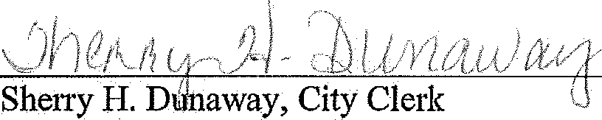
Ce1tificate

The undersigned duly qualified City Clerk of the City of Gastonia certifies that the foregoing is a true and correct copy of a resolution adopted as a legally convened meeting of the City of Gastonia held on the 18th of September, 2018.
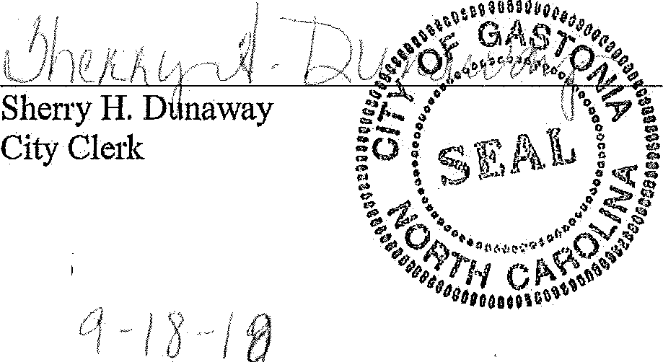
(seal)
Date

GASTO N-CLEVELA ND-LINCOLN
=-_{M}
\ r& \,

' . ' .. ' ..
Molroponlon Pkui nlna Oigon lzo tlon

RESOLUTION IN SUPPORT OF THE CHARLOTTE AREATRAf\JSIT SYSTEM'S (CATS) WEST CORRIDOR EXTENDING INTO DOWNTOWN GASTONIA

WHEREAS; more transportation options are needed to provide greater mobility to our existing residents as well as the growing population in the Gaston-Cleveland,-Lincciln MPO planning areai and

WHEREAS, the US Census Bureau's American Community Survey (2009-2013_) indicates that 25,653 Gaston County residents, 2,482 Cleveland County residents, and 9,345 Lincoln County residents are traveling into Mecklenburg County each weekday for worki and '

WHEREAS, the Charlotte region is home to over 1.8 million people and is expected to grow to over 2.5 million by 2030 and the,key to supporting this economic growth is a rapid transit system integrated with land-use planning creating a sustainable, economic-environment which improves the quality oflife ahd attracts businesses and people to the region; and

WHEREAS, the Gaston-Clevelan d-Lincoln Metropolitan Planning Organization (GCLMPO), formally the Gaston Urban Area MPO, completed the Gastonia Rapid Transit Alternatives Study in 2005 which identified the need to link to the Charlotte Area Transit's (CATS) West Corridor service via rapid transit to improve its accessibilityto and from other parts of the Greater Charlotte area; and

WHEREAS, CATS·· is currently conducting a study to reevaluate and update the transit recommendation for the West Corridor with the primary purpose to conduct the necessary transportation and land use analysis to select a locally Preferred Alternative(LPA) to update the 2030 Transit System Corridor Plan, which wiHbe approved by the MetropolitanTransit Commission (MTC);
and

WHEREAS, since the current West Corridor LPA was adopted in 2006, land use changes have continued along Wilkinson Boulevard, the CLT Airport has continued to expand, and the Charlotte City Council recently approved the River District, a large mixed0 use development along the Catawba River; and

WHEREAS, Gaston County stakeholders have expressed renewed interest in exploring rapid transit options into Gaston County from Mecklenburg County; and

WHEREAS, the transit options that will be considered may extend beyond Mecklenburg County; and at a minimum, will not preclude extensions into Gaston County as part of future investments; and

WHEREAS, based on the Strategic Transportation Investments (STI) Law, public transportation projects with service spanning two or more counties and serving more than one municipality are eligible for funding at the Regional Impact Tier; and

WHEREAS, there are two light rail transit corridor options currently being studied with both utilizing the US 74 Catawba River Bridge to connect into Gaston County; and

WHEREAS, the replacement of both the US 74 Catawba River Bridge and the US 74 South Fork Catawba River Bridge are funded projects and there is a feasibility study currently underway to examine the potential for the design of the new bridges to include a future light rail corridor; and

WHEREAS, the GCLMPO supports the proposed light rail west corridor extending all the way into Downtown Gastonia, providing better access for Gaston, Cleveland, and Lincoln County residents; and

WHEREAS, the GCLMPO understands that the West Corridor Study is intended to define a project to move forward and is not identifying a "shovel ready" rail project; and

NOW THEREFORE, BE IT RESOLVED that the GCLMPO Board supports the Metropolitan Transit Commission's (MTC) Locally Preferred Alternative (LPA) for the West Corridor extending into Downtown Gastonia.
Scott Neisler, GCLMPO Board Chairman Gaston-Cleveland-Lincoln MPO

ATTESTED:
12 h---

Randi P. Gates, AICP, Principal Transportation Planner GCLMPO Administrator

Resolution adopted upon a motion of Mr. Richard Turner, seconded by Mr. Todd Pierceall, by a vote of the majority of the Gaston-Cleveland-Lincoln MPO Board on the 5th day of December, 2018.

North Carolina Gaston County

I, l(risten N. Wheeler, a Notary Public for said County and State, do hereby certify that Scott Neisler
personally appeared before me on this the /Z,#1day of [Mumbey, 2.ol 8, and acknowledge the due
execution of the foregoing instrument.

Witness my hand and official seal, this the./2..-rh day ofl£1embet 1-0J<l.

11-1
•
KRISTEN N WHEELER
Notary Public, North Carolina
Gaston Counw
My Commission El!pires

My Commission expires May 10, 2023.

RESOLUTION IN SUPPORT OF THE CHARLOTTE AREA TRANSIT SYSTJiM'S (CATS) LYNX SILVEifLINE LIGHT RAIL CORRIDOR EXTENDING EASTWARD TO THE TOWN OF ST LINGSIN UNION COUNTY

WHEREAS, the Charlotte region is home to over 1.8 million people and is expected to grow to over 2.5 million by 2030 and the key to supporting this economic growth is a regional rapid transit system integrated with land-use planning creatip.g a.su tainable, economic-environment which improye,s the quality of life and attracts businesses and people to the region; and

WHERE;AS, more transportation options are needed to provide greater mobility to our existing residents as well as the owing population in Stallings and Union County; and

WHEREAS, Union County has experienced rapid population growth for several years; and
WHEREAS, the US Census :J3ureau, OnThelYhm. APPli. f.l1;i91.J.g I;,EHP, Origin-Destination Employment Statistics 2015 data indicates that al.inost 45,000 Union County resideri.ts are traveling into Mecklenburg County each weekday for work; and .

WHEREAS, in November 2016, the Metropolitan0 Transit Commission (MTC) adopted light rail as the Locally Preferred Alternative for the LYNX Silver Line corridor from Uptown Charlotte to Matthews with a proposed terminus station at the CPCC-Levine Campus; and

WHEREAS, on Janua;ry 23, 2019, CATS staff presented recommendations for the LYNX Silver Ljne to continue west from Uptown Charlotte to Belmont in Gaston County creating a continuous 25-mile light rail corridor from Matthews (Mecklenburg County) to Belmont (Gaston County); and

WHEREAS, the Metropolitan Transit Commission is. scheduled to approve/update the LYNX Silver Line Locally Preferred Alternative (LPA) at their February 27, 2019 meeting as part of updating the 2030 Transit System Corridor Plan; and

WHEREAS, Union County stakeholders have expressed renewed interest in exploring rapid transit options into Union County from Med<lenburg County; and

WHEREAS based on the Strategic Transportation Investments (STI) Law public transportation projects with service spanning two or more counties and serving more than one municipality are eligible for funding at the Regional Impact Tier; and

WHEREAS, extending the LYNX Silver Line eastward to the Town of Stallings would create a regional tier light rail project connecting the three counties of Mecklenburg, Union, and Gaston; and

WHEREAS, The Town of Stallings has adopted a Small Area Plan for the Stallings Road/US 74 Intersection; and

22

WHEREAS, The To.wn of Stallings along with Indian Trail, Matthews, Charlotte, Belmont, and
Gastonia were awarded a Federai Transit Administration Transit Oriented Development (TOD) planning grant to explore TOD opportunities along the LYNX Silver Line corridor;
WHEREAS, Atrium Health announced on October 16, 2018 their intent to build the Atrium Health Union West Hospital and Medical Office Campus in the Town of Stallings at the intersection of Stailin s Road and US 74 with completion in 2022; and. ·

WHEREAS, the Stallings Road/US 74 Intersection is only about one mile from the CPCC-Levine Campus and woul.d ini'ike ideal lpcation for the eastern terminus station of the LYNX Silver Line with easy access to us 74 and supporting alarge commuter parking deck.
an

NOW THEREFORE, BE IT RESOLVED that the Town of Stalling.s

reque M that the

Metropolitan Transit Commission's (MtC) Locally Preferred Alternative (LP.A) for the LYNX Silver Line be exte1nded eastward into the Town of Stallings (Union County)for evaluation of a potential terminus station near the Stallings Road/US 74 intersection.
................... ...... ......................................................................................................................................................................................

Resolution adoP,ted this, the 28th of January, 2019, upon a motion of Council member S\ctX1/\.)ffiSfet:£and, seconded by Cou,ncil member l \jYldO Pm.fer, by a vote of 5 affirmative votes to D negative votes. ·

- --l-1f-,r#-- .-.-::::_:-

=---

_,, Mayor

ATTEST:

Certi:ti.cate

, Town Clerk

The1llid.ersigned duly qualified Town Clerk of the Town of Stallings certifies that the foregoing is
- a t.l}f d/ rrect copy of a resolution adopted as a legally convened meeting of the Town of

&::
Town Clerk

(seal)
Ol ·:l.O/
Date
/DJ

23

J1SO1R't'fl ,C\ ReOLl N,\
RESOLUTION NO. 2018-10 DEMONSTRATING SUPPORT FOR THE
CHARLOTTE AREA TRANSIT SYSTEM'S {CATS) SOUTHERN CORRIDOR LIGHT RAIL LONG-RANGE PLAN
TO EXTEND TO CAROLINA PLACE MALL AND BALLANTYNE

WHEREAS, more transportation options are needed to provide greater mobility to the growing population in Pineville and residents of Mecklenburg County; and

WHEREAS, the Charlotte region is expected to grow to over 2.5 million by 2030 and the key to supporting this economic growth is a rapid transit system integrated with land-use planning creating a sustainable, economic-environment which improves the quality of life and attracts businesses and people to the region; and

WHEREAS, area residents are traveling into and through Pineville, the Ballantyne area and Mecklenburg County in greater numbers than ever before each weekday for work, creating more traffic; and

WHEREAS, Pineville stakeholders now recognizes the need to extend the line into Pineville, the Ballantyne area and beyond to accommodate this growth, improve the accessibility of rapid transit and provide a faster link to and from other parts of the Greater Charlotte area; and

WHEREAS, CATS is currently conducting a study to reevaluate and update the transit recommendations
  - for the Southern Corridor which may even extend beyond Mecklenburg County as part of its future investment in the project; and

WHEREAS, the Town of Pineville is in favor of and supports South Charlotte Partners' efforts to extend the light rail into Pineville and Ballantyne; and

WHEREAS, the Town of Pineville understands that the extension is not an immediate plan for CATS but part of a 20 year plan for the future.

NOW THEREFORE, BE IT RESOLVED that the Town of Pineville supports the South Chartotte Partners' efforts of CATS future plan to extend the Light Rail System to Pineville and Ballantyne.

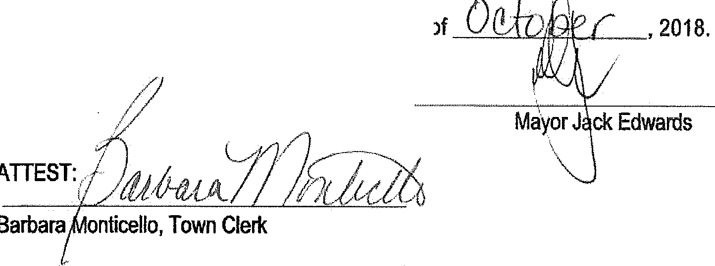Resolution adopted this, the _
- C(_
---

,.,,. I
'•J1 , I I, ·:
..
  - ' '

METROPOLITAN TRANSIT COMMISSION INFORMATION ITEM
STAFF SUMMARY

SUBJECT: CEO Recommended DATE: March 27, 2019 FY2020 Preliminary Operating and Debt Service Budget
FY2020-2024 Community Investment Plan (CIP)

1.0 PURPOSE/SCOPE: To provide additional information on Community Investment Plan (CIP) projects in CATS FY2020-FY2024 CATS Preliminary budget.

  - BACKGROUND/JUSTIFICATION:
An executive summary of the FY2020 Preliminary Operating and Debt Service Budget and FY2020-2024 CIP was presented to the MTC on January 24, 2019.

Operating Highlights were presented to the MTC on February 27, 2019, to provide additional information on the FY2020 Preliminary Operating Budget.

In order to provide the MTC with detailed information on the FY2020-FY2024 CIP budget, the following programs are identified for more in-depth review at the MTC’s March 27, 2019 meeting:
    - Safety & Security
    - Bus
    - Rail & Facilities
    - Marketing and Technology
    - Development

3.0 PROCUREMENT BACKGROUND: Not applicable

  - POLICY IMPACT: The recommended FY2020 Preliminary Operating and Debt Service Budget and FY2020-2024 CIP have been developed in compliance with the following MTC Policy directives:

    - CATS Mission, Vision and Strategic Goals
    - CATS Financial Policies (Rev. 2016)
    - The 2030 Transit Corridor System Plan
    - CATS Service and Fare Policies

5.0 ECONOMIC IMPACT:
The Blue Line Extension (BLE) light rail service will complete its first full year of implementation in March 2019 and continues to spur economic development along the alignment. The Envision my Ride initiative will provide more frequent mobility options and more direct services, providing riders with better access to jobs. The Charlotte Gateway Station Phase 1 is currently underway as well as the CityLYNX GoldLine extension of the existing streetcar services. The full implementation of the new CATSPass mobile payment application and the North Corridor Direct Connect Studies, are all anticipated to have a positive impact on fare revenue and ridership.

6.0 ALTERNATIVES: Not applicable

7.0 RECOMMENDATION: Not applicable at this time since information is being presented for review by the MTC.

  - ATTACHMENT(S): None

SUBMITTED AND RECOMMENDED BY:

John M. Lewis, Jr.
Chief Executive Officer, Charlotte Area Transit System Director of Public Transit, City of Charlotte

FY2020 PRELIMINARY CAPITAL BUDGET
HIGHLIGHTS
Presented To
METROPOLITAN TRANSIT COMMISSION
March 27, 2019

Agenda
FY2020 Preliminary Capital Budget Highlights
- Budget Overview
- Safety & Security Ill. Bus
- Rail & Facilities
- Marketing & Communicat ions
- Development
- Other Initiatives
- Next Steps
\,. :

CITY OF CHARLOT "( OJ}
www .RIDETRAN SIT.org

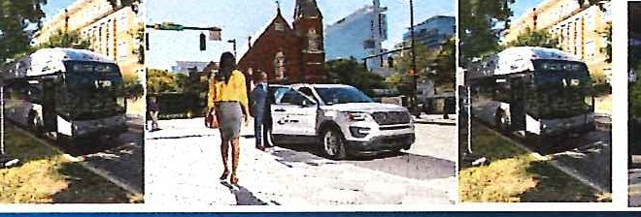
MaiJ·H·MMhJ·f!MMaA·f!MMhJ·f!MMaiJ·f¥MM l·Ji·iLM
USES OF FUNDS
State of Good Repair - Vehicle
Re placement , Facilities & Others
Mad1R•MMUJ·BMMeH·fJMMaE·f!MM,tfJ f¥MM i·lf·i◄t
Trans it Safety & Security Transit Long Range Capital Improvement
Non-Revenue Vehicle Transit New Equipment Other Programs
Carry Ove r Projects
TOTALS

Notes :
" FY2020 Preliminary Capital Budget includes some prior year re-allocation but excludes carry ove r amount s
* Excludes Grant-Funded Operating Projects totaling $51.1 million for FY20 20 -FY2024

Budget Overview
FY2020 Preliminary Budget Overview
MTC Preliminary Budget Presentation
- January 23,2019 TSAC Budget Presentation
- February 14, 2019
CTAG Preliminary Budget Presentation
- February 19, 2019
MTC Preliminary Operating Budget Highlights February 27, 2019
-
CITY
OJ}
w vvw.RIDETRANSlT.o rg
OF CHARLOT t

Grants - Federal | $1S,682,283 | $11,3S6,315 | $11,064,285 | $11,113,414 | $11,102,818 | $60,319,115
Grants - State | 1,627,828 | 1,581,717 | 1,105,948 | 1,050,740 | 1,126,780 | 6,493,013
local Yi% Sales Tax | 6,541,455 | 4,219,688 | 5,564,964 | 5,577,246 | 5,574,597 | 27,477,950
Carry Over Project Balance | 668,800 |  |  |  |  | 668,800
TOTALS | $24,520,366 | $17,157,720 | $17,735,197 | $17,741,400 | $17,804,195 | $94,958,878

$10,541,779 | $12,641,199 | $11,613,344 | $12,318,543 | $12,714,889 | $59,829,754
390,718 | 220,395 | 222,144 | 223,897 | 226,136 | 1,283,290
8,048,412 | 1,781,717 | 3,200,000 | 3,200,000 | 3,200,000 | 19,430,129
1,240,200 | 685,010 | 530,320 | 390,530 | 320,740 | 3,166,800
2,590,227 | 1,024,969 | 1,364,959 | 804,000 | 538,000 | 6,322,155
1,040,230 | 804,430 | 804,430 | 804,430 | 804,430 | 4,257,950
668,800 |  |  |  |  | 668,800
$ 24, 520,366 | $ 17,157,720 | $ 17,735,197 | $ 17,741,400 | $ 17,804,195 | $ 94,958,878

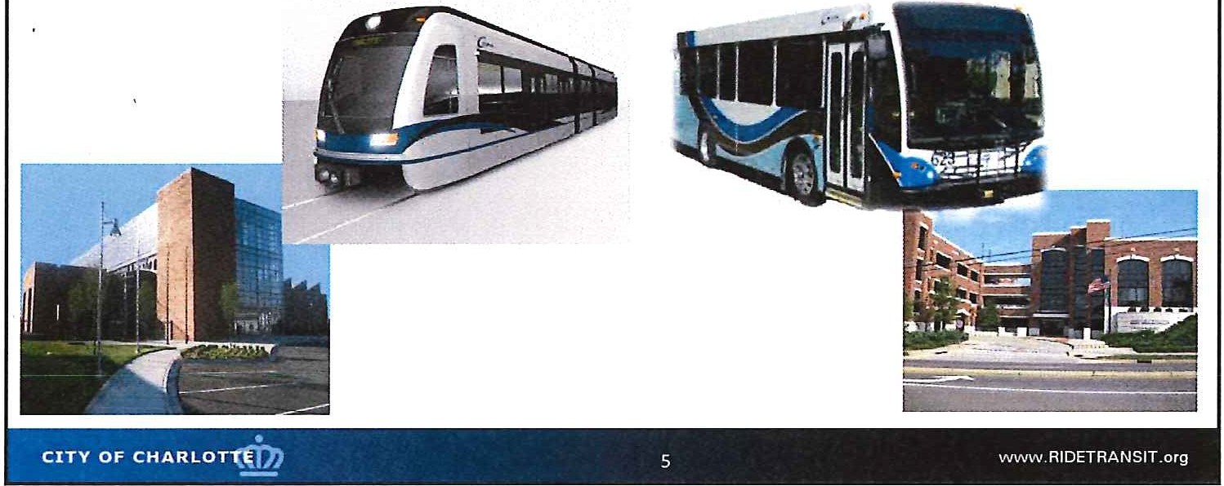

SAFETY
&
SECURITY
.

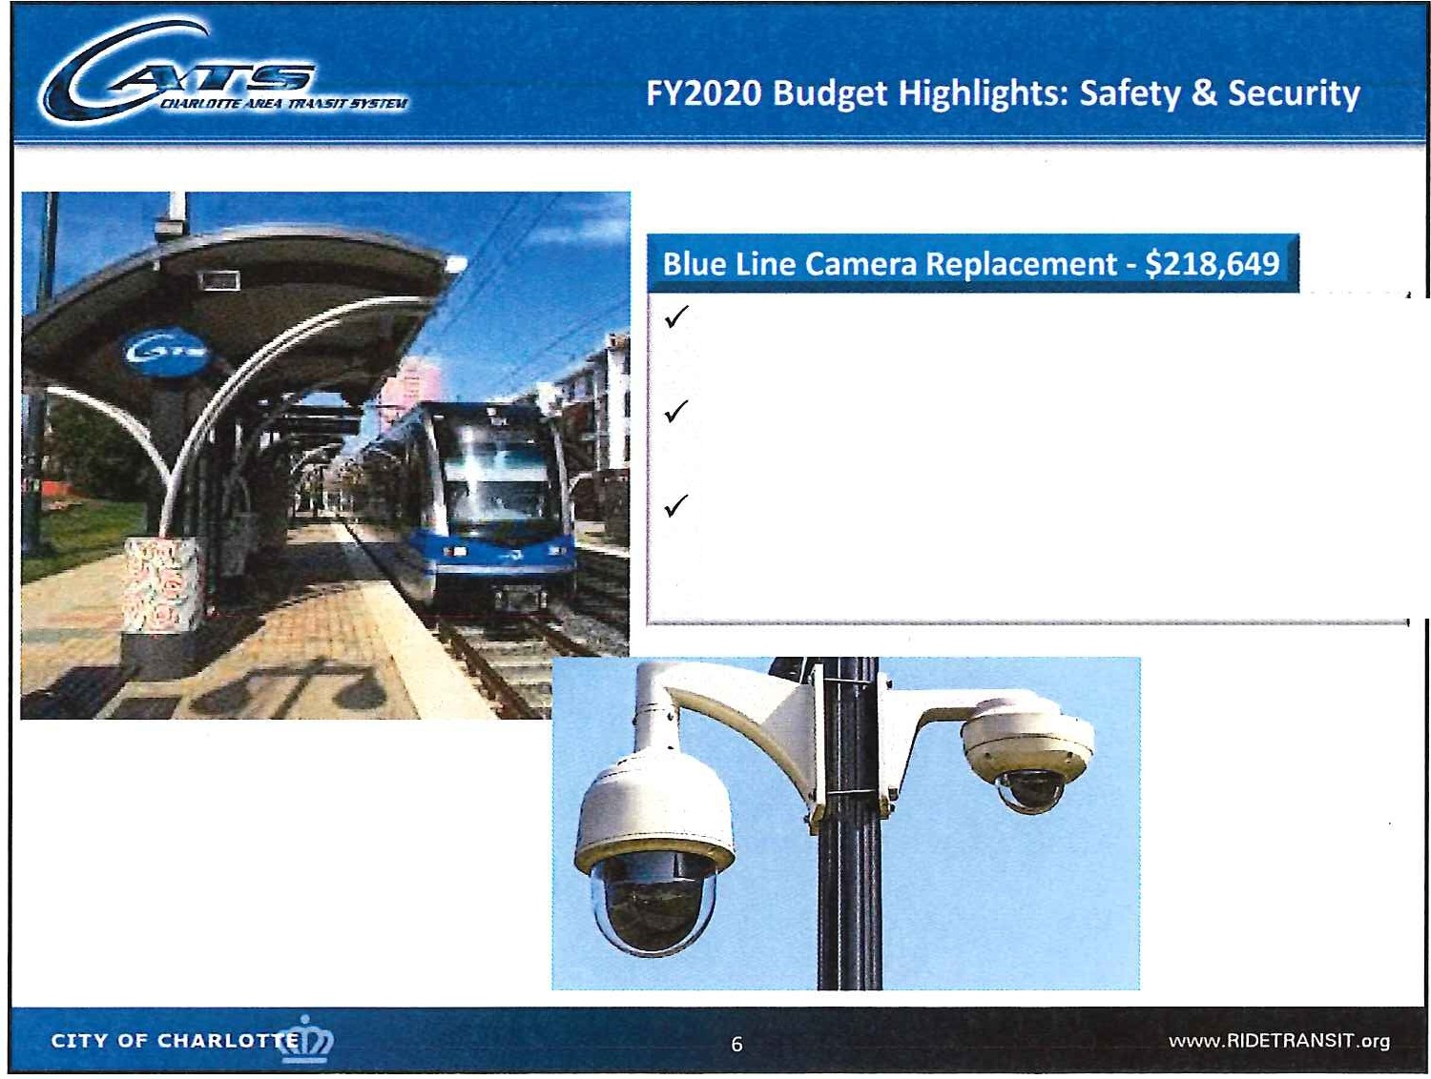

Replace cameras along the South End alignment
Current cameras have reached the end of their useful life and need to be replaced
Repairs have become more difficult because cameras in use are no longer made by the manufacturer

Transit Police Dispatch has outgrown its current location
Will relocate to a larger area inside the Sugar Creek Parking Deck Will replace video wall, consoles and various operating systems

Estimated 2 year total- $1,920,588

, :.,-:-·,=-
(
Mobile Video Camera System Replacement/Upgrad
-
'
e
......;

42 Rail Car Upgrades - 10 Cameras and 1 HVR per Rail Car
133 Fixed Route Bus Upgrades - 8 Cameras and 1 HVR per Bus
47 STS Vehicle Upgrades - 7 Cameras and 1 HVR per
..
' '
.,
•.
-

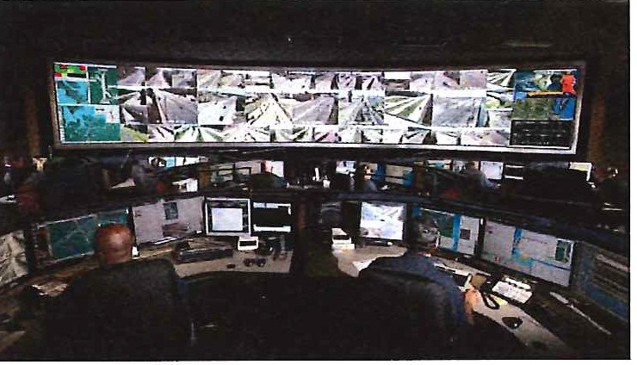
STS Vehicle

Year 1 Capital Need - $967,667
21 Rail Car Upgrades
67 Fixed Route Bus Upgrades 24 STS Vehicle Upgrades

Year 2 Capital Need - $952,921
21 Rail Car Upgrades
66 Fixed Route Bus Upgrades 23 STS Vehicle Upgrades

CITY OF CHARLOT"t(D}
-- ,,- -::--"-_

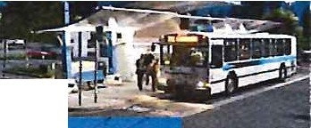
._·-1.1,l'i;;_', - 1· - ,.·:· I
ww w .R IDETRAN SIT.org

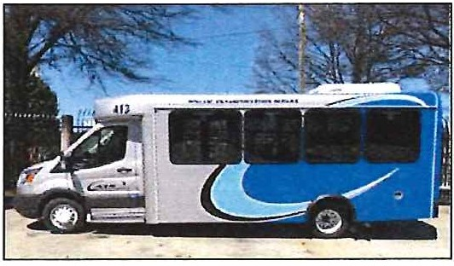
t
fjl
1f
t'lj
/riB

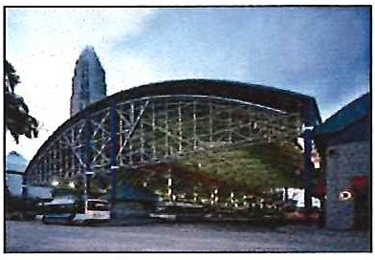
BUS

i
10 local bus replacements in FY2020 6 Local 40' vehicles
4 local 30' vehicles
- . ' t ·I .
--.........,-
_·
- :a-:id^{ii}
.. '
••
. !
I
Bus Replacements
10
55
65
STS Vehicle Replacement
17 vehicle replacements in FY2020
al
STS Replacements
17
68
85
iii_
-
w ■
r

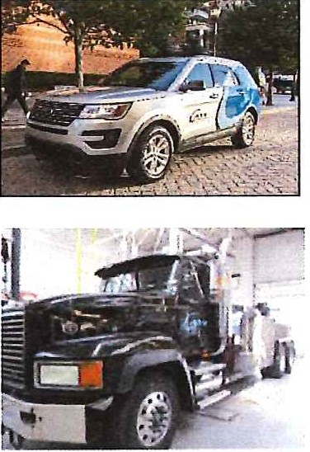
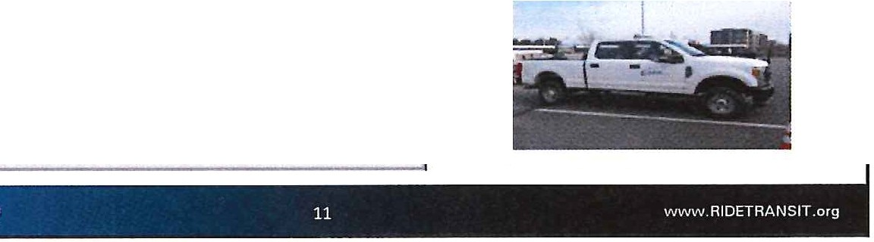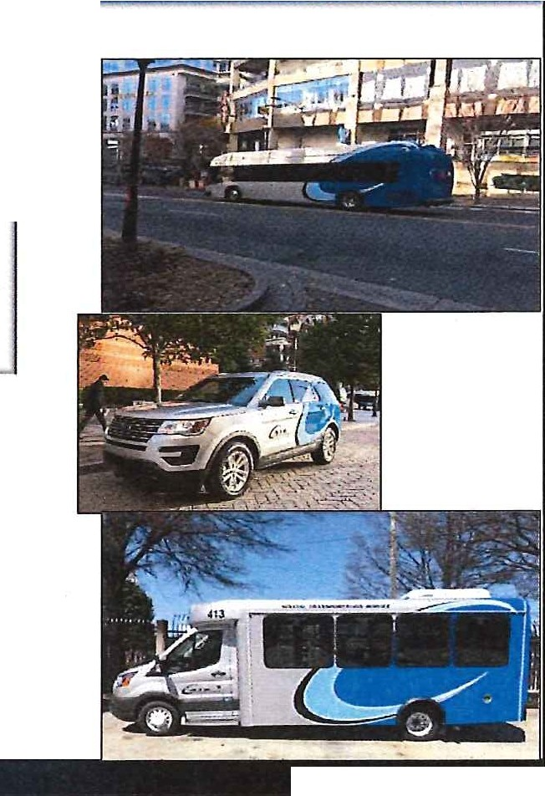 Bus: Other Initiatives
Vanpool Replacement
16 vehicles replaced in FY2020 5 expansion vehicles in FY2020
19 new or replacement vehicles in FY2020
www.RIDETAANSIT.org
Bus Operations & Maintenance |  | 27 | 35
Special Transportation Services |  | 1 6 | 20
Rail Operations
Mainte nance of Way
Facilities
Total | 19 | 49 | 68

Vanpool Replacements | 16 | 60 | 76
Vanpool E>cpansions | 5 | 5 | 10
Tota l | 21 | 65 | 86

Compressed Natural Gas (CNG)
Conside ring pilot program with paratransit vehicles
Long term plan to convert additional vehicles
Benefits of CNG
Lower carbon content Cheaper fuel price Better Mile per gallon

I Hii·iiiRHH•u 12

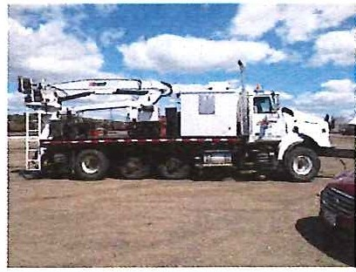

RAIL & FACILITIES
Ii]
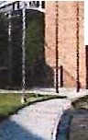
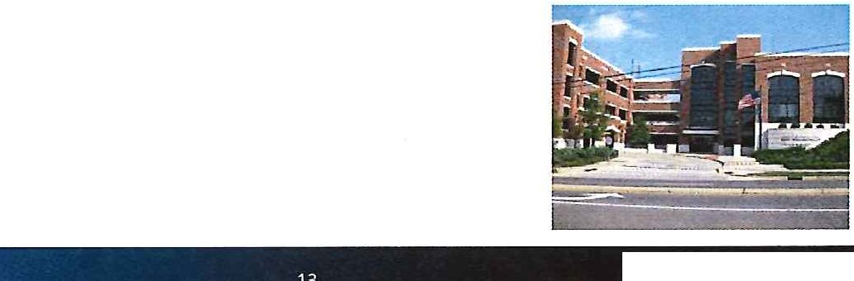,,o·I'.
13
www.RIDETAANSIT.org

CITY OF CHARLO a•

Rail Operations
Emergency Response Vehicle
3 Year investment Totaling $1,078,000
Covered in FY19, FV20 and FY21 Capital Outline
Back Hoe for Maintenance of Way Track
$100,000 Investment
Required Equipment for Maintenance on the ROW

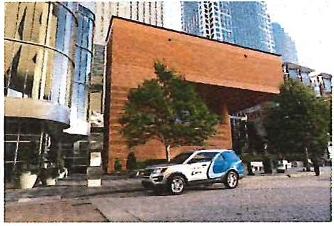
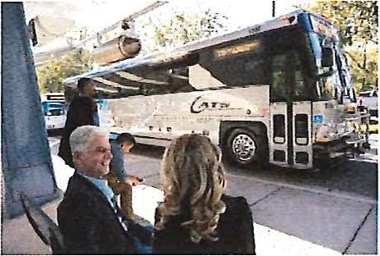
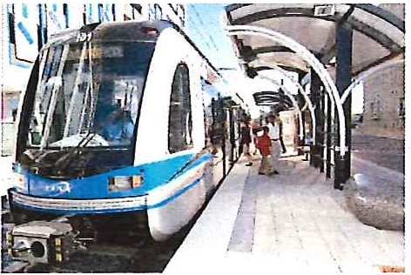
'
4
, =
·' .:
!!11

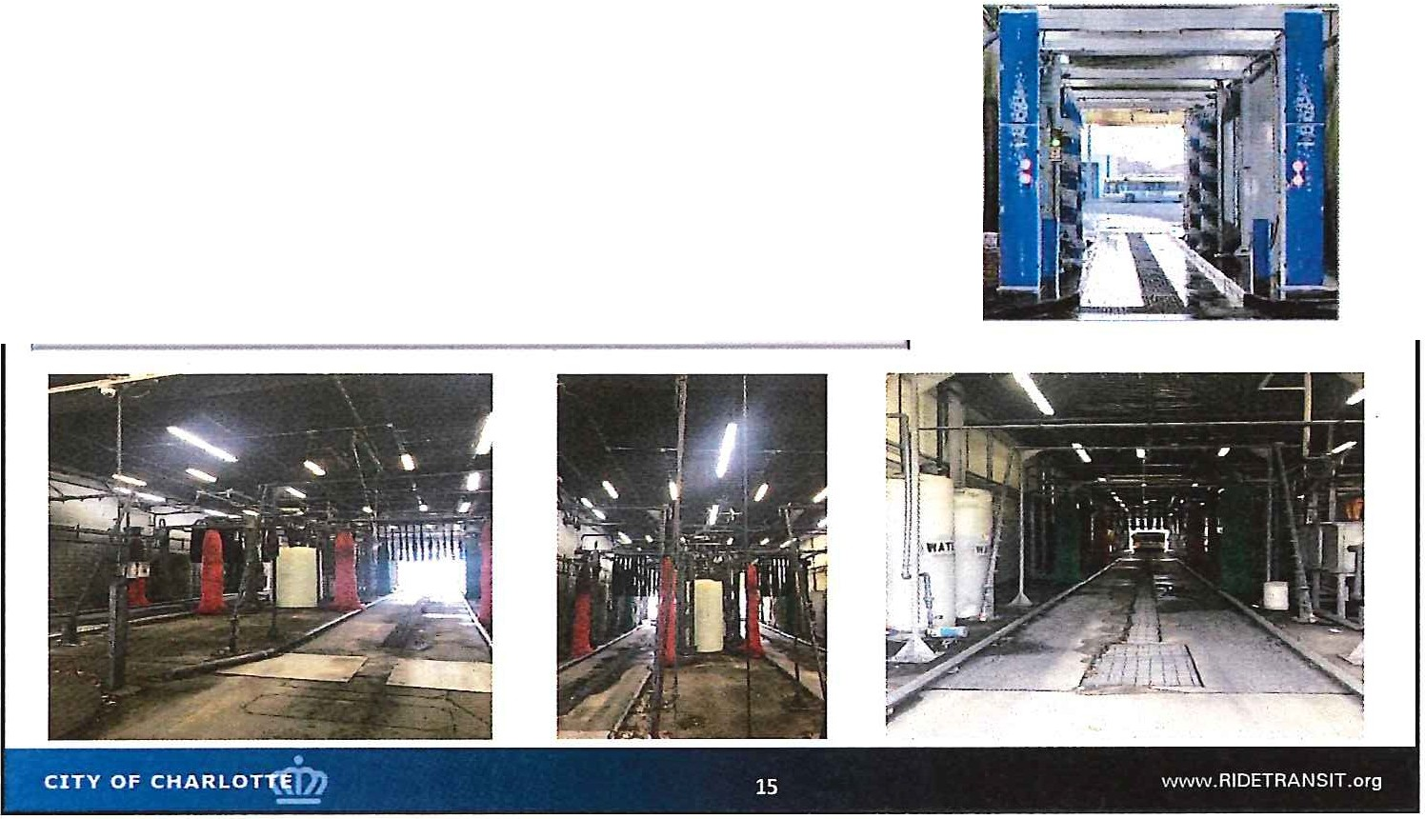
CATS Facilities
South Tryon HVAC Replacement
$325 ,000 Investment
Improve Energy Consumption reducing Cost
North Davidson Bus Wash Replacement
$400,000 Investment
Required Equipment for Maintenance

Marketing, Communications &
Technology
y -
-.··.·
-· • · · · '
1..·. · ''··
f:· >·.
; -;·I-
Bi
- ' ,.,. ·.
'jf. '
'
...{ '.. X
.,.,7a, .- - , (. -
- ,.J
/
- -
I '-. " J. ' •
, -_"-⁻ .,. ..-.,. 1
1·
'
1 1
11!::1
,:t.
i
·-·-
-

City is procuring a federated video system to focus around the Genetec Technology
VMS solution will reduce the number of recorders and increase system capability to share video with City Departments
Estimated cost over 5 years:

FY2020 | $1,500,000
FY2021 | 549,000
FY2022 | 1,000,000
FY2023 | 770,000
FY2024 | $
5-Year Total | $3,819,000

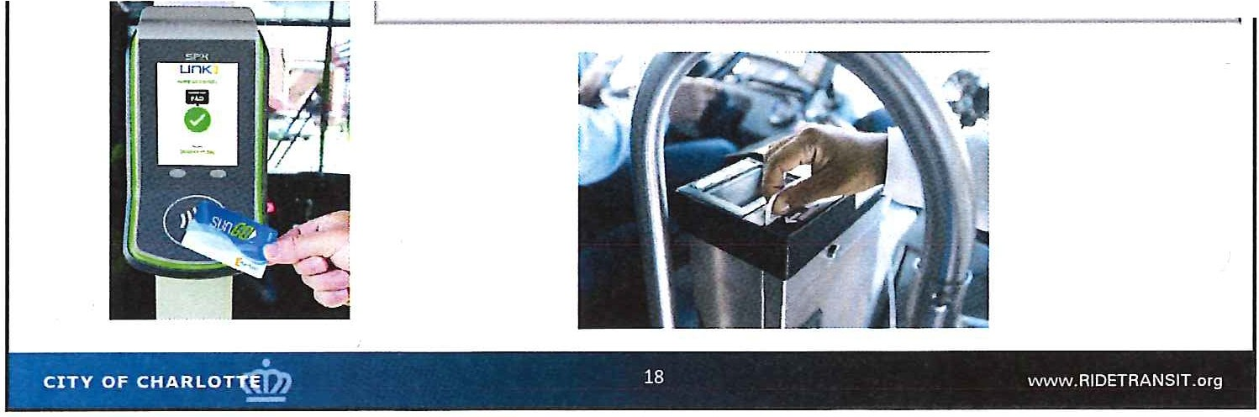
FY2020 Budget Highlights: Marketing & Technology
FirstNet AT&T Private Mobile Network - $904,600
Communication modems on buses and ½ LYNX fleet are past End­ of-Life. New devices will allow for enhanced and new option s:
- Wifi for public use
- Pulling of video remotely
- Sending fare collection information for UNC Charlotte and future contactless implementation
- FirstNet for higher priority for communications during city­ wide emergencies

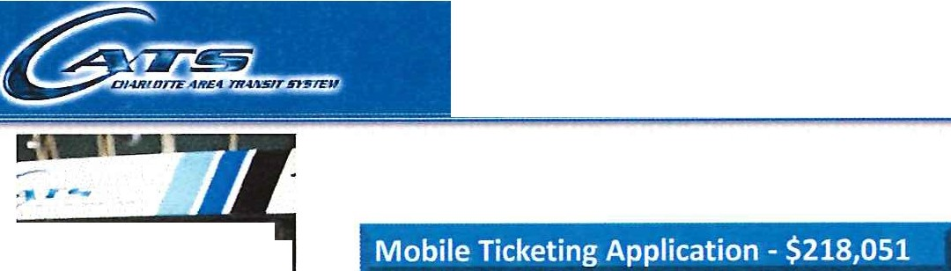FY2020 Budget Highlights: Marketing & Technology

, ;.v f1Ull I
- ,
<I
Additional funding in FY2020 to move the pilot ticketing app program to a full time program
Integration with existing fare collection equipment and parking control system
l1J
BJ
-
m
7Da y
t,,...., ..,, ,,.,., ,, ..., n,
.
, - , - ... I·
•
··" l o
Q
''·· ·.,
; .

J Col

_;"' ",
...
i

, I\ , ,
    - Ii,' '
- 0'

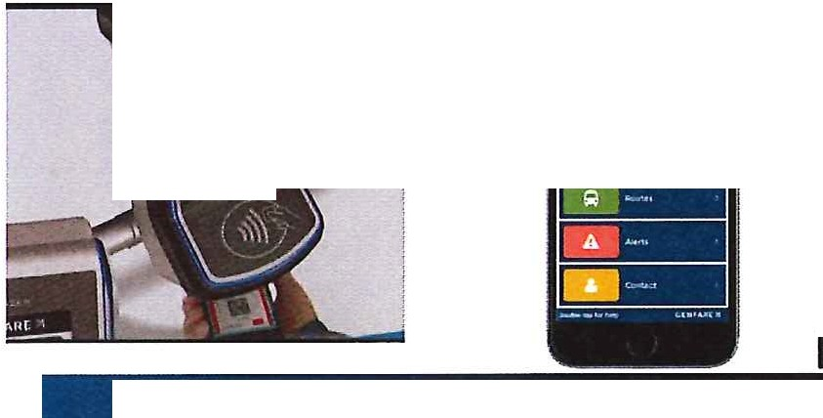.;i
"
CITY OF CH ARLOT"((D) 19 WWVV, RIDETRANSIT .org

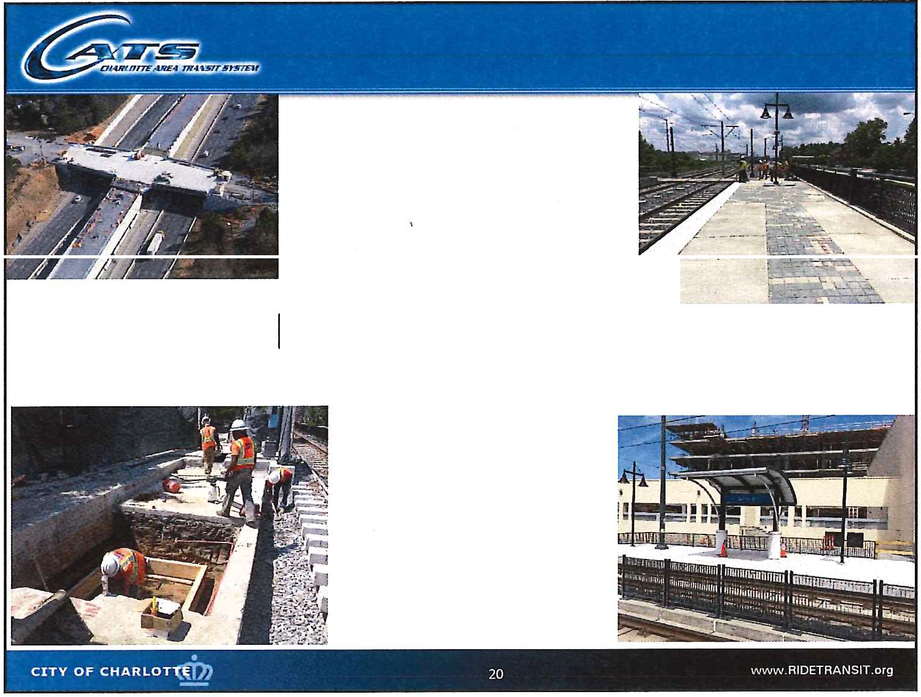

I
DEVELOPMENT

ADA Capital Improvements
Funding in FY20 operating budget for the ADA Accessibility Assessment FY21- FY24 funding to implement the corrections, enhancements and improvements derived form the assessment and required under ADA
Failure to comply with the ADA can result in the loss of federal funding and a consent decree specifying spending levels and acti ons.
Cost estimate of capital projects:

FY2020
FY2021 | 200,000
FY2022 | 200,000
FY2 0 23 | 200,000
FY2024 | 200,000
5-YearTotal | $800,000

FY2020 | $1,340 ,000 | CATSfunds
FY2021 | 1,360,000 | CATS funds
FY2022 | 3,000,000 | Private funds
FY2023 | 3,000,000 | Private funds
FY2024 | 3,000,000 | Private funds
5-Year Total | $11,700,000

11

New South End Light Rail Station Design
Funding provided in FY2020/2021 to plan/design a new light rail station in the vicinity of Publix and establish project cost/budget to assist in negotiations with private sector to fund construction

Hambright Park & Ride Lot and Transit Center
Regional Park & Ride adjacent to 1-77 express lanes Project cost of $10,000,000 over 3 years:
- Year 1 $2,010,000
- Year 2 $5,490,000
- Year 3 $2,500,000
Proposed Hambright Park and Ride
Hambright Express Lane Direct Connect January 2019

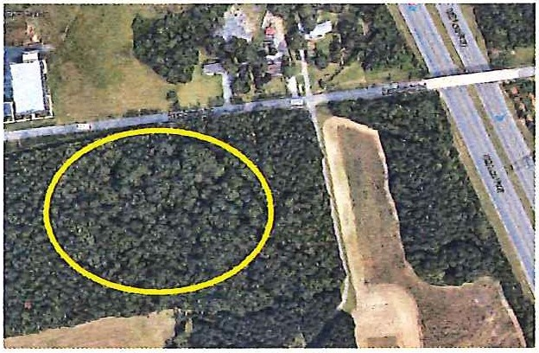
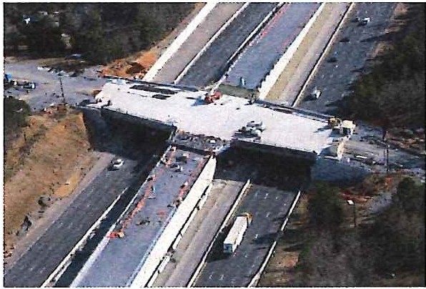
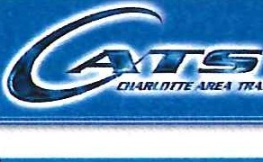
Development: Other Initiatives with Funding Challenges
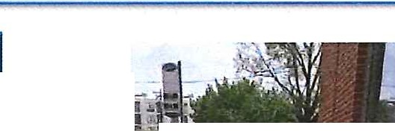

Envision My Ride Amenity Initiatives - Shelter Program
Current bus shelters and other passenger amenities are either nearing the end of their useful life or no longer meet public expectations
Would implement the capital recommendations of the Envision My Ride effort to refresh the design of the standard bus passenger shelter, specify related bus stop amenity needs, select and procure a vendor to manufacture and deliver, and subsequently install them as replacements and expansion over a four (4) year period.
In Year 1 the design phase would include public outreach and stakeholder involvement to reach a consensus on a desirable and affordable replacement product, and implementation strategy

Fiscal Year

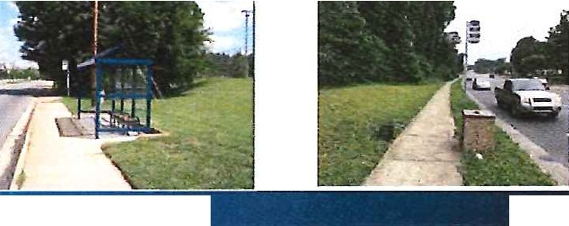Year 1
OF CHARLOT "((D)
24
Year 2

Year 3 Year4 Year 5
5-YearTotal

oo0.000

000,000
00,000
$6,000,000 1

CITY

ww w. AIDETRANSIT.org

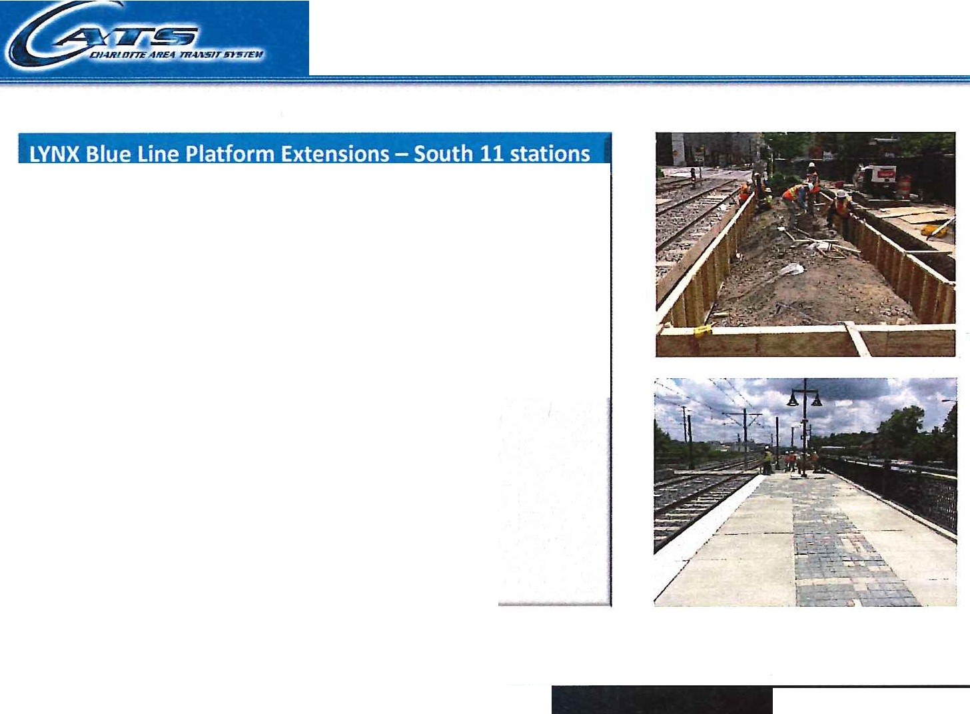
Development: Other Initiatives with Funding Challenges
Design and incrementally construct the platform extensions on the LYNX Blue Line in order to meet the '' FTA required capacity needs.
The incremental approach positions CATS to take
advantage of potential federal and state grants as they become available
CITY OF CHARLOT •..
25
www. RID ETRANS IT.org
Development: Other Initiatives with Funding Challenges
This project will design and construct new operator comfort stations at key locations to improve operational efficiency.
Envision My Ride recommends a decentralized bus network. The greater number of bus comfort
stations provide operational flexibility to achieve i
the core vision of Envision My Ride.

Fiscal Year | Amount
Year 1 | $5,247,000
Year 2 | 3,578,000
Year 3 | 4,628,000
Year4 | 9,671,000
Year 5 | 21,090,000
5-Year Total | $44,214,000

Year 1 | $325,000
Year 2 | 200,000
Year 3 | 200,000
Year 4 | 200,000
Year S | 200,000
5-YearTotal | $1,125,000

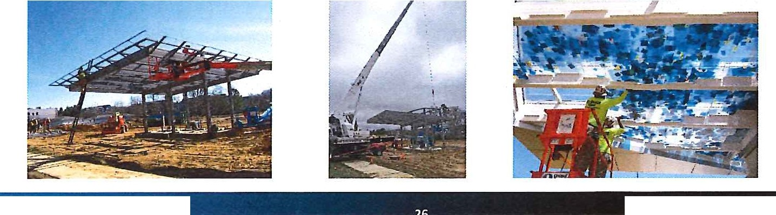
CITY OF CHARLOT •
26
www.RIDETRA NSIT.org

13

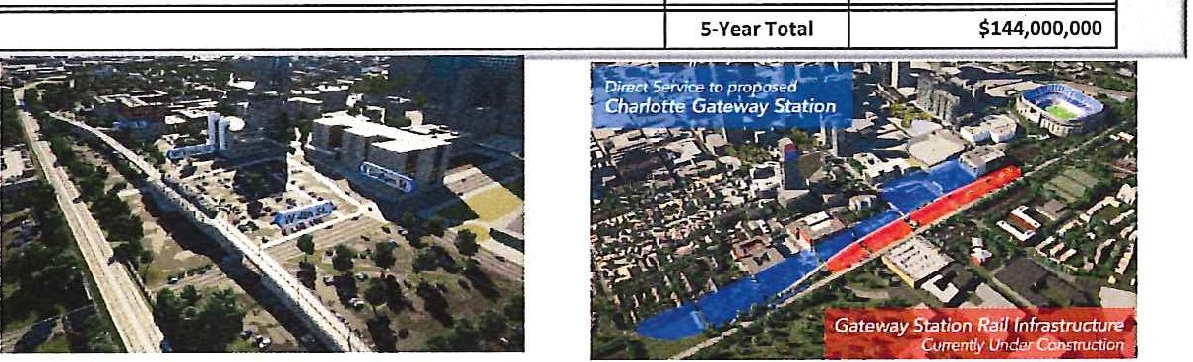
Silver Line (Airport to Matthews)
Consultant Services to advances planning and design work
Silver Line and Charlotte Gateway Station

15% Design | Year 1 | $18,000,000
30% Design/Draft Environm e nta l Impact Statement (DEIS)/ Enter Project Development | Yea r 2 | $22,000,000
30% Design/Draft Environmental Impact Statement (DEIS)/ Enter Project Development | Year3 | $20,000,000
65% Des ign/ Final Environmental Impact Statement (FEIS)/ Enter Engineering | Year4 | $39,000,000
65% Design/Final Environmental Impact Statement (FEIS)/Enter Engineering | YearS | $45,000,000

Continue to review funding available to support CATS 2030
Vision Plan
Prioritize Other Initiatives (Including the Other Operating
Needs)

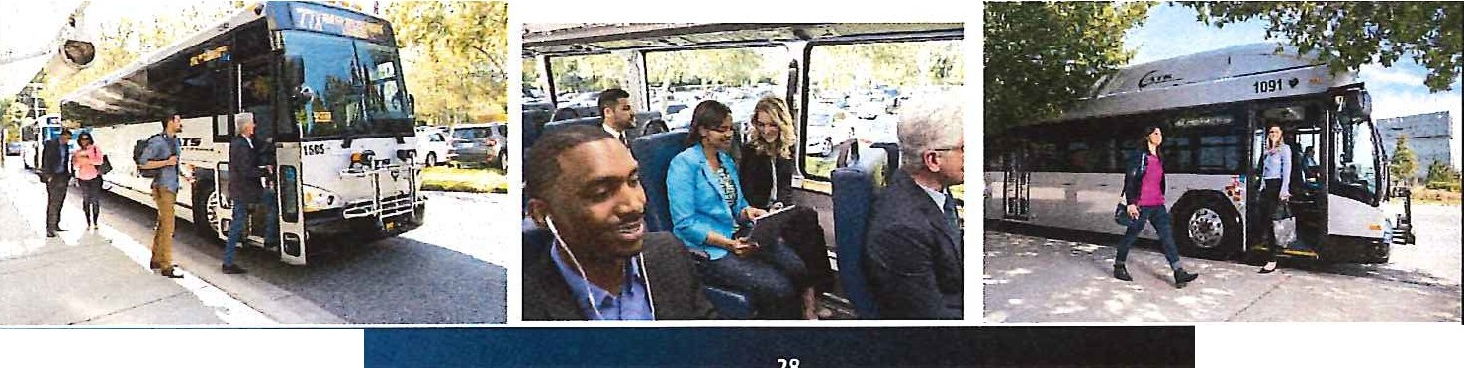
CITY OF CHARLOT {D)
28
w w w .RIDETRANSIT.o rg

April 16, 2019
CTAG Recommendation
April 24, 2019
MTC Approval
June 2019
City Council Adoption

Thank you
CITY OF CHARLOT \ (D}
30
ww w .RIDETR ANSIT.org

METROPOLITAN TRANSIT COMMISSION INFORMATION ITEM
STAFF SUMMARY

SUBJECT: Regional Transit Plan Status Update DATE: March 27, 2019

1.0 PURPOSE/SCOPE: Update the Metropolitan Transit Commission on the most recent staff work in support of the development of a Regional Transit Plan.

  - BACKGROUND/JUSTIFICATION:

    - During calendar years 2017/2019, CATS and the Centralina Council of Governments have collaborated on an extensive public engagement process as part of the Regional Transit Engagement Series (RTES).
    - The public engagement process included Mecklenburg and the surrounding counties of Union, Cabarrus, Iredell, Gaston, Lincoln, York SC, and Lancaster SC.
    - The RTES culminated in a Transit Summit held May 16, 2018 at UNC Charlotte. A key takeaway from the Summit was the consensus need for a Regional Transit Plan.
    - CATS and the CCOG are currently collaborating on the next phase of project outreach including project scope development and identification of funding partners.
    - Staff will provide an update on recent and upcoming activities.

3.0 PROCUREMENT BACKGROUND: Not Applicable

4.0 POLICY IMPACT: Informs 2030 Transit Corridor System Plan

5.0 ECONOMIC IMPACT: Not Applicable

6.0 ALTERNATIVES: Not Applicable

7.0 RECOMMENDATION: Not Applicable

8.0 ATTACHMENT(S): Not Applicable

SUBMITTED AND RECOMMENDED BY:

John M. Lewis, Jr.
Chief Executive Officer, Charlotte Area Transit System Director of Public Transit, City of Charlotte

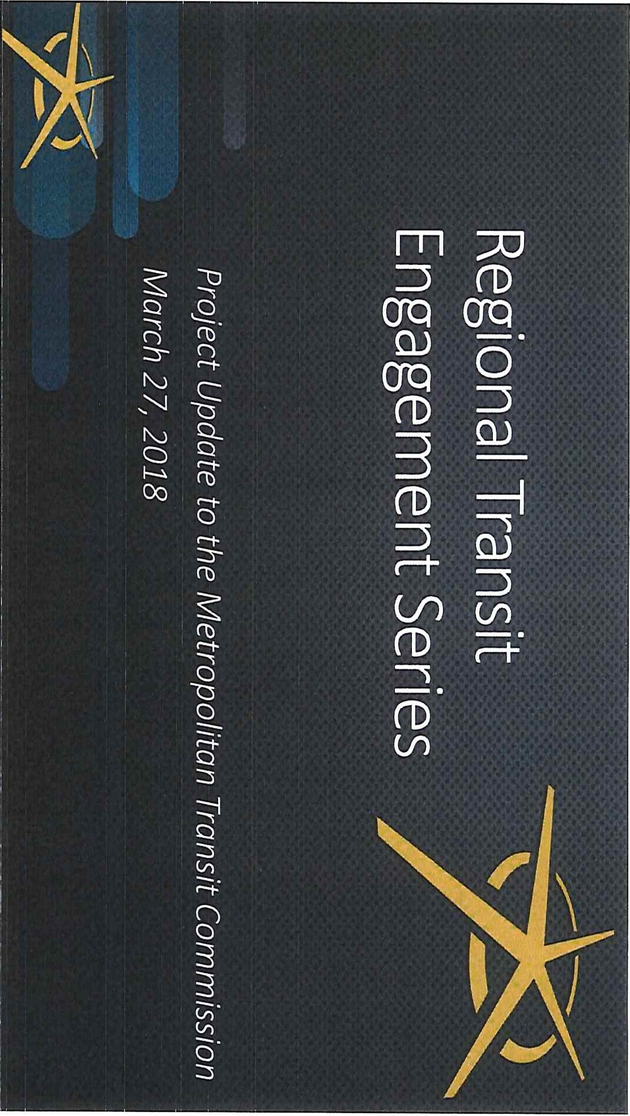
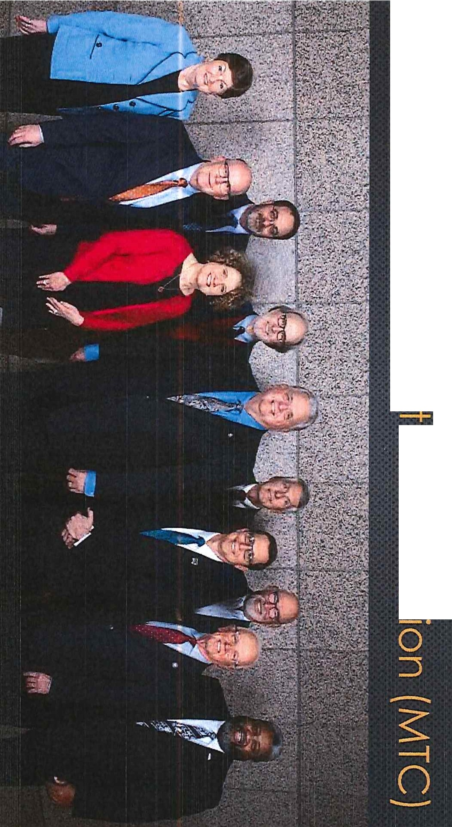I
CD
-+
0u
0
-+
0
::J
---i
0
::J
(/)
()
0
3
3
(/).
(/)

I

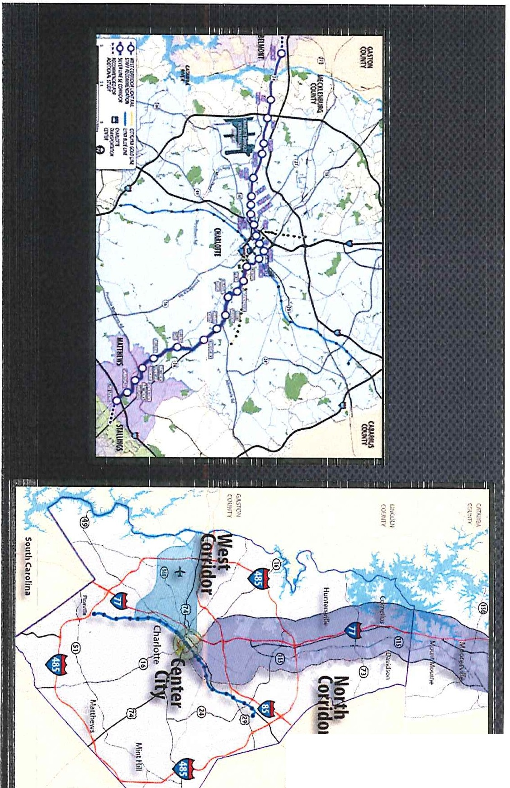
u
H
. _{:-}
=
-Il<l
!3:!:;II
i
C><
!i
'"

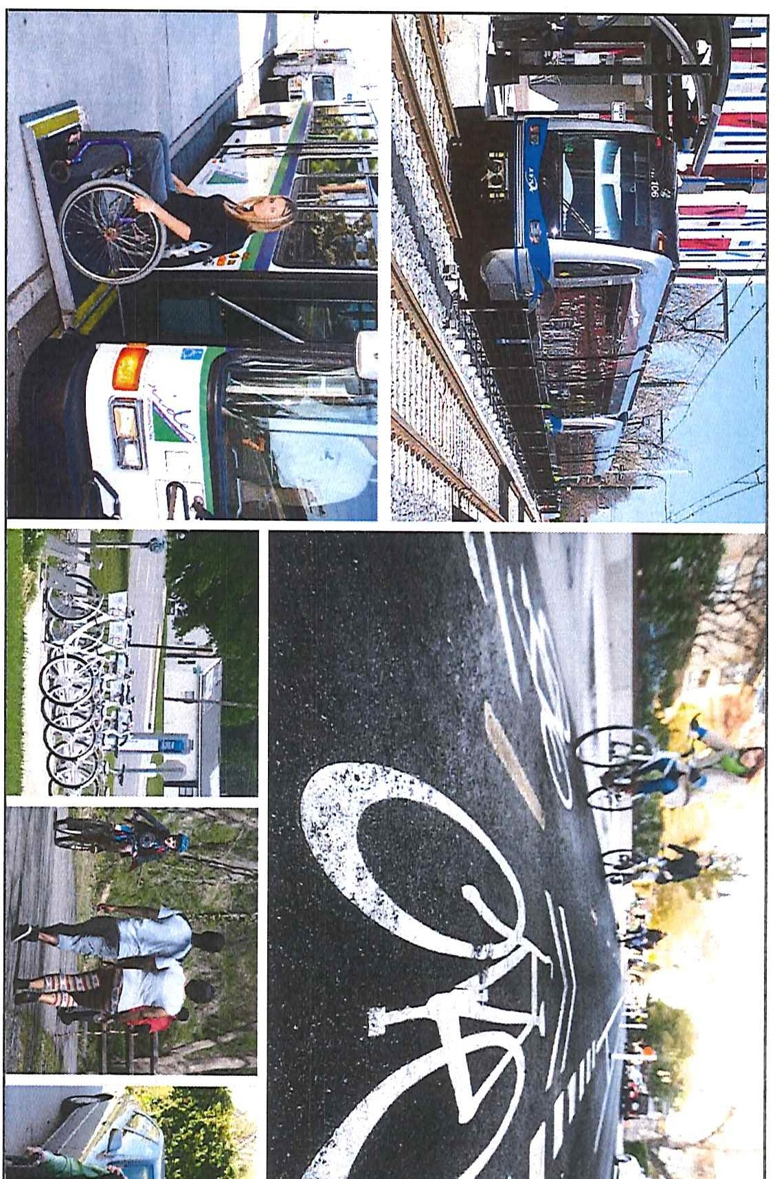I
ii,
--
w
N
-...J 11
N
0......,
N I.D

3/27/2019

Cross-County Co mmut ing in Charlotte Region, 2017
A, er \ -' I w,.. J I or.yt h I Gre e nsboro I

'1 · --.... \ --- - -
- - .-
-, _.i,,\ C _{<r} iA'.rn .Jn, ,

/ i P/11m.l'tr.f/\ I
I
O . \ 531 3q,S03
- \ caldw e ll
Q \ _,,' . '- ,.r
- Moving workforce
JYIO I -
<
-s.
I 8urh '\ ( 0-'Vvd on
1/.cDowell, R,,ndo lph

) '--·
\

}'' ·
s. 240 r
Nor\11
----- -'\cr
v-- .... \
- Predictable travel times

", Ru\ e,/ord
Pol '"\
:,
..

I \
Spart nbur
l
, Spo1r1,,n°burg( ~,

>- '
\ _ / U11l on ,
-\.,,,. l
' Lau rens />-'0,
/

33$!16

1,049
\
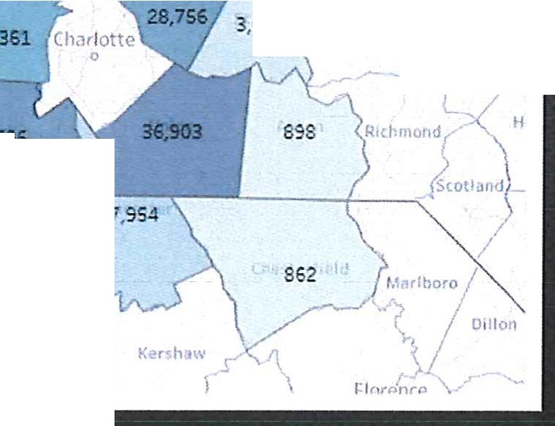
070 , I >ntgomor·\ Moor
-\
- Attract businesses, talent
- Enhancing mobility
- Access to jobs

- Transportation option

•, I \
/' P'.'JOrl
019 M.-!obox r, Oo"

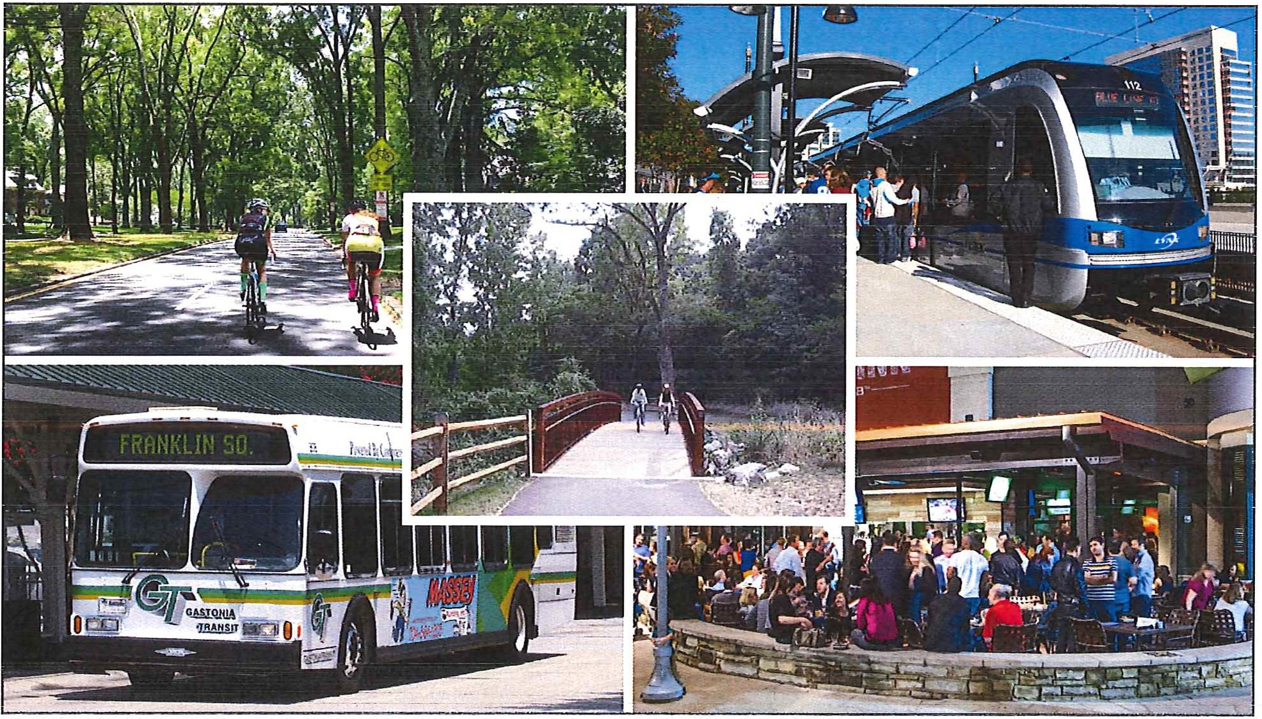

3/ 27/ 2019

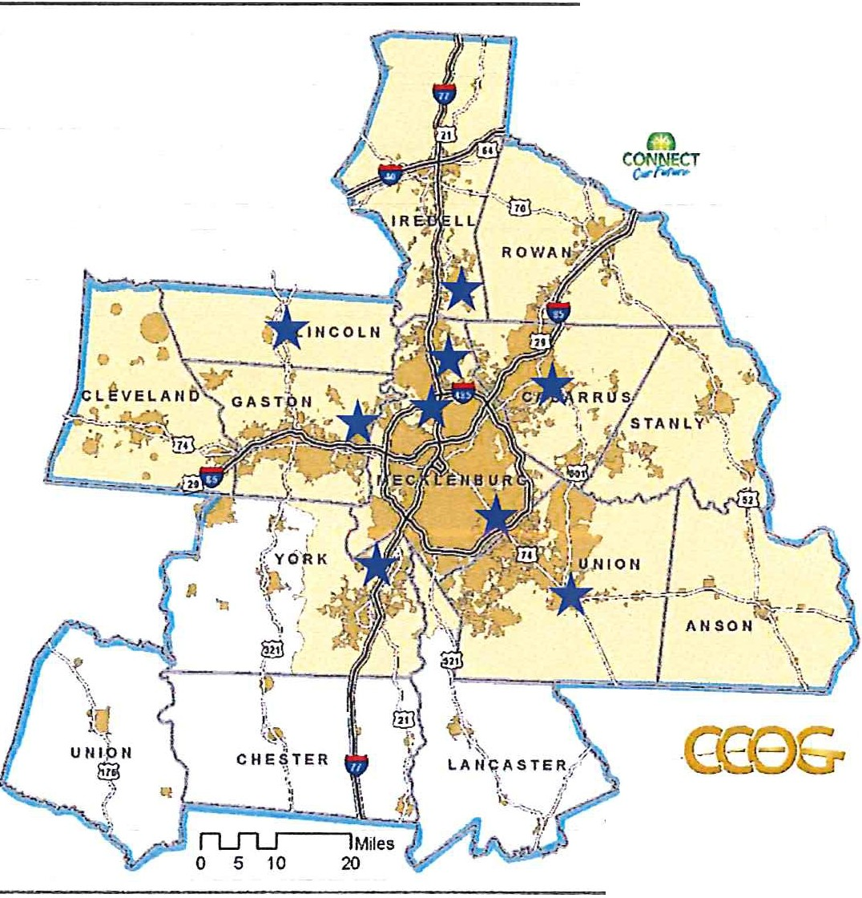r Eng.1gementlorea
r:-:'.J Munic.JpaliliM
l:I CONNECT Rego,'}

October 2018 County Meetings
*

N r 1V•.•-<15Q ' IA1 ,· '-I>•, :
+
Melropolitan Transit
w F. Commission (MTC)
J.llpa ted0d 20111by
S Cenh 1 CCl<.l<let of Go.w nmeot1

3/ 27/ 2019

Regional Transit Ad visor.y
- Guide scope development
C ommitte e

- Ensure community and regional interests considered
- Inform consultant selection

Name rtli½1ilfitU1M
op Ch ar lotte Area Transit Syst em (CATS}
! BobCook Charlo tt e Regional Tran spor t atio n Plannin g Organizat ion Vincent Wong Cit y of Gastoni a
Randi Gates Gasto n-Cle veland- Lin coln Metro politan Planning Organi zat ion Bill Thunberg Lake Norman Transportation Com m ission
>-
Andrew Bryant Lincoln County

Debbie Collins NCDOT Publi c Transportation Division

U Weslowski
Rid er Transit

David Hoop.err Rock Hill-Fort Mill Area Transportation Study Dana Stoogenke Rocky River Rural Plannin g Organization

Helena Conncors UNC-Charlotte
Bjorn Hansen Union Count y

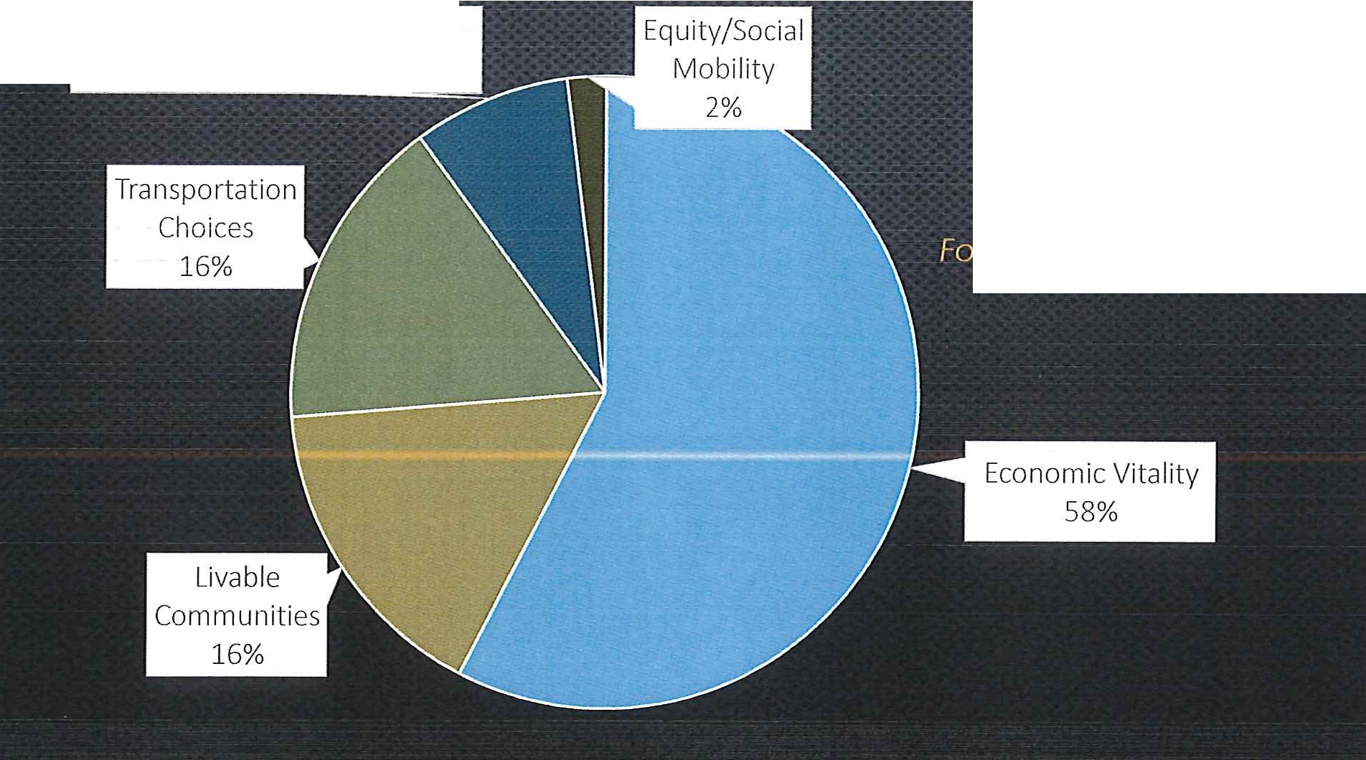
Effi cient Transit Performance
8'3-o
Top Priority
Themes
Fo r a Re g io na l Tra nsi t Pla n

3/27/2019

What should communities be doing to prepare for transit?

- Early Action
- Funding
- Local Consensus & Engagement 4. Planning & Development
- Regional Coordination
- Sustained Leadership

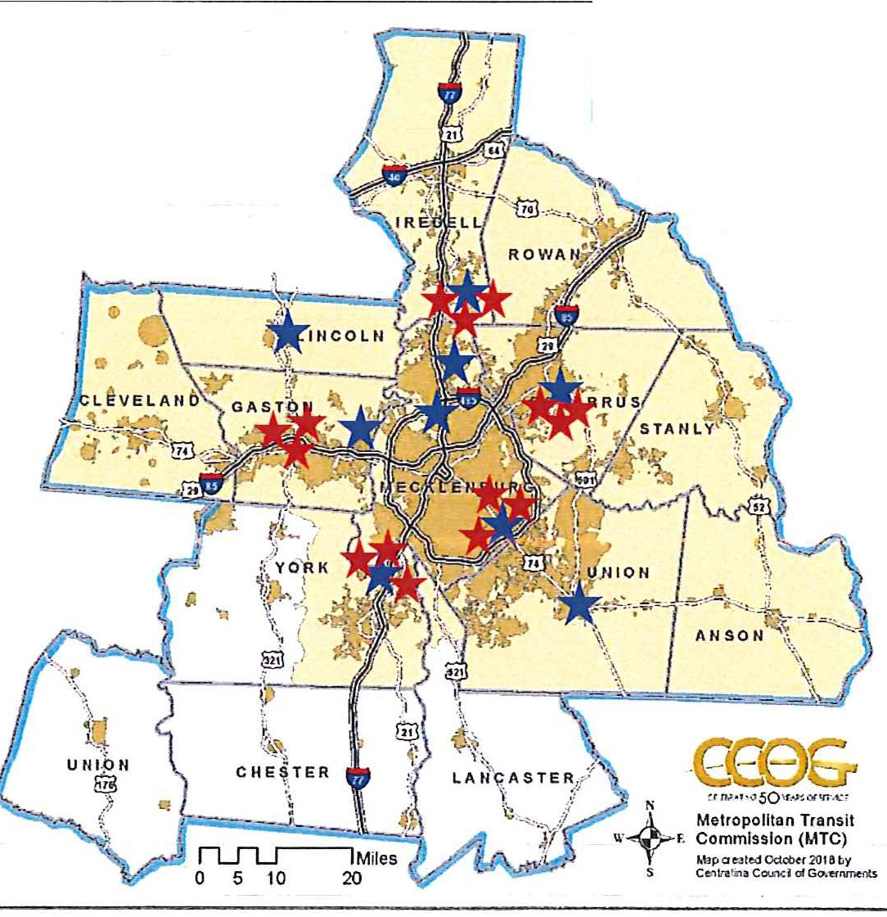
l EngagemantAtea
M11nlcipl lrtiE.s
c::l<X)/'/NECT Rag!on
C
C ,&S T
*
October 2018
County Meetings
*
November 2018
Focus Groups
- Economic
- Opportunity
- Planning & Community

:::y
.u,
o
.
w .r,..J
-+
-<
(/)
-+
0
OJ
::J_
m
:::;-
.1--l
n
3
03 CD
C CD
0
s:: (/) n m
5!!.
""""'i ::::)
(/)-+
0-
a.
z
-·
u,
(/) 8
CD 0
g_
-+(/)
m
C
n
:::y C
vi
0-Q-_
0-
-·
)
Q_ ;;:::o
CD
- (/) C\)(/)o
::::)
0
CD
-+
,,
C
a
0
-+
(/)
-+
0
m
.en
c
u,
m
-,
C
i=i=
m
.
V,
C
.w .r,..J .1--l
c n
0
0
n
::J
,-+
m
O'Q
0
::J
DJ
C
(/)
,-+
0
:::,
0
m
3
DJ
::J
o-
::J
3
m
3
::J
-,
,,
,-+
n
,-+
0
:
3
C
.g n
a, (/)
C
n
(/)
vi
m
m r-+
(/)
: m
::J
)
a
C
n
nm
-+
-< CD
03
V,
V,
:::
m
:::

CD
Q.
DJ
0
- -,
DJ
0
0-
=
z -· 3
n
3
(/) ::::)
0
0-+-(/)
§
m
,-+
DJ
n
7'
m
m
DJ
m o
0
CD 0
a. )>
0
-, n
:::y C
c§
"m
0 Q_ Q_ ;;:::o
(/)
(/)
Ci
:J
3
Ci

CD
::J
r-t
(•/)C\()/)o
::::)

0
-+

CD

w
-
-
N
--.J
N
0
I-'
lO

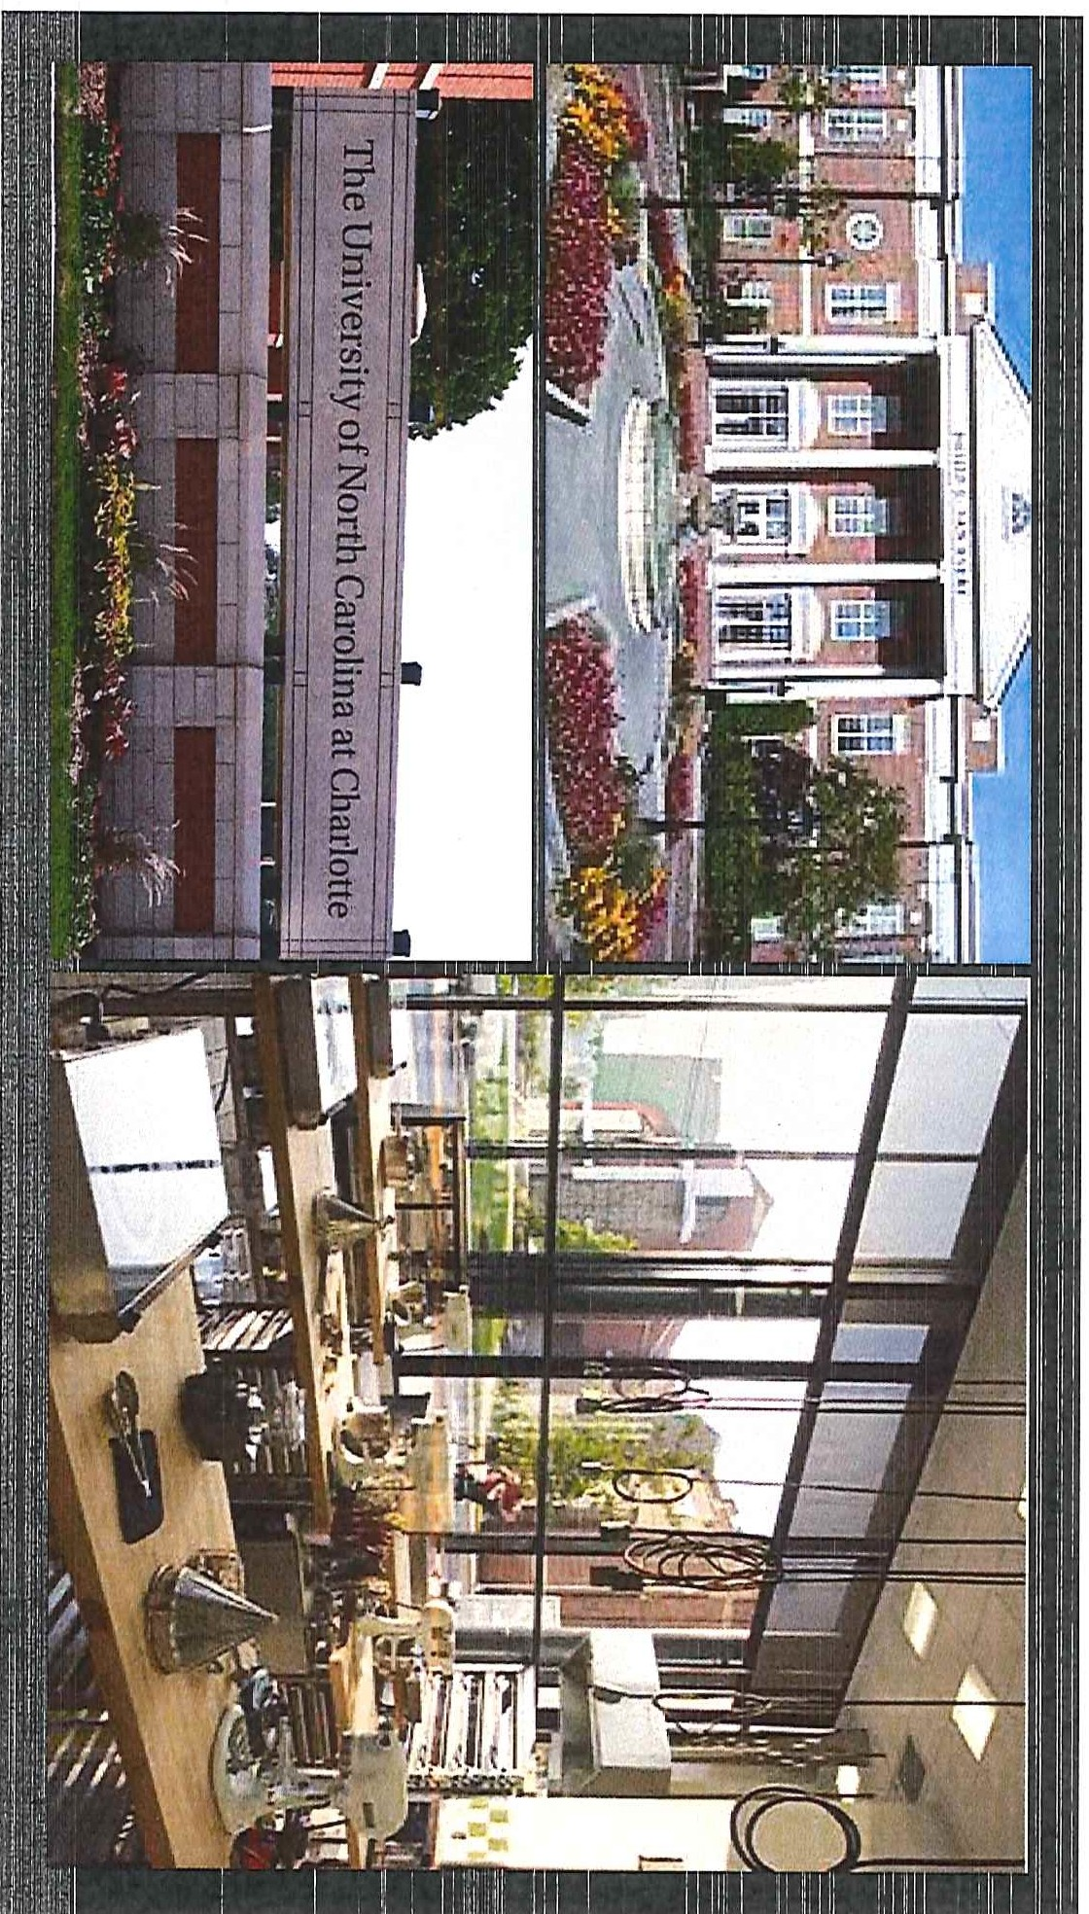
c§
,
-
0
n o
- o
DJ
-·
-·
r--i
-·
0
o
n:::::, n
::::,
"'<
;::.:
m3
m m
3
C
- •
.c
n
?o
:::J
OQ
-·
O
:::J
·
<-
mn
- ;
ru· :
0
"'C
3

00
:::y
0
-+
(/)
-+
0
-+
""'C -< (D
DJ 03
v,
ODJ
::::s C (D
::::s -; ::::5
OQ
-■
::::s (/)-+
-+ V>
S20
n

(D 0
0

:::y C
3 0--0..
- o..AJ
m
C
:::J
r-t
,.....
m
co
::::s
-·
V> V>
0
•C\)
::::5
0
-+
(D

--+·
:::y

I
I

lD

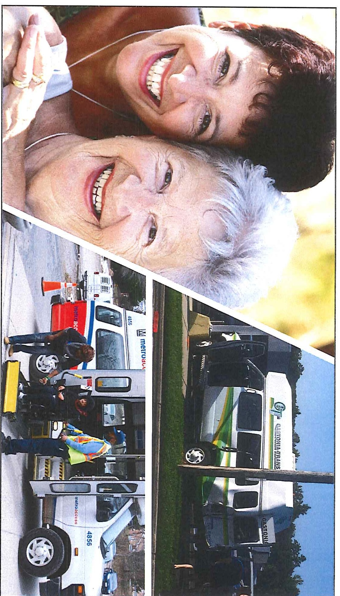
·
f:<
:, .. '.
'
-:---:
•♦•• •♦•• •♦•• •♦•• •♦••
V,
,-,
, Q
n
_,
,-,
s:,.,
--,
;:;
s
-0(
0
u
0

•. u
:::l
OJ
:::J
::::0 Tl
C
0
C
:::J
0
n
:::J
r-t-
:::J C (D
n
3

< (./)
::l
r-t-
..
3 oJ o z

V, - C O
OJ
Q
:::J
0
:::J

V, f
;:::+
N 0 N 0
3
3
(D
:::J
..--t
(/)
I
3
t
(D n m

0_,
( n· (D

•
n
(0 -
,-,
-
-,

:::l -
. s:,.,
, n
0
-
.,t .
-
. l
.
f
rt

OJ
:::J
(/)
M
o
r-t-
C
(")
OJ
r-t-.
0

OJ
r-t-
0
:::J
rn

:::r-
:::r-
r-t-
:::J
OQ
(/)
X
-I
(/)
rt
-I
m
-a
(/)
(D

,..,
:::J ::::0 N
(D 0

0....,
C)
OQ
0 lD

0 :::J
<
(0

:::l
::l

. (0

\.0

_ ,-,
V,

w
-
-
N
-..J
N
0
I->
\.0

45

Metropolitan Transit Commission
Charlotte Area Transit System Ridership Report
Feb-19
Mode / Service |  | Feb-19 | Feb-18 | Percent Increase/Decrease | YTD FY 2019 | YTD FY 2018 | Percent Increase/Decrease | Avg Daily Ridership per Month WeekDay Saturday Sunday
Local  BOD Local |  | 873,479 | 1,048,930 | -16.7% | 7,680,714 | 8,598,374 | -10.7% | 37,314 21,418 14,584
Subtotal |  | 873,479 | 1,048,930 | -16.7% | 7,680,714 | 8,598,374 | -10.7% | 37,314 21,418 14,584
Local Express
Arboretum Express | 4,145 |  | 4,304 | -3.7% | 31,167 | 31,772 | -1.9% | 209 | - | -
Carmel Road Express | - |  | 1,183 | n/a | 3,654 | 10,058 | -63.7% | - | - | -
Harrisburg Road Express | 2,622 |  | 3,448 | -24.0% | 19,354 | 28,455 | -32.0% | 132 | - | -
Huntersville Express | 8,102 |  | 8,686 | -6.7% | 67,535 | 68,646 | -1.6% | 409 | - | -
Idlewild Road Express | 1,907 |  | 2,977 | -35.9% | 17,422 | 22,529 | -22.7% | 96 | - | -
Independence Blvd Express | 4,272 |  | 5,070 | -15.7% | 34,973 | 37,402 | -6.5% | 216 | - | 1
Lawyers Road Express | 2,463 |  | 2,955 | -16.6% | 21,690 | 25,234 | -14.0% | 124 | - | -
Matthews Express | 3,868 |  | 4,113 | -6.0% | 29,440 | 32,353 | -9.0% | 195 | - | -
Mountain Island Express | 1,186 |  | 1,296 | -8.5% | 9,810 | 10,827 | -9.4% | 58 | 4 | 3
Northlake Express | 5,789 |  | 6,368 | -9.1% | 50,783 | 46,471 | 9.3% | 292 | - | -
North Mecklenburg Express | 13,382 |  | 13,297 | 0.6% | 103,345 | 104,314 | -0.9% | 676 | - | -
Rea Road Express | 2,888 |  | 2,260 | 27.8% | 22,776 | 19,067 | 19.5% | 146 | - | -
Steele Creek Express | 1,457 |  | 1,647 | -11.5% | 13,120 | 14,677 | -10.6% | 74 | - | -
University Research Park Express | - |  | - | n/a | - | 70,849 | n/a | - | - | -
Huntersville Greenhouse Express | 192 |  | - | n/a | 1,869 | - | n/a | 19 | - | -
Airport Connector - Northlake | - |  | 5,426 | n/a | 14,282 | 45,896 | -68.9% | - | - | -
Subtotal Regional Express  Concord Express | 52,273  - |  | 63,030  2,638 | -17.1%  n/a | 441,220  - | 568,550  20,253 | -22.4%  n/a | 2,646  - | 4  - | 4  -
Gastonia Express | 3,151 |  | 3,369 | -6.5% | 26,811 | 23,245 | 15.3% | 159 | - | -
Rock Hill Express | 2,664 |  | 2,816 | -5.4% | 21,725 | 19,525 | 11.3% | 134 | - | 4
Union County Express | 2,299 |  | 2,413 | -4.7% | 18,398 | 19,459 | -5.5% | 116 | - | -
Subtotal  Community Circulator  Neighborhood Shuttles | 8,114  30,500 |  | 11,236  43,354 | -27.8%  -29.6% | 66,934  257,744 | 82,482  367,608 | -18.9%  -29.9% | 409  1,308 | -  739 | 4  411
Beatties Ford Neighborhood Shuttle | - |  | 13,928 | n/a | - | 113,715 | n/a | - | - | -
Eastland Neighborhood Shuttle | 14,595 |  | 16,739 | -12.8% | 137,131 | 142,669 | -3.9% | 580 | 464 | 314
Pineville-Matthews Road | 3,319 |  | 3,932 | -15.6% | 25,949 | 29,858 | -13.1% | 144 | 118 | -
Village Rider | 6,608 |  | 6,546 | 0.9% | 53,100 | 57,992 | -8.4% | 281 | 173 | 89
Subtotal | 55,022 |  | 84,499 | -34.9% | 473,924 | 711,842 | -33.4% | 2,313 | 1,494 | 814

Metropolitan Transit Commission
Charlotte Area Transit System Ridership Report Feb-19
Activity Center Circulators
Gold Rush | - - n/a |  |  | - 23,831 |  | n/a | - - -
Subtotal | - - n/a |  |  | - 23,831 |  | n/a | - -
Human Services Transportation
Special Transportation Services | 20,540 19,542 5.1% |  |  | 170,220 167,833 |  | 1.4% | 918 286 258
DSS | 295 429 -31.2% |  |  | 2,606 3,580 |  | -27.2% | 15 - -
Subtotal | 20,835 19,971 4.3% |  |  | 172,826 171,413 |  | 0.8% | 933 286 258
Rideshare Services
Vanpool | 12,144 | 10,111 | 20.1% | 89,579 | 93,320 | -4.0% | 607 | - -
Subtotal | 12,144 | 10,111 | 20.1% | 89,579 | 93,320 | -4.0% | 607 | -
Rail
LYNX Blue Line | 671,346 | 366,048 | 83.4% | 5,147,328 | 3,219,187 | 59.9% | 27,452 | 20,150 | 10,424
CityLynx Gold Line | 14,875 | 23,337 | -36.3% | 163,006 | 249,835 | -34.8% | 698 | 336 | 201
Subtotal | 686,221 | 389,385 | 76.2% | 5,310,334 | 3,469,022 | 53.1% | 28,150 | 20,486 | 10,625

Total
1,708,088
1,627,162
5.0%
14,235,531 13,718,834 3.8% 72,372 43,688 26,289

CATS Sales Tax Report FY2019
FY2019 Forecast Trendline
FY2018 Receipts
FY2019 Budget Target
FY2019 Receipts
Jul Aug Sep Oct Nov Dec Jan Feb Mar Apr May Jun
$110

$100

$90

$80

$70

$60

$50

$40

$30

$20

$10

$0
FY2019 Sales Tax Receipts Forecast
($ millions)
$120
C umulati ve Monthl y Recei pts / Esti mates

Local Government Sales and Use Tax Distribution
- Source: North Carolina Department of Revenue Sales & Use Distribution Report for the month ending January 31, 2018
- Published by NC Secretary of Revenue on 3/12/2019 with actual receipts through December 2018
- CATS sales tax report only includes Mecklenburg County Article 43 sales tax
Sales Tax Budget Data
- The model projects FY2019 year-end receipts of $105,872,659, which is $7,318,226
(7.5%) above the budget target
- FY2019 sales tax budget is $98,211,941
- FY2018 actual sales tax was $103,021,757
Sales Tax Collections and Distribution – December 2018
- December 2018 receipts of $8,906,774 were $1,391,001 (-13.5%) below the budget target for the month
- December 2018 receipts were $417,493 (-4.5%) below December of 2017
December Receipts

FY2019 Sales Tax Receipts
Jurisdiction | Population | % of Total | Jul 18  actuals | Aug 18  actuals | Sep 18  actuals | Oct 18  actuals | Nov 18  actuals | Dec 18  actuals | Jan 19  accrual | Feb 19  accrual | Mar 19 | Apr 19 | May 19 | June 19 | Total
Charlotte | 830,258 | 40.5% | $ 3,128,556 | $ 3,904,914 | $ 3,694,818 | $ 3,274,062 | $ 3,816,955 | $ 3,607,034 | $ 3,237,434 | $ 3,498,681 | $ - | $ - | $ - | $ - | $ 28,162,455
Cornelius | 30,207 | 1.5% | 112,497 | 140,413 | 132,859 | 117,729 | 138,871 | 131,234 | 117,786 | 127,291 | - | - | - | - | 1,018,681
Davidson | 12,572 | 0.6% | 47,218 | 58,935 | 55,764 | 49,414 | 57,797 | 54,619 | 49,022 | 52,978 | - | - | - | - | 425,748
Huntersville | 57,145 | 2.8% | 212,533 | 265,273 | 251,001 | 222,418 | 262,713 | 248,265 | 222,826 | 240,807 | - | - | - | - | 1,925,837
Matthew s | 30,849 | 1.5% | 116,044 | 144,841 | 137,048 | 121,441 | 141,822 | 134,023 | 120,290 | 129,997 | - | - | - | - | 1,045,506
Mint Hill | 26,690 | 1.3% | 99,810 | 124,579 | 117,876 | 104,453 | 122,702 | 115,954 | 104,073 | 112,471 | - | - | - | - | 901,917
Pineville | 8,873 | 0.4% | 33,350 | 41,626 | 39,387 | 34,902 | 40,792 | 38,549 | 34,599 | 37,391 | - | - | - | - | 300,595
Meck. County | 1,053,545 | 51.4% | 3,958,494 | 4,940,804 | 4,674,973 | 4,142,600 | 4,843,475 | 4,577,098 | 4,108,100 | 4,439,605 | - | - | - | - | 35,685,149
Total | 2,050,139 | 100.0% | $ 7,708,503 | $ 9,621,386 | $ 9,103,726 | $ 8,067,019 | $ 9,425,129 | $ 8,906,774 | $ 7,994,130 | $ 8,639,220 |  |  |  |  | $ 69,465,887
Year-over-Year Comparison (FY19-FY18) |  |  | -5.4% | 14.0% | 3.6% | 2.3% | 6.1% | -4.5% | 15.9% | 10.2% | - | - | - | - | 4.2%
FY19 Budget Target |  |  | $ 8,079,462 | $ 7,747,794 | $ 7,725,621 | $ 7,814,127 | $ 7,201,246 | $10,297,775 | $ 6,971,686 | $ 7,624,864 | $ 8,920,485 | $ 8,081,597 | $ 8,353,234 | $ 9,394,050 | 98,211,941
% of FY19 Budget Achieved |  |  | 7.8% | 17.6% | 26.9% | 35.1% | 44.7% | 53.8% | 61.9% | 70.7% | 70.7% | 70.7% | 70.7% | 70.7% | 70.7%

Sales Tax Receipts: FY2015 – FY2018
Fiscal Year | Jul | Aug | Sep | Oct | Nov | Dec | Jan | Feb | Mar | Apr | May | June | Total
FY2018 | $ 8,147,197 | $ 8,436,960 | $ 8,784,051 | $ 7,883,713 | $ 8,884,437 | $ 9,324,267 | $ 6,897,695 | $ 7,842,800 | $ 9,303,951 | $ 8,539,748 | $ 9,277,676 | $ 9,699,263 | $ 103,021,757
FY2017 | 6,706,169 | 8,123,310 | 8,099,598 | 6,984,259 | 8,275,157 | 9,927,120 | 5,142,666 | 7,510,515 | 9,105,261 | 7,459,176 | 6,747,425 | 8,520,759 | 92,601,412
FY2016 | 7,470,371 | 6,971,746 | 7,551,677 | 6,188,499 | 6,607,520 | 9,383,261 | 6,142,552 | 6,944,204 | 7,858,189 | 7,952,022 | 7,781,259 | 8,765,518 | 89,616,819
FY2015 | 6,087,774 | 6,938,945 | 5,932,063 | 7,114,003 | 6,853,209 | 8,378,347 | 5,947,801 | 5,641,898 | 6,914,523 | 6,057,389 | 7,522,357 | 7,762,101 | 81,150,409

