SP-XX, PRECAST REINFORCED CONCRETE CULVERT
Version Date: 5/8/2020 Revision Date: XX/XX/XXXX by XXX

Description

Work covered by this special provision consists of installation of a precast reinforced concrete culvert or arch culvert (culvert), a precast reinforced concrete culvert bend (bend), or a precast reinforced concrete culvert transition (transition) in accordance with the plans and specifications at locations shown on the plans and Figure 2.1 below. The work shall also include the construction of such joints and connections to other culverts, pipes, drainage structures, and steps as may be necessary to complete the work shown on the plans.

Materials and Construction Methods

Installation of the culvert, bend, and/or transition shall conform to Section 414 Box Culvert Excavation of the NCDOT Standard Specifications as well as any requirements of this provision. Backfill shall be as specified in the Earthwork, Excavation, Unsuitable Materials, and Backfill Materials Special Provision.

Design and Manufacture
Culvert, bend, and/or transition sections shall conform to ASTM C-1577 Standard Specification for Precast Reinforced Concrete Monolithic Box Sections for Culverts, Storm Drains, and Sewers or ASTM C-1786 Standard Specification for Segmental Precast Reinforced Concrete Box Sections for Culverts, Storm Drains, and Sewers in the latest edition of the AASHTO LRFD Bridge Design Specifications. Provide a precast culvert that meets the requirements of Section 1077 and any other applicable parts of the Standard Specifications.

The concrete mixture shall meet the requirements for Single Cell Box Sections shown in Table 1077-1 in Section 1077 Precast Concrete Units of the NCDOT Standard Specifications. Movement of the precast culvert, bend, and/or transition sections should be minimized during the initial curing period. Any damage caused by moving or handling during the initial curing phase will be grounds for rejection of that precast section. Air entrain the concrete in accordance with Section 1077 - 5(A) Portland Cement Concrete of the NCDOT Standard Specifications. For dry cast manufacturing, air entrainment is not required.

Handling devices or holes are permitted in each culvert, bend, and/or transition section for the purpose of handling and laying. Submit details of handling devices or holes for approval and do not cast any concrete until approval is granted. Remove all handling devices flush with concrete surfaces as directed. Fill holes in a neat and workmanlike manner with an approved non-metallic non-shrink grout, concrete, or hole plug.

Each culvert, bend, and/or transition section shall be checked at the plant for fitment and numbered which shall correspond to the laying schedule.

All openings shown on the plans in the culvert, bend, and/or transition shall be formed during the manufacturing process.

Culvert minimum waterway area shown on the plans shall be verified with the manufacturer for the culvert sizes due to manufacturing differences.

Precast reinforced concrete box culverts shall meet the minimum flow area listed on the plan detail sheets for each culvert.

Joints
Produce the precast reinforced concrete culvert, bend, and/or transition section with tongue and groove ends. Design and form these ends of the culvert, bend, and/or transition section so, when the sections are laid together, they make a continuous line of culvert sections with a smooth interior free of appreciable irregularities in the flowline. The internal joint formed at the tongue and groove ends of the precast units shall be sealed with either bitumen/butyl sealant or closed-cell neoprene material conforming to ASTM C990 Standard Specification for Joints for Concrete Pipe, Manholes, and Precast Box Sections Using Preformed Flexible Joint Sealants or C1677 Standard Specification for Joints for Concrete Box, Using Rubber Gaskets. The internal joint material shall be installed in accordance with the manufacturer's recommendations. The material shall be shown on the shop drawings when they are submitted for review.

Seal the external joint with an outside sealer wrap conforming to ASTM C877 Standard Specification for External Sealing Bands for Concrete Pipe, Manholes, and Precast Box Sections that is at least 12 inches wide and covers the joint on both the sides and the top of the culvert, bend, and/or transition sections. Use ConWrap CS-212 from Concrete Sealants, Inc., EZ-Wrap from Press-Seal Gasket Corporation, Seal Wrap from Mar-Mac Manufacturing Co., Inc., Cadilloc External Pipe Joint from Cadilloc, or an approved equal for the outside sealer wrap. If the outside sealer wrap is not applied in a continuous strip along the entire joint, a 12 inch minimum lap of the outside sealer wrap is permitted. Before placing the outside sealer wrap, clean and prime the area receiving the outside sealer wrap in accordance with the sealer wrap manufacturer recommendations. The joint wrap manufacturer installation recommendations shall be included with shop drawings submitted for review.

Installation
Ensure that equipment of the correct lifting capacity is available to install precast concrete culverts, bends, and/or transitions. Site conditions must be checked well in advance of shipping to ensure proper equipment location and to avoid any lifting restrictions. The lift anchors or holes provided in each section are only means to lift the elements unless otherwise approved by manufacturer.

In no case shall equipment operating in excess of the design load be permitted over the precast concrete culvert, bend, or transition units unless otherwise approved by manufacturer.

No construction equipment shall cross the bare precast concrete culvert, bend, or transition units. The contractor shall refer to the Manufacturers specifications for additional restrictions.

No backfill shall be placed against any structural elements until they have been approved by the Engineer. Complete backfill in accordance with Sections 410-8 and 414-7 of the NCDOT Standard Specifications, Manufacturer’s Specifications, and as specified in the Earthwork, Excavation, Unsuitable Materials, and Backfill Materials Special Provision. Sections 410-10 and 414-9 of the NCDOT Standard Specifications do not apply.

Bedding for precast culvert shall meet the requirements of Section 410 and 414 of the NCDOT Standard Specifications. Excavate 12 inches below the bottom of barrel and footings and backfill with Class VI select material in accordance with Section 1016 of the NCDOT Standard Specifications or as shown on the plans. Bedding shall extend 12 inches outside of the culvert or footings. In addition, 10 inches of bedding material shall be placed on filter fabric conforming to Type 4 requirements in Section 1056 of the NCDOT Standard Specifications. The filter fabric shall be placed perpendicular to the culvert barrel and wrap around the bedding with a minimum lap of 2 feet to be provided. Place remaining 2 inches stone bedding on top of fabric

Precast concrete units shall be placed at the beginning of the outlet end of the culvert with the groove end being laid upgrade. Tongue sections shall be laid into the groove sections. Positive means shall be provided to pull each section firmly into the previously placed section so that the joints are tightly homed. Use a "come-along", box pullers or other approved methods to create a positive means of joining box culvert, bend, or transition sections. Construction equipment shall not have direct contact with the culvert, bend, and/or transition sections. The load of the culvert, bend, and/or transition sections shall be suspended by a lifting device during joining procedure.

Place multiple, parallel lines of a culvert such that the separation between the lines of culvert has a minimum width of 3 inches. Fill the separation between multiple lines of culvert with non-excavatable flowable fill. Use flowable fill that meets the requirements listed in Section 1000 of the NCDOT Standard Specifications except that Field Compressive Strength Specimens are not required.
Concrete Baffles/Sills

If Concrete Baffles or Sills are proposed, they are to be included in the manufacturer’s design and installed per manufacturer’s specifications.

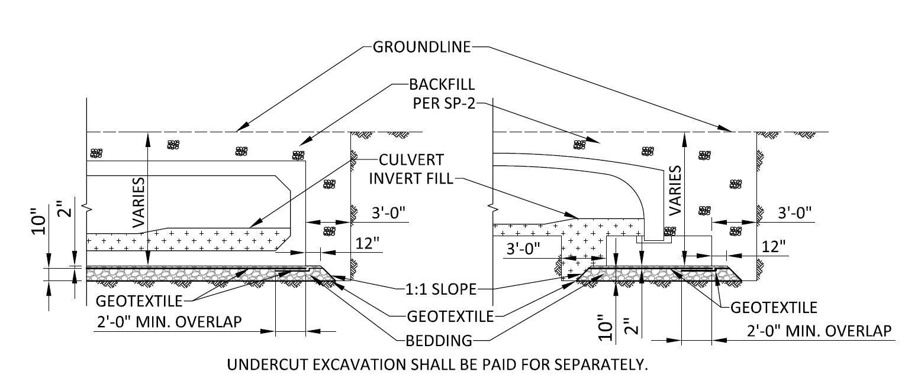

Figure 2.1 – Precast Reinforced Concrete Culvert Typical Section

Invert Fill Material (as needed)

The culvert shall be filled with native soil as shown on the plans and details. Native material consists of material that is excavated from the stream bed or floodplain at the project site during culvert construction. Only material that is excavated from the stream bed may be used to line the low flow channel or culvert barrel. Rip rap may be used to supplement the native material. If rip rap is used, native material shall be placed on top to fill voids and provide a flat surface for animal passage. Native material is subject to approval by the Engineer and may be subject to permit conditions. If native material is not available, the Engineer shall approve an alternate source of material.

The material shall be compacted as little as possible but firm enough to walk on without leaving footprints, with voids filled such that water flows over, not under or through.

Submittals

The designs of the precast culverts, bends, and/or transitions are the responsibility of the Contractor and are subject to review, comments, and approval. Submit two sets of detailed plans for review. Include all details in the plans, including the size and spacing of the required reinforcement necessary to build the precast culverts, bends, and/or transitions and the laying schedule. A North Carolina Registered Professional Engineer shall seal the plans and design calculations. The shop drawings must show the proposed openings (top and sides) and reinforcing for pipe connections, structure openings, direction of flow arrow, minimum flow area, weep holes (if applicable), sills/baffles (if applicable), and precast holes for steps (if applicable).

The Contractor shall submit the manufacturer’s certification for the culvert, bend, and/or transition sections and those products to be used in the installation. The Contractor shall also submit the manufacturer’s certification for the sills/baffles if required per plans.

All submittals shall be made a minimum of two weeks prior to construction or placing an order for materials for review by the Engineer.

Measurement

The quantity of precast reinforced concrete culvert to be measured will be the actual number of linear feet of culvert which has been installed and accepted. Measurement will be made horizontally along the centerline of the installed culvert. Measurement will not be made across precast bends, transitions, or other drainage structures.

The quantity of precast reinforced concrete culvert bends will be measured on a per each basis which has been installed and accepted. A bend is defined as a change in direction from zero to ninety degrees. A bend can be composed of a single or multiple sections. A bend starts at the first joint initializing the bend and stops at the last joint completing the bend.

The quantity of precast reinforced concrete culvert transitions will be measured on a per each basis which has been installed and accepted. A transition is defined as a change in culvert size. A transition can be composed of a single or multiple sections. A transition starts at the first joint initializing the transition and stops at the last joint completing the transition.

Payment

Payment for all work covered by this special provision will be made at the contract unit price per linear foot for “X’ x X’ PRECAST R. C. CULVERT,” per each for “X’ x X’ PRECAST R.C. CULVERT BEND”, and per each for “X’ x X’ TO X’ x X’ PRECAST R.C. CULVERT TRANSITION”. Such payment will be full compensation for all work covered by this special provision including, but not limited to, furnishing all labor, materials, filter fabric, equipment, excavating, bedding, invert fill material, flowable fill, installing culverts, bends, and/or transitions, constructing joints and connections, baffles/sills if necessary, furnishing project submittals and other incidentals necessary to complete this work. There shall be no separate payment for Culvert, Bend, and/or Transition Excavation, filter fabric, bedding, or any other items required by Section 410 (Articles 1-6 and 9) Foundation Excavation or 414 (Articles 1-5 and 8) Box Culvert Excavation of the NCDOT Standard Specifications. Backfill shall be as specified in the Earthwork, Excavation, Unsuitable Materials, and Backfill Materials Special Provision. Sections 410-10 and 414-9 Measurement and Payment of the NCDOT Standard Specifications do not apply.

Payment will be made under:

X’ x X’ PRECAST R. C. CULVERT LF
X’ x X’ PRECAST R.C. CULVERT BEND EA
X’ x X’ TO X’ x X’ PRECAST R.C. CULVERT TRANSITION EA

