How to search for Certified Vendors by Business Description while NOT Logged into the System

- Go to https://charlotte.diversitycompliance.com/
- Click on “Search Certified Directory”
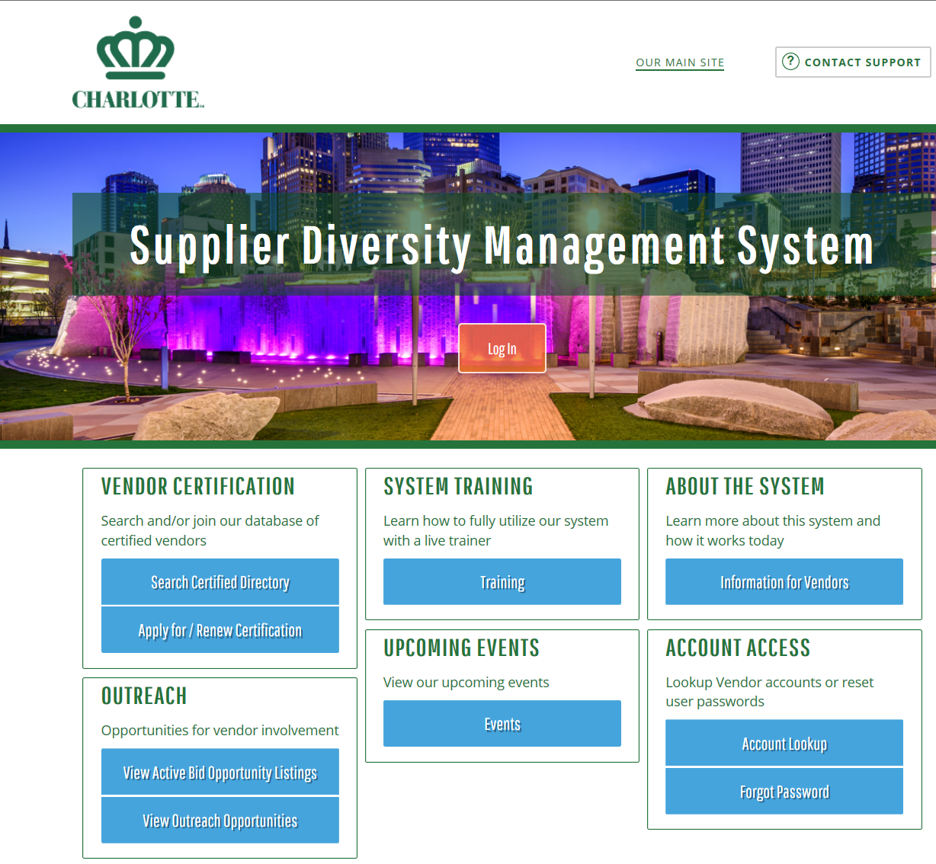
- Check Minority Business Enterprise (MBE), Small Business Enterprise (SBE), and Women Business Enterprise (WBE) to search the City of Charlotte Certified Directory List
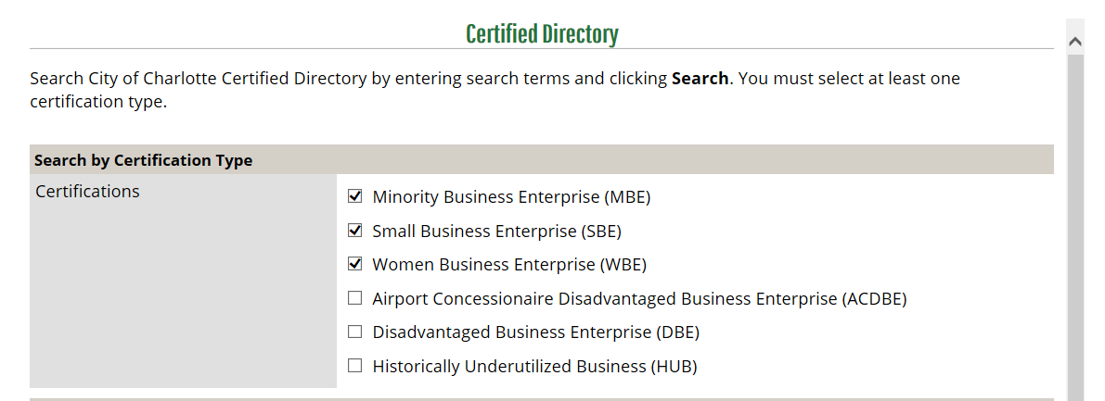

- Type in the business description in the “Business Description” field and then click “Search” (ex: Landscape is being used as an example)
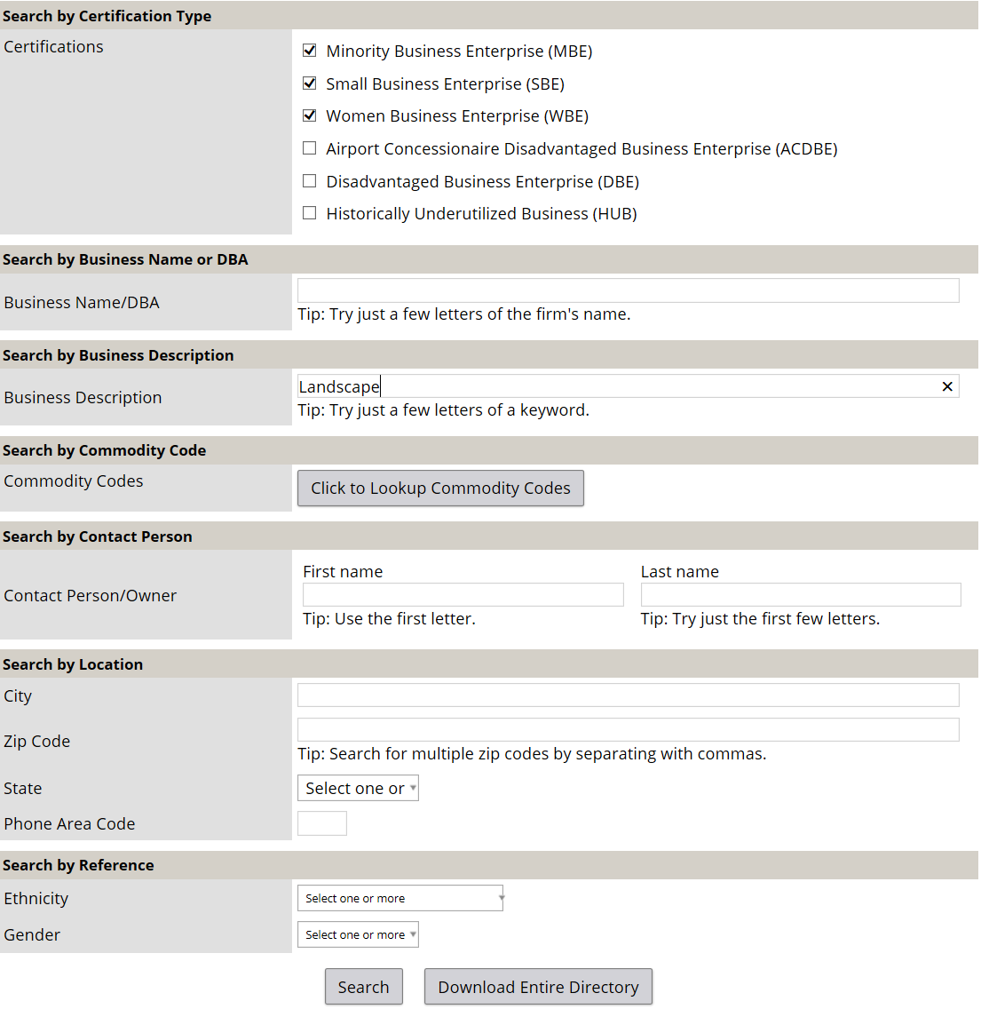

- A list will appear of all certified vendors that have the type of business description that match the description
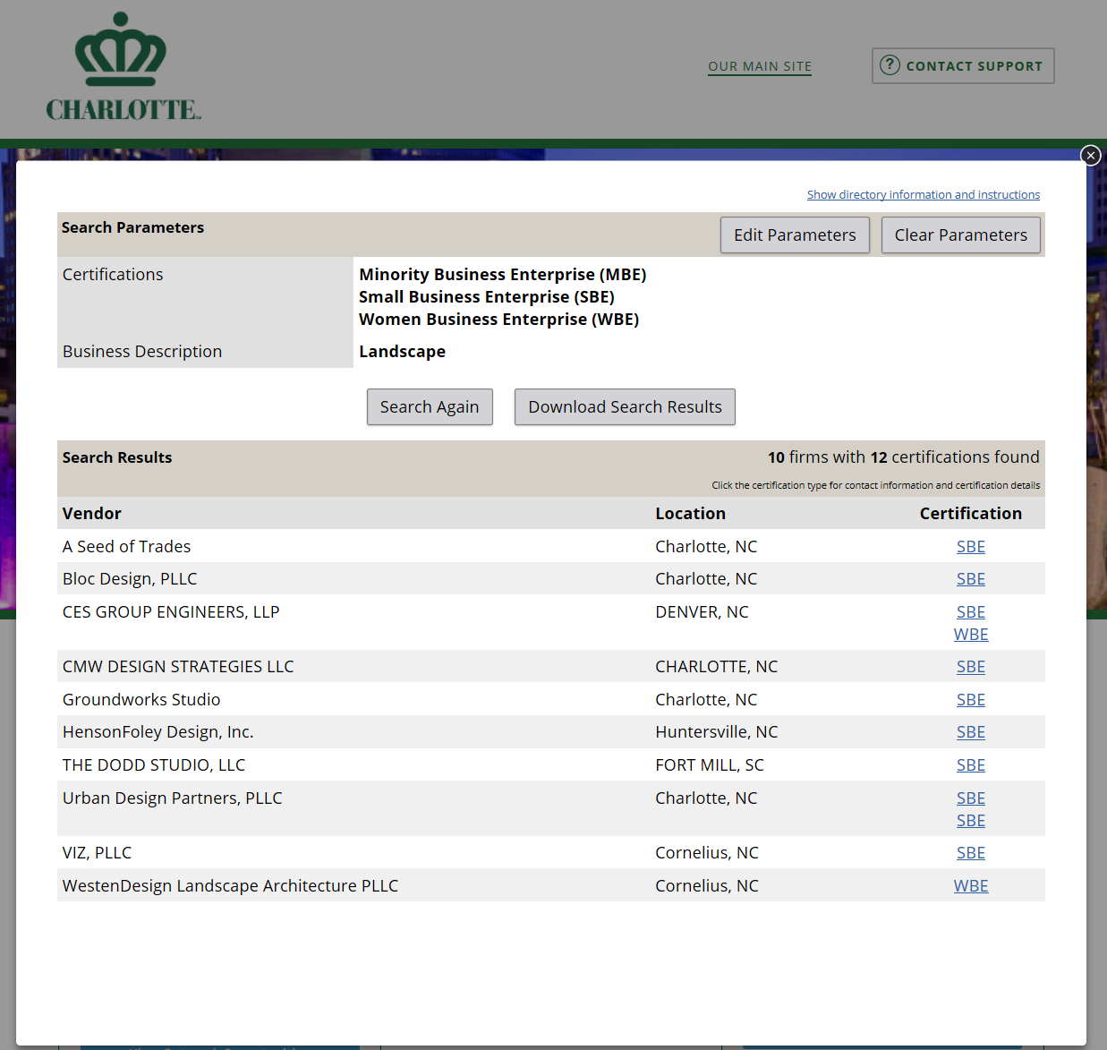

- Click on the certification of the vendor that you would like to view and the contact information will appear
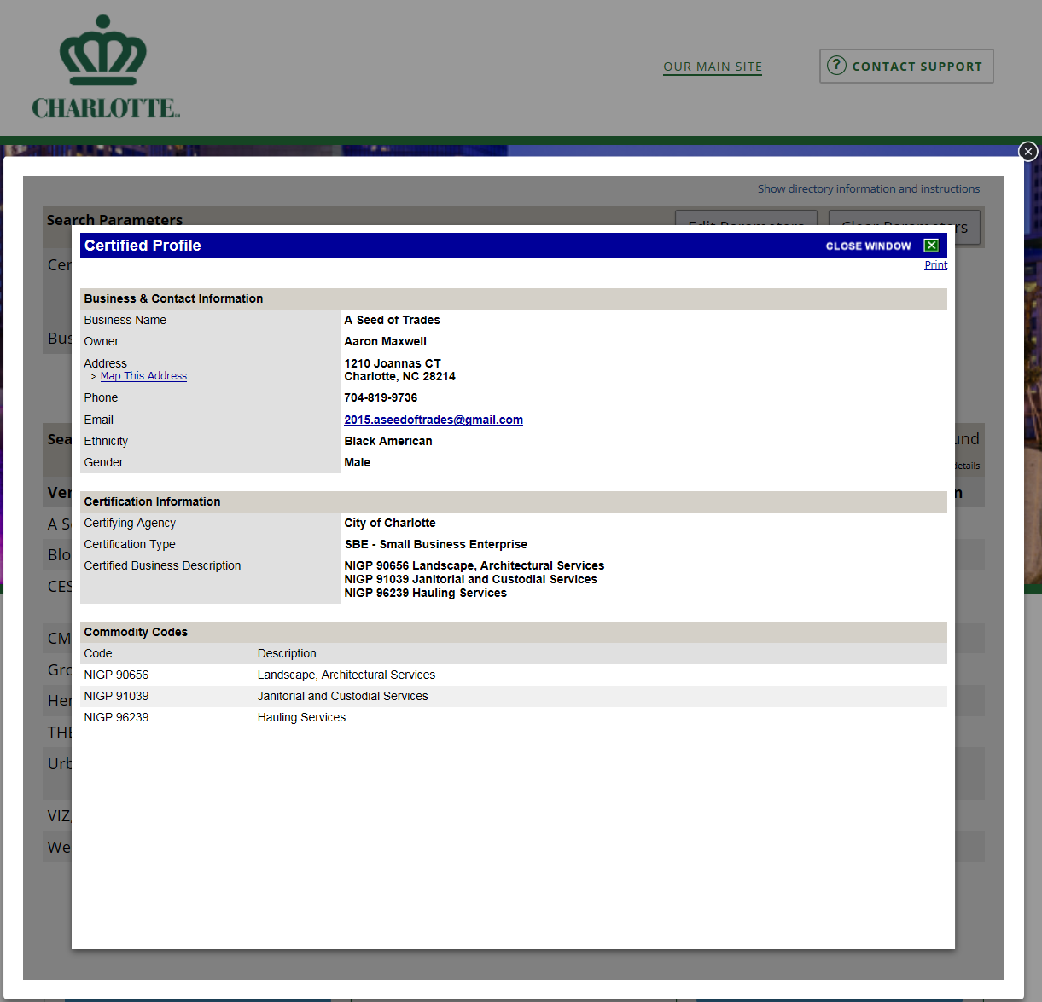
- Click Print (optional) or click “Close Window” to close the screen

- To review all entries, click on “Download Search Results”
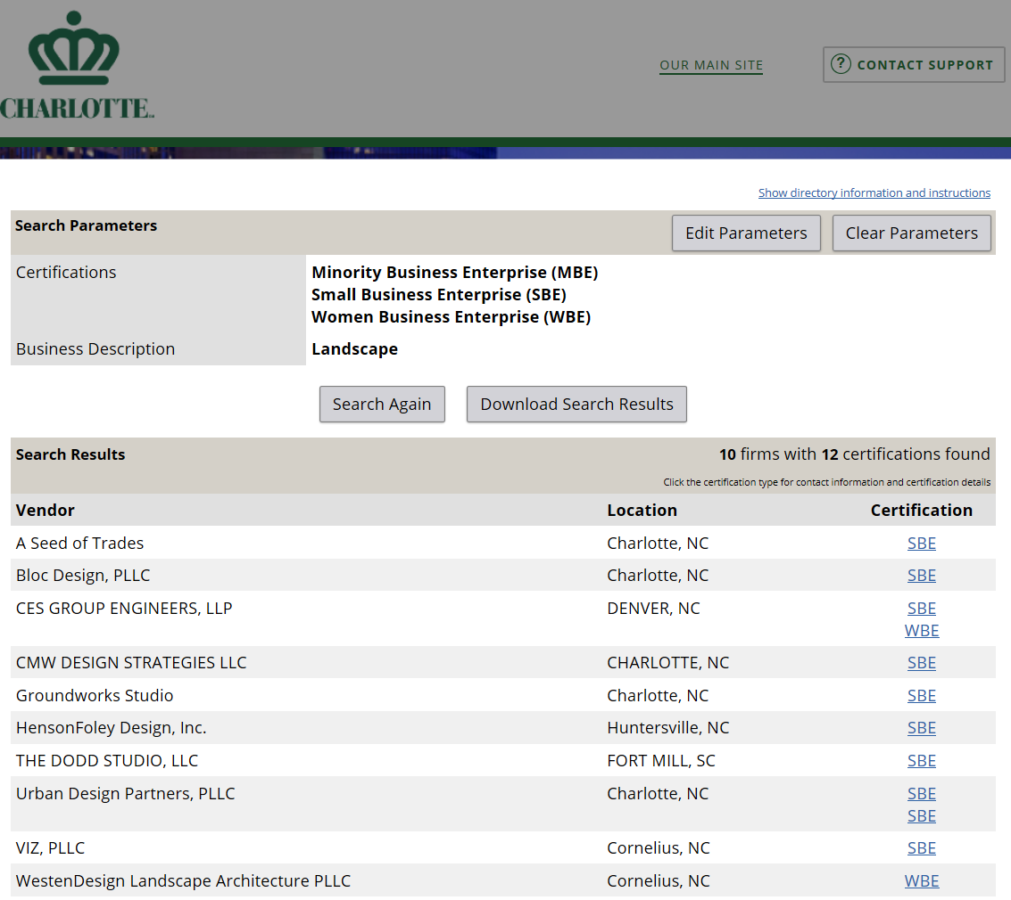
- Click the box titled “I’m Not a Robot”
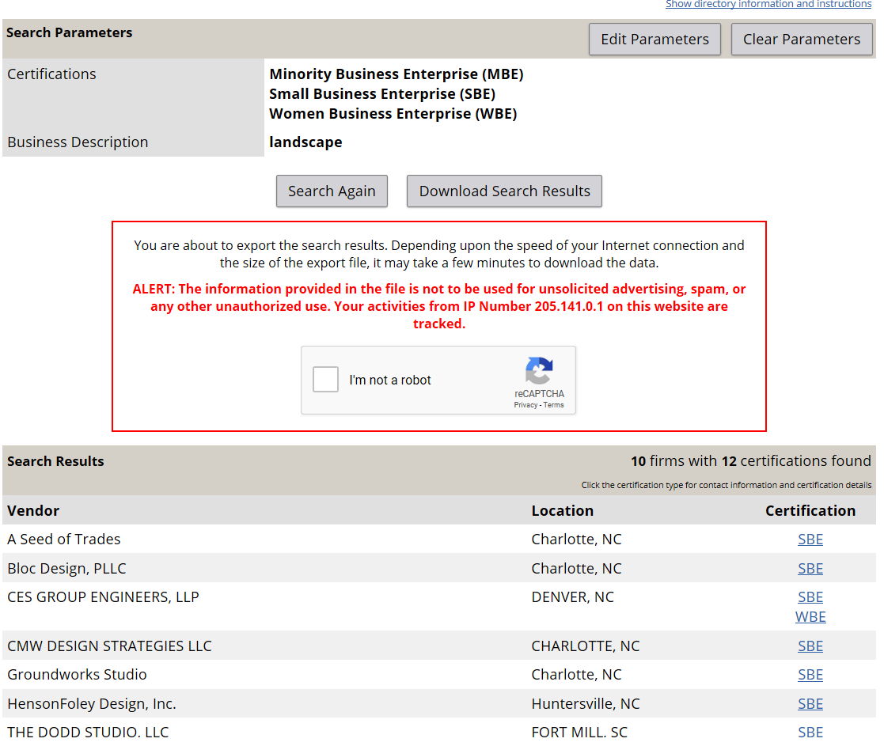

- Complete the next security steps that was provided and click the check box to download commodity codes
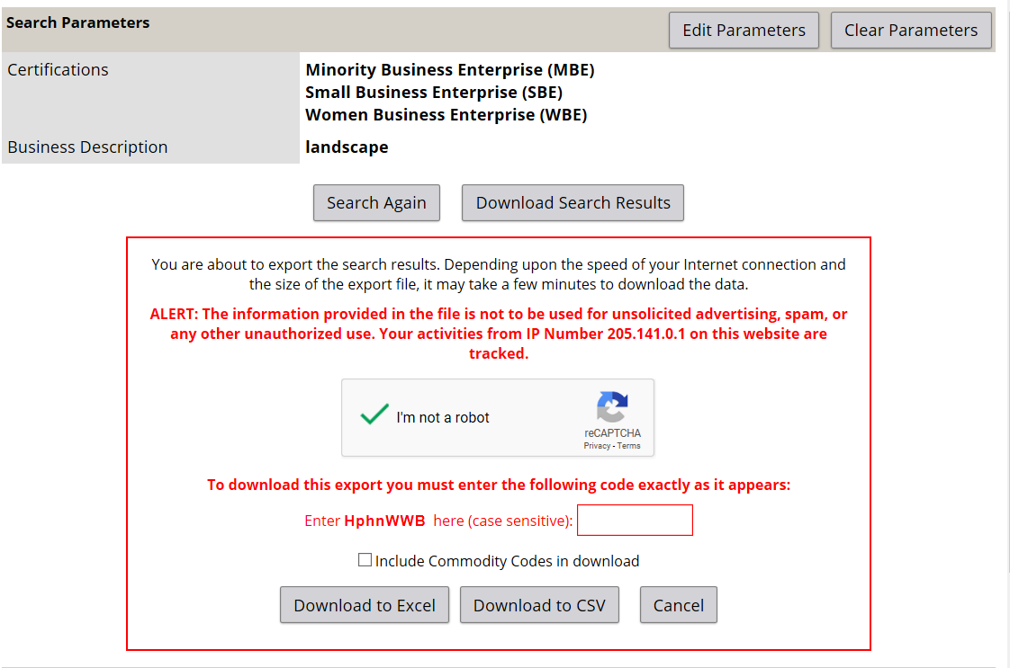
- Complete the next security step by placing the letters in the required box and then click “Download to Excel”
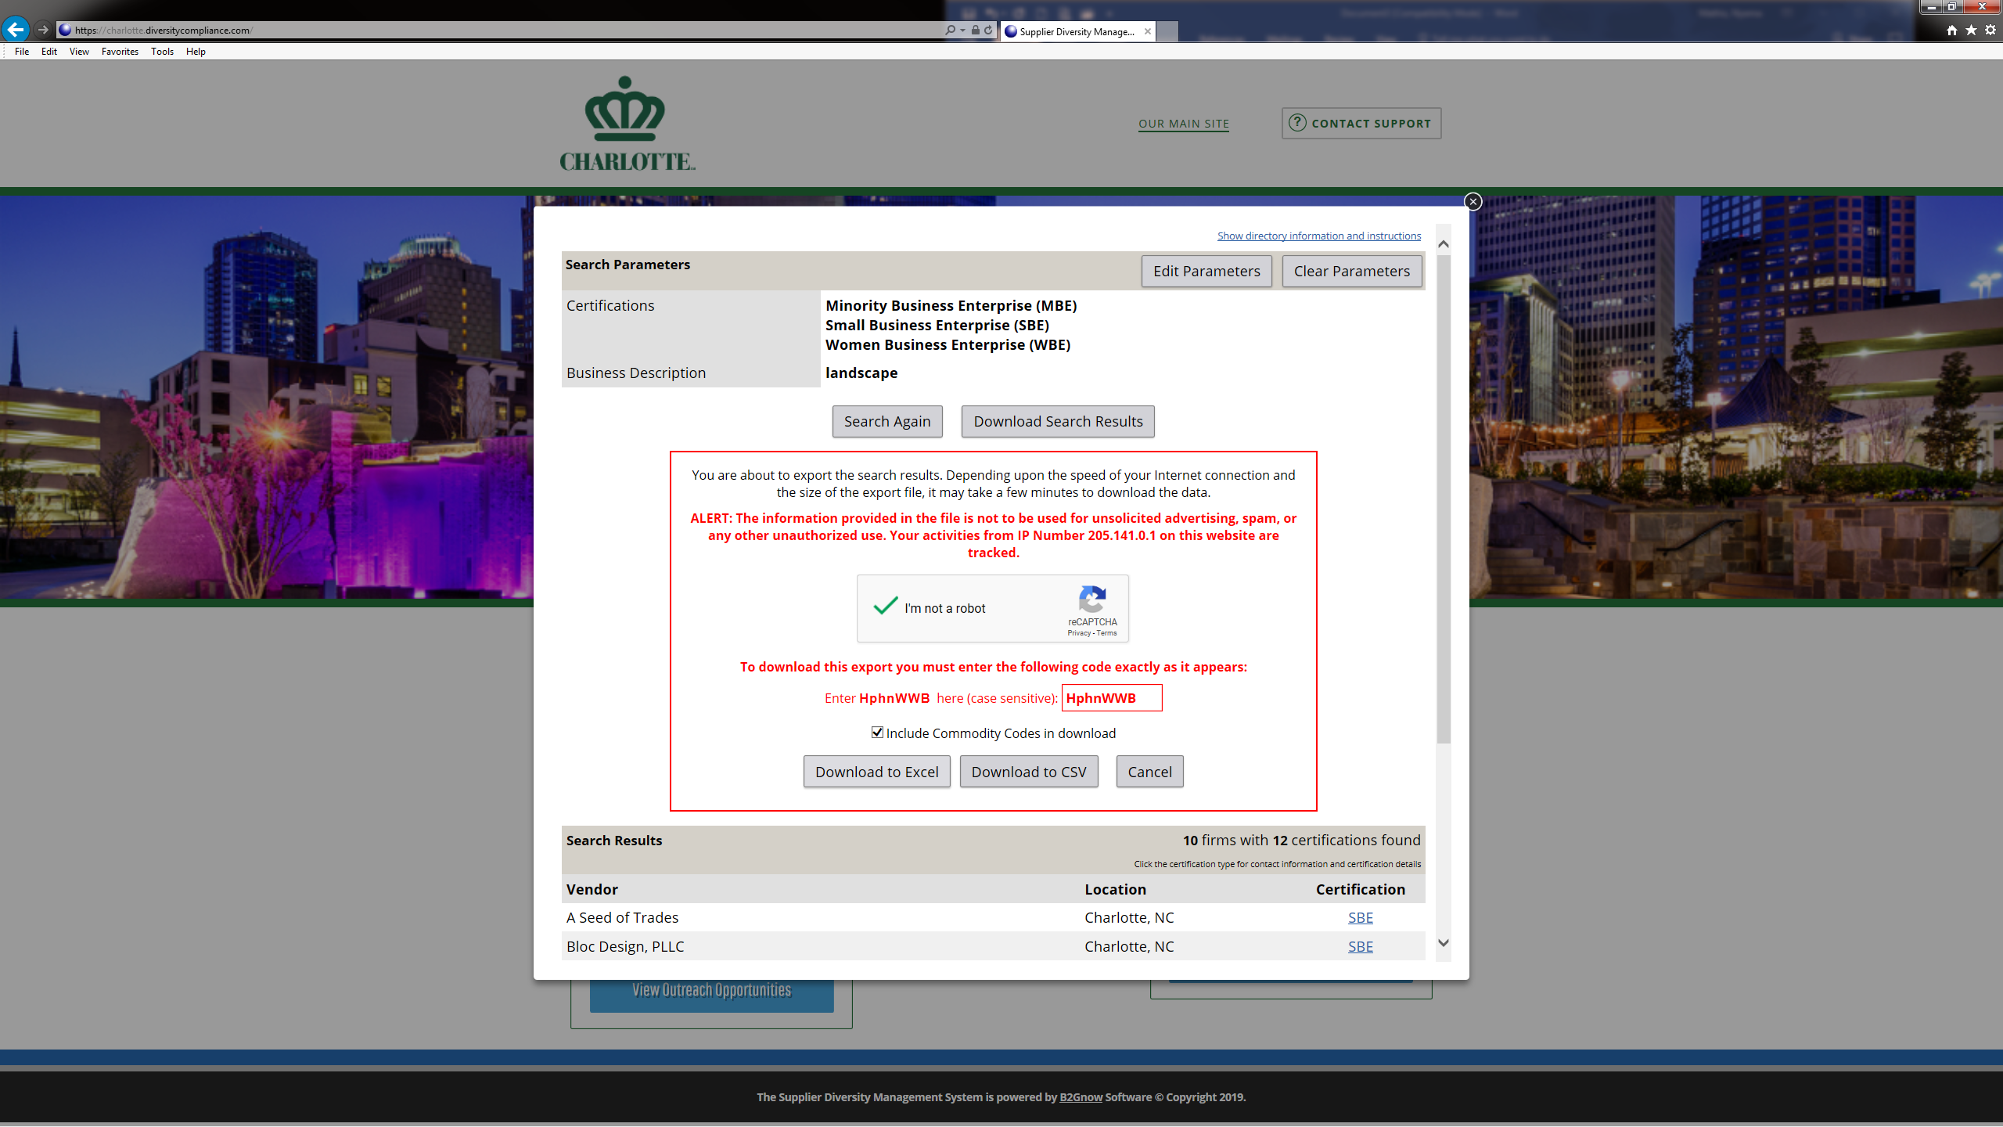

- Click on “Open”
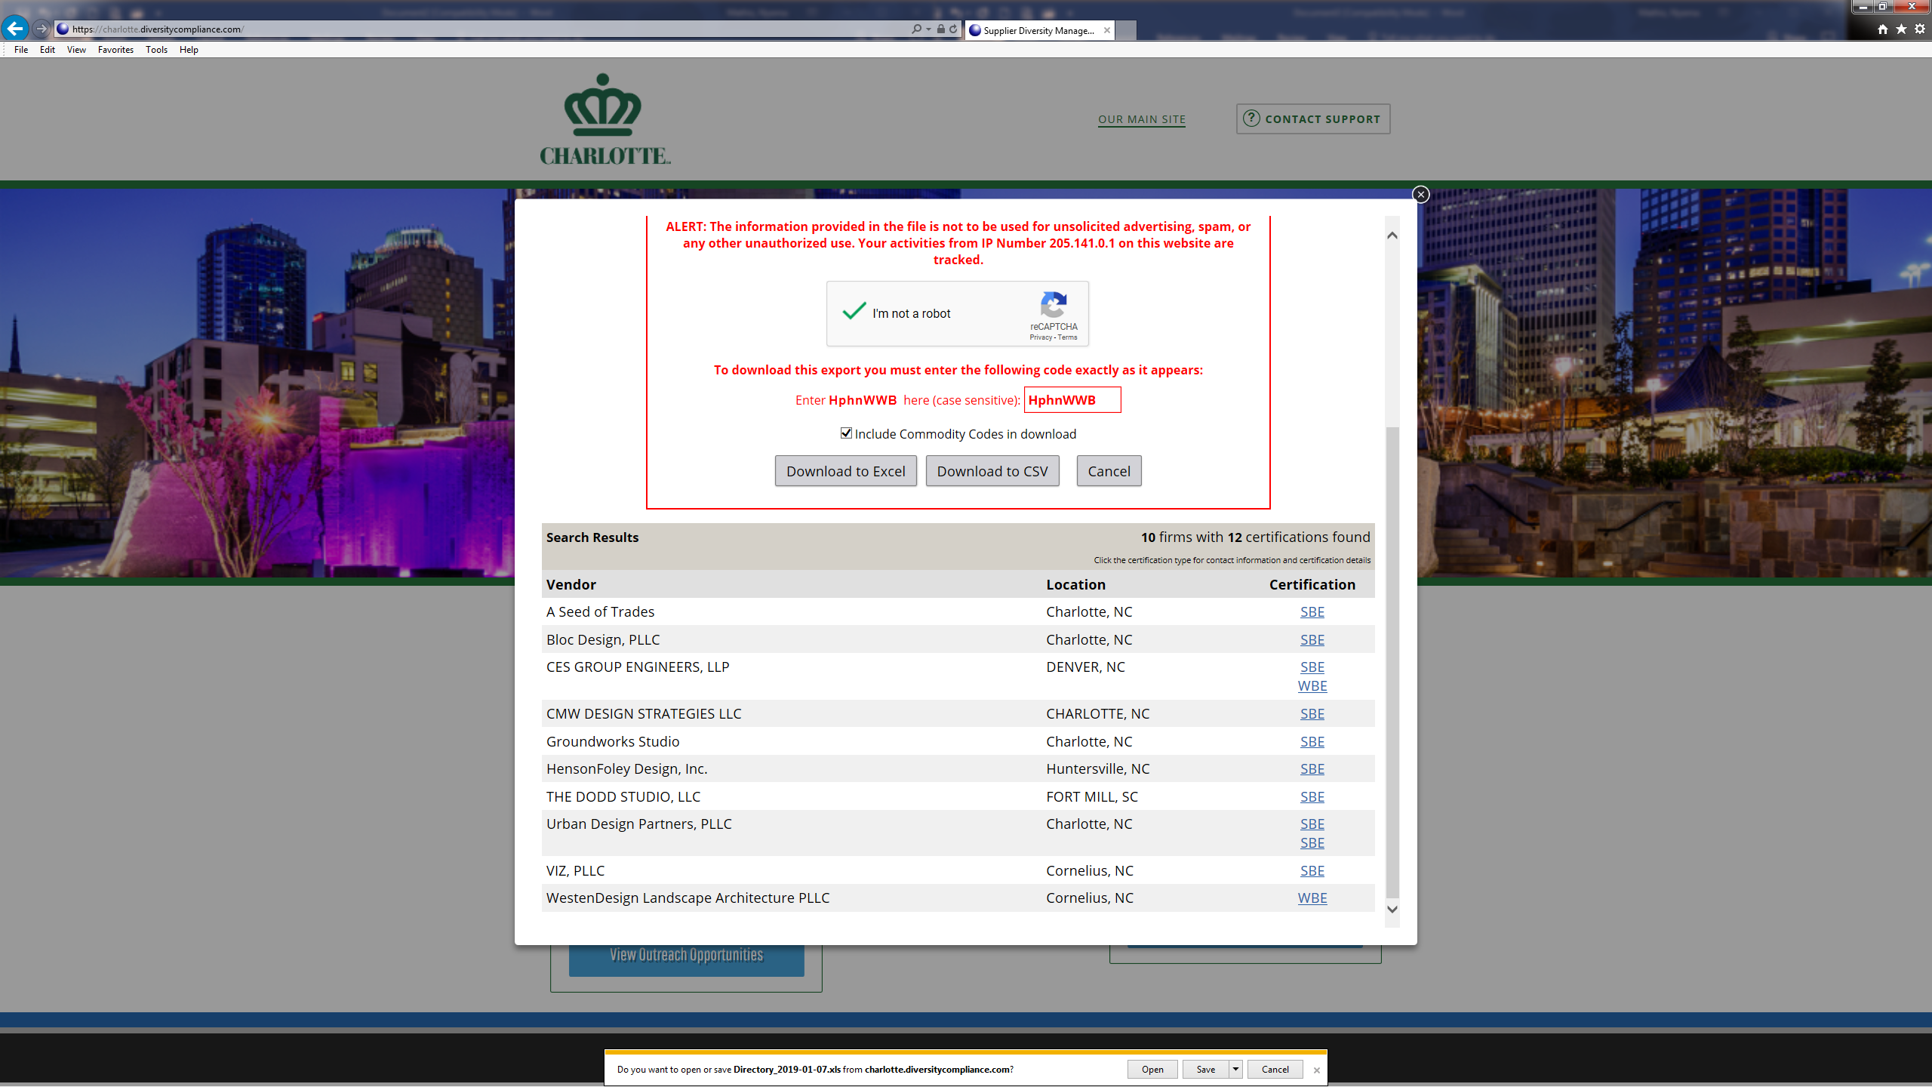

- Click “Enable Editing”
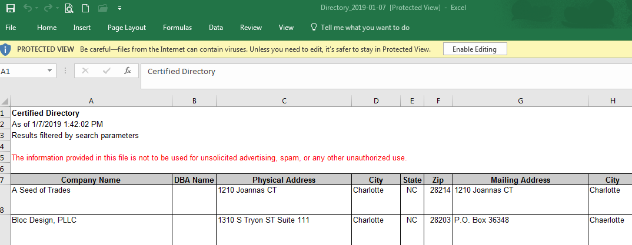

- Format excel worksheet for easy viewing
- Click “File”
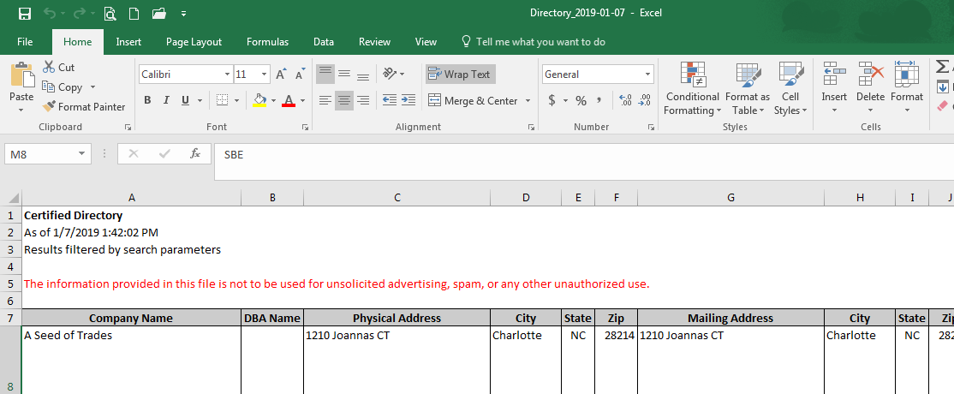

- Click on “Print”
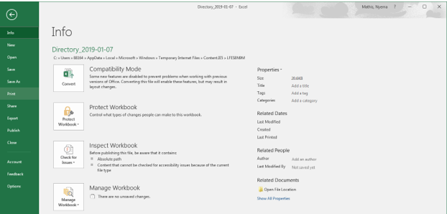
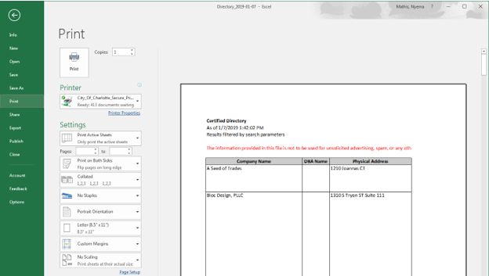
***Note, if you need to change the format of the print, select print properties before clicking “Print”

How to search for Certified Vendors by Business Description while Logged into the System

- Go to https://charlotte.diversitycomplaince.com/
- Click on “Log In”
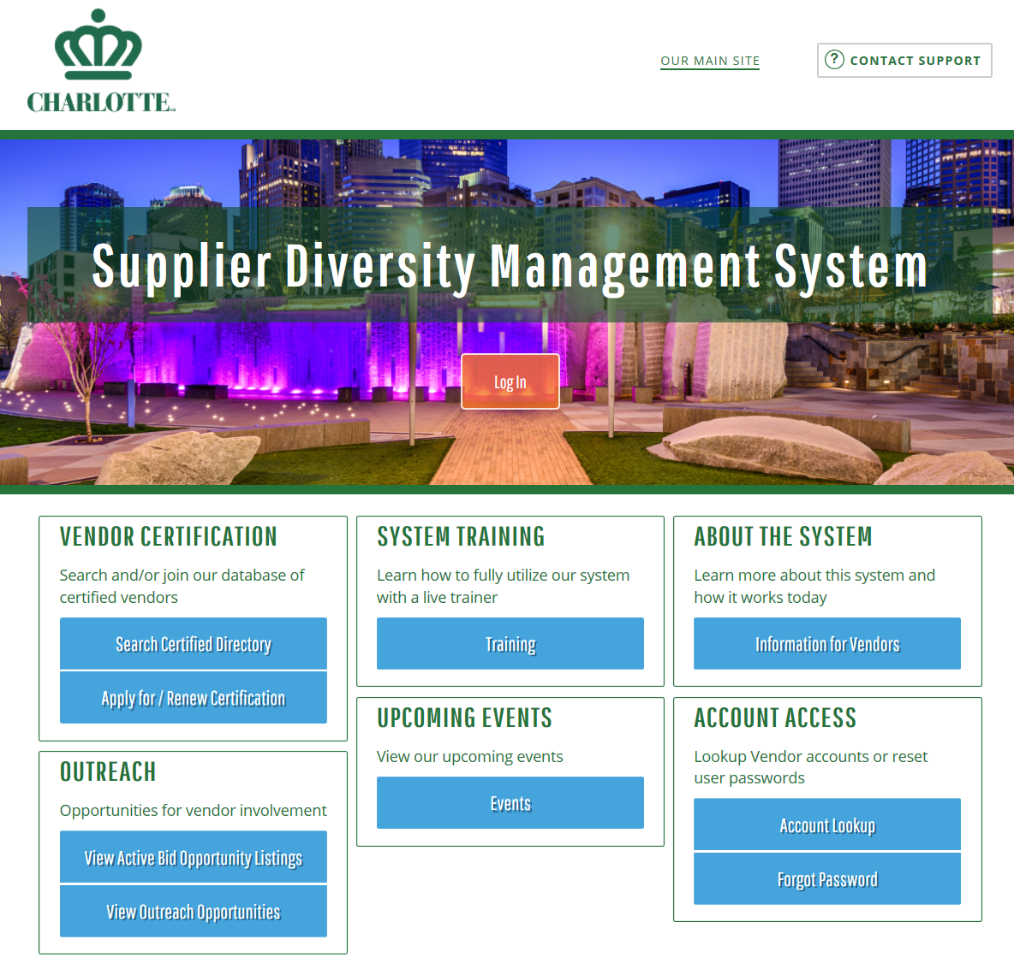
- Type in your username and password credentials in the appropriate fields
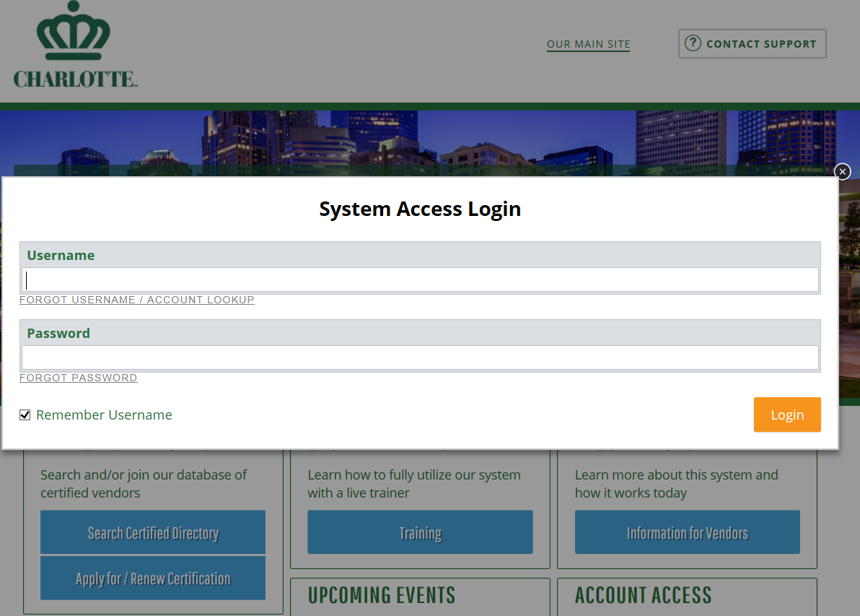
- Click on “Search” on the left side of the screen
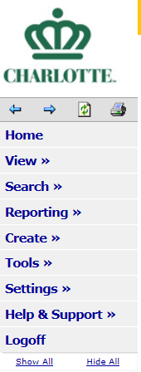
- Click on “Certified Vendors”
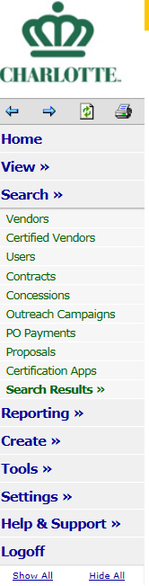

- Type in the business description in the “Business Description” Field
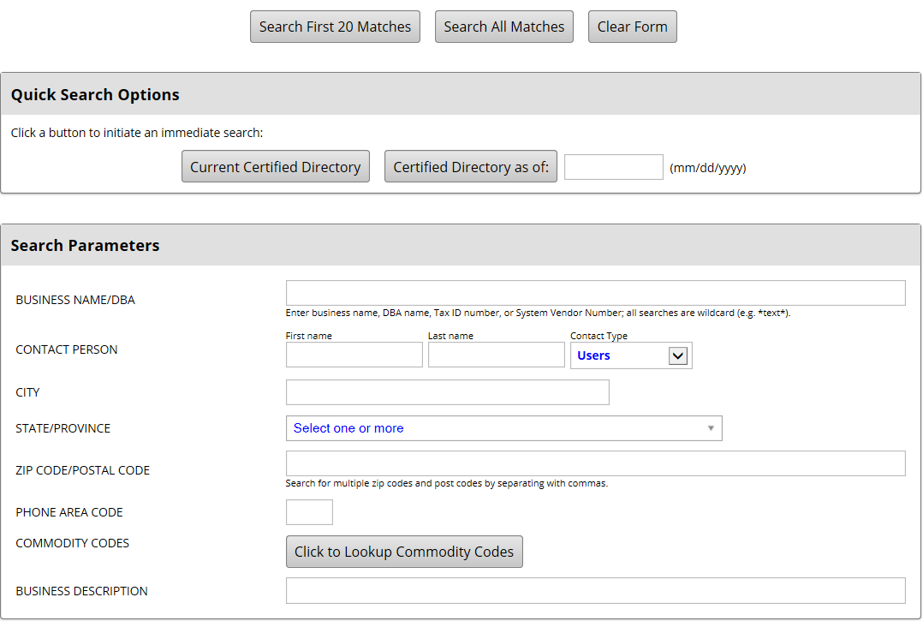
- Click the drop-down box to and click on Minority Business Enterprise (MBE), Small Business Enterprise (SBE), and Women Business Enterprise (WBE) and click “Search All Matches”
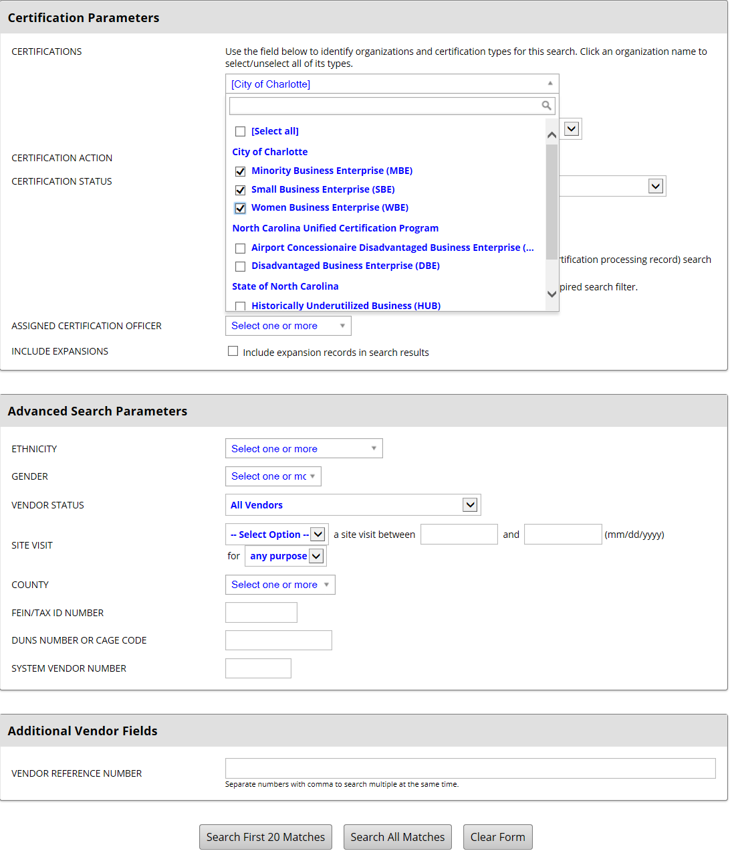
City of Charlotte Certified Directory

- Click on “Go To” to view contact information on the selected vendor
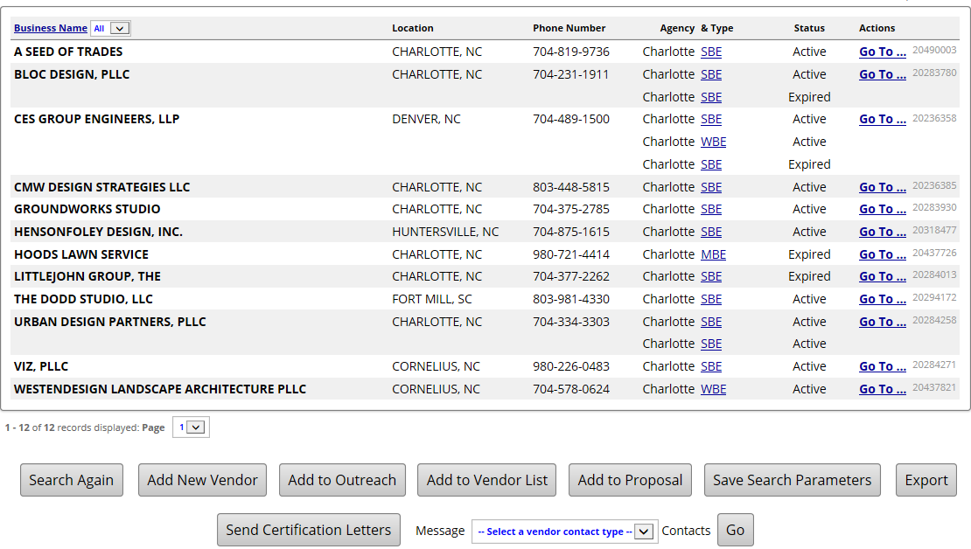

- Vendor basic contact info listed to the left of the box. Once viewed, click close to close out the screen
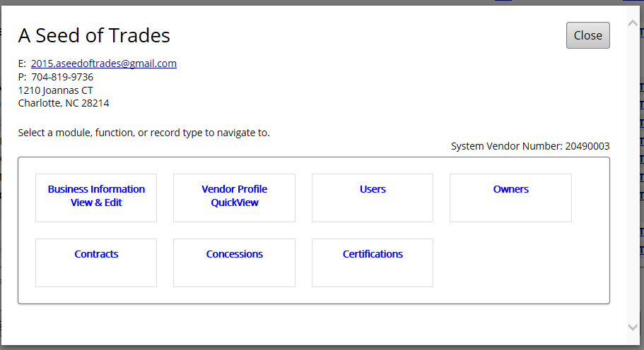

- Click on “Export” to view all firms that were displayed from the search
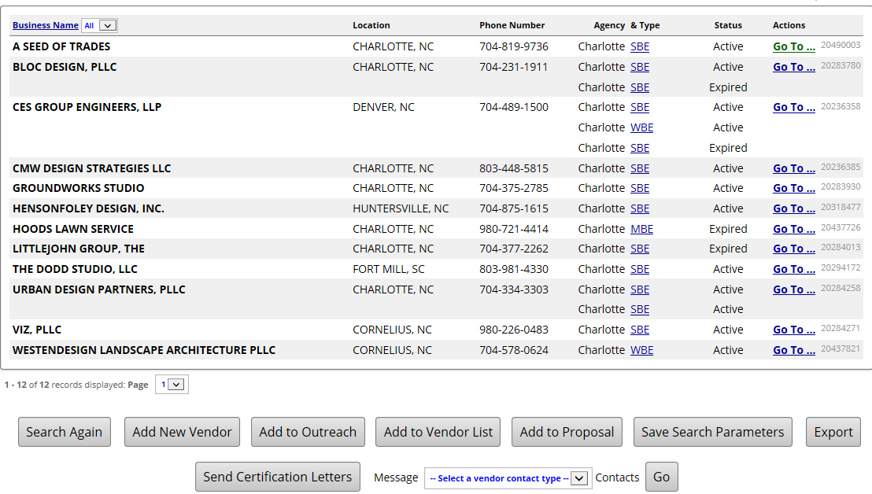

- Click on each parameter that you want to show in the exported file. After all items checked, click “Export Records”
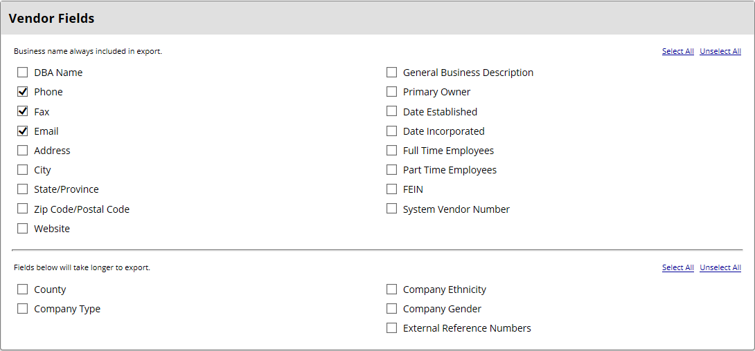
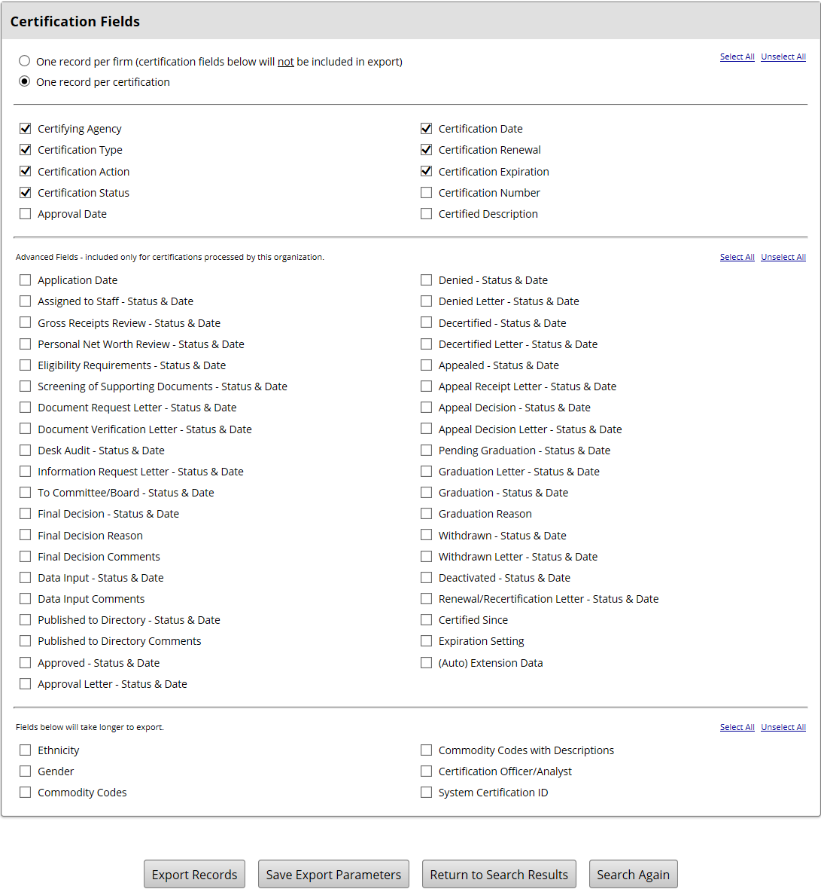

- Click “Open”
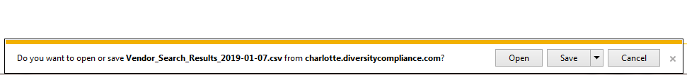

- Format Excel Worksheet to your preference
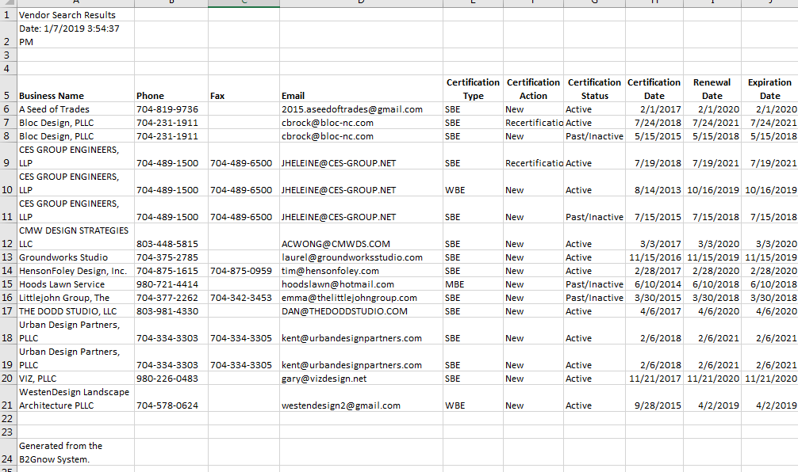

- Click “File”
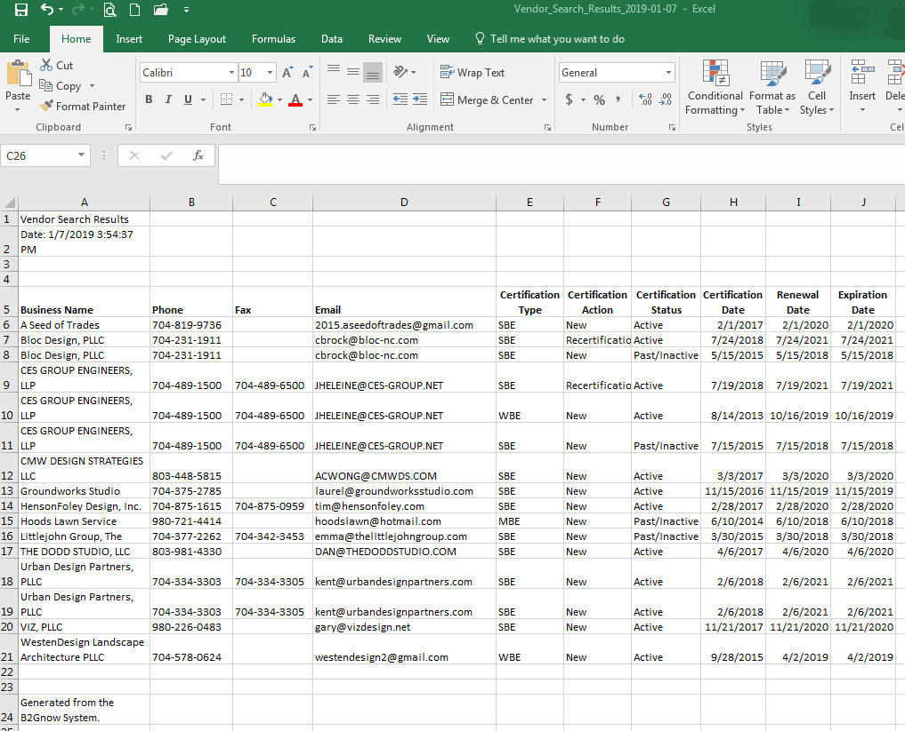
- Click on “Print”
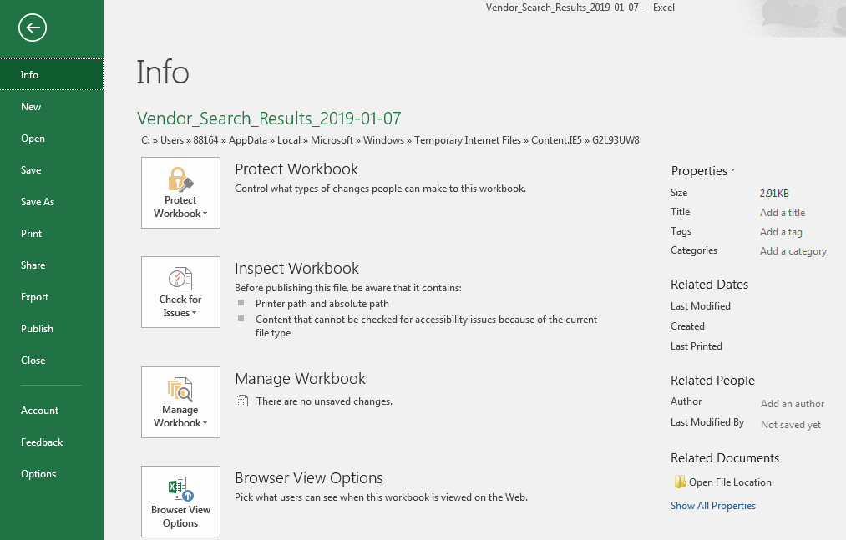

- Click on “Print” (if the print setup needs to be changed, click on print properties to make necessary adjustments)
