How to Clear Rejected Contracts

- Double click on B2GNow or type in the B2GNow link

- Click “Login

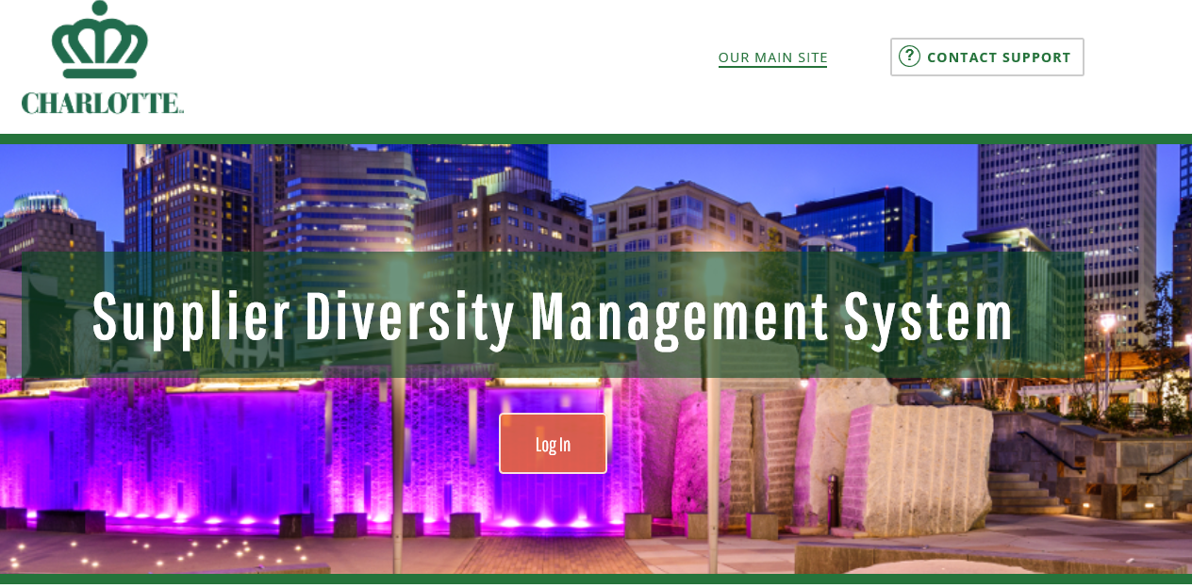

- Type in your login credentials

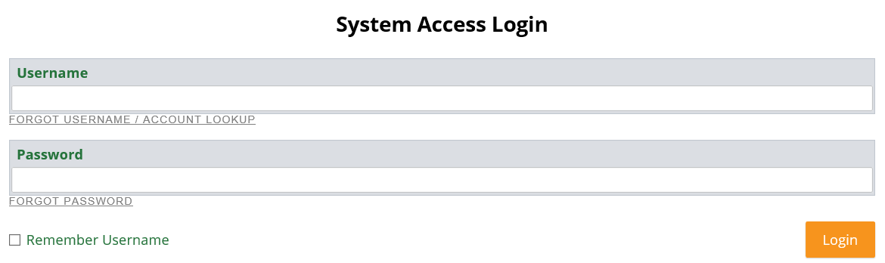

- Click “Login”

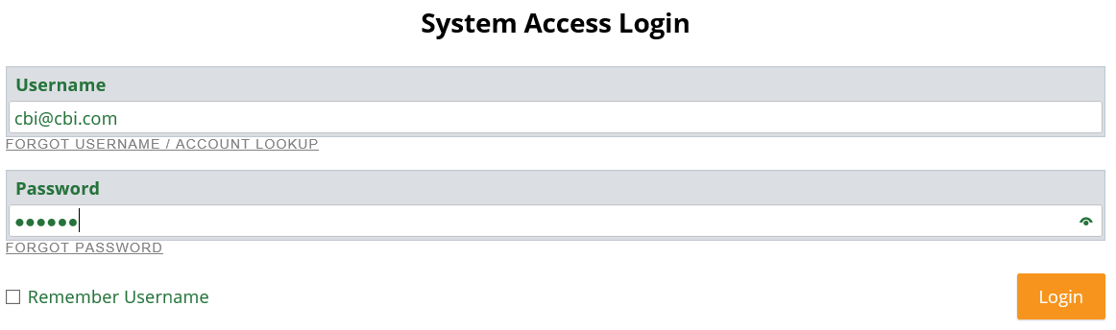

- Click “Tools”

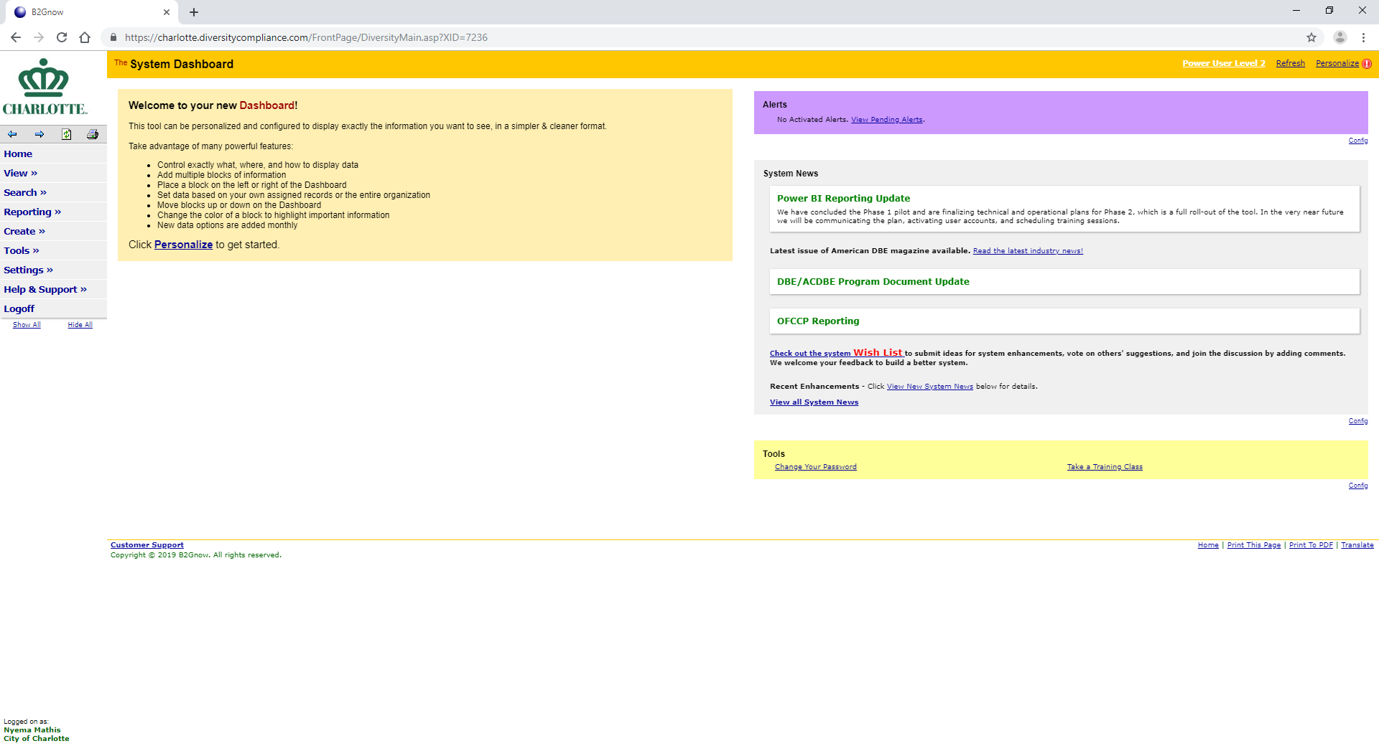

- Click “Data Management”

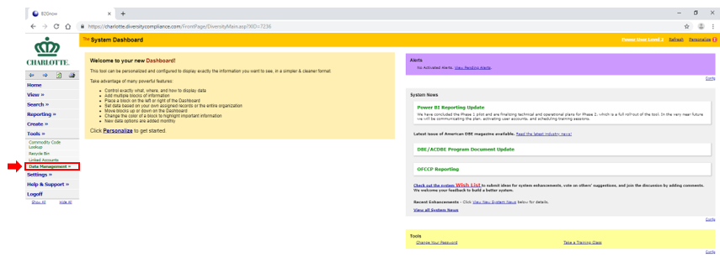

- Click “Contracts”

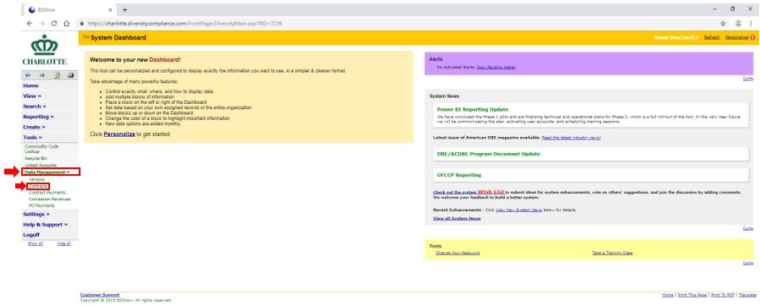

- Click “View Rejected Records”

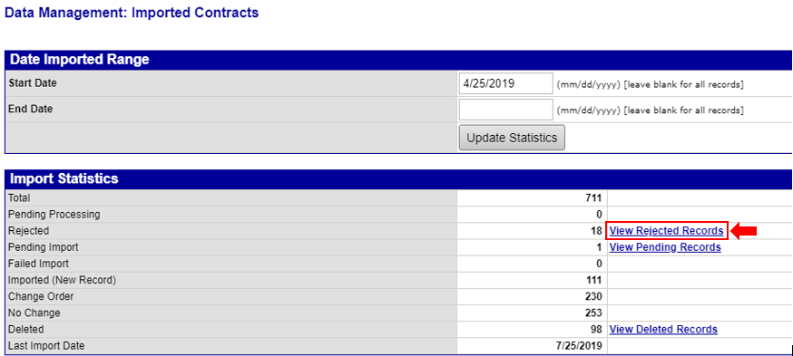

- Click “View”

- Review Record Status and Errors to determine what information is needed to the record

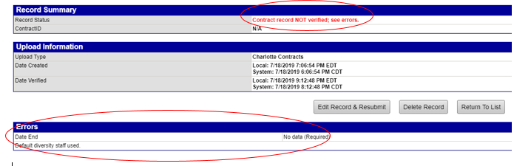

- Click “Edit Record & Resubmit”

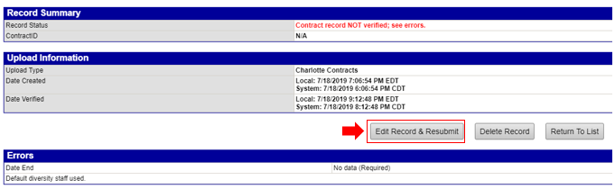

- Correct the error listed in the error section

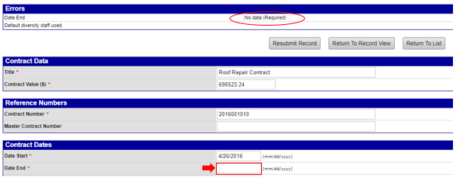

- Input required data and click “Resubmit Record”

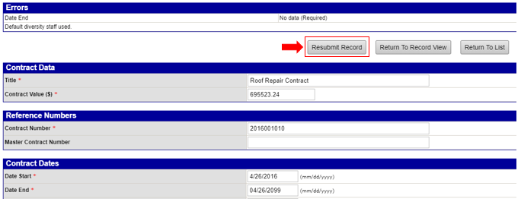

- Click “OK”

