The following is a checklist of typical monthly Compliance Officers tasks in B2Gnow for existing contracts. This may not be wholly inclusive as the responsibility of Compliance Officers differs at every organization. However, completion of this checklist will help ensure quality reporting at the individual contract as well as overall program level.

- Manage Unresponsive Vendors (Vendors that have not completed audits)
  - Find Unresponsive Vendors
    - Run ‘Unresponsive Vendors’ report
- Use the Dashboard > Incomplete Audits Incomplete Audits
  - Provides incomplete prime and sub audits for all contracts filtered by selected compliance officers.
- Research why the vendor has been unresponsive and correct for the future
  - Contact vendor and confirm system contact information, update any wrong contact information. (Page 2‐9)
  - Add new contact for a vendor. (Page 2‐8)
  - Send user login and password. From the ‘User Information’ page > “User Administration” button > “Send Password Reminder” button
  - Update the contact person on contracts, so the correct contact person is notified of the audit. From the ‘Contract Management: Subcontractor List’ page > Actions > Edit Sub / Edit Prime > change the “Vendor Compliance Contact”
  - Extend reporting deadline (Page 3-58)
- Manage Discrepancies
  - Find Discrepancies
    - Run “Reported Discrepancies” Report
    - Use the Dashboard > Contract Audits > Discrepancies
- Send Not Meeting Goal Notices
  - Find Contracts that are NOT meeting goal
    - Run ‘Active Contracts (Include Prime Payments and Participation) [Individual COO]’ report
    - **each COO will get a report of only the contracts assigned to them
    - Use report as a starting point and review contracts that are not meeting goal **Based on knowledge of the contract, contract progress, missing goal amount and organization policies NOT all contracts that are missing goal will be sent a notice
  - Sending Notices
    - Send not meeting goal notices to any new Primes. From the ‘Contract Audit: Audit Summary for Total Contract’ page (Compliance Audit Summary Tab)> “Not Meeting Goal Letter” > complete the ‘Contract Management: Print Not Meeting Goal Letter’ page and then click “Print Letter” / “Save Letter” or “Email”
- Unlock Contracts
  - Provides incomplete prime and sub audits for all contracts filtered by selected compliance officers.
- Contract Missing Information
  - Listing of contracts missing CCO, contract number, category, department, prime contractor, zero value

- Rejected Contracts
  - Contracts that could not be matched to an existing contract record or open audit -- by contract number.

HOW TO GUIDE

- Manage Unresponsive Vendors (Vendors that have not completed audits)
  - Find Unresponsive Vendors
    - Run ‘Unresponsive Vendors’ report
    - Use the Dashboard > Incomplete Audits

Run “Unresponsive Vendors’ Report”
Step One
From the Navigation Menu select reporting > full list
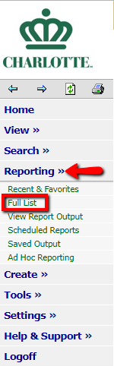

Step Two
Select reporting category > Contracts
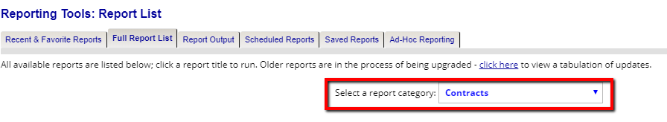
Step Three
Select the report titled “Unresponsive Vendors”. By clicking on “Add to favorites” will allow for this report to be added to your favorite report list on the dashboard.
Step Four
Enter in the date range of your choice to view within a specified time period > View Report. The results of the report will populate where you can export to Excel, PDF, Word etc.

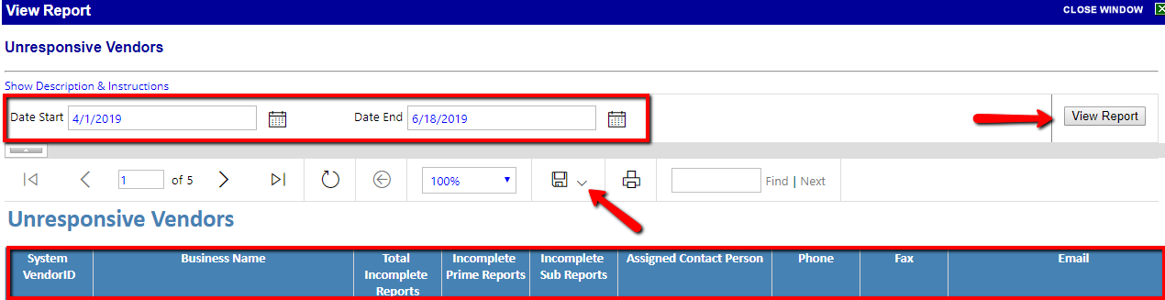

- Use the Dashboard > Incomplete Audits
Step One
From the dashboard under the Contract Audits you can select all of the incomplete audits, or narrow the results to review those who are greater than or less than 90 days simply by clicking on the number.

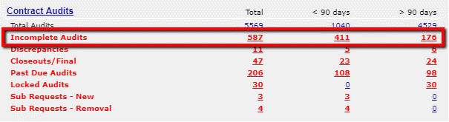

Step Two
Once you have selected “Incomplete Audits” from the Dashboard the following page will appear. There is an option to view the incomplete audits assigned to you or throughout the system. You can also filter the results based on Reporting Status / Audit period / Prime Name etc.
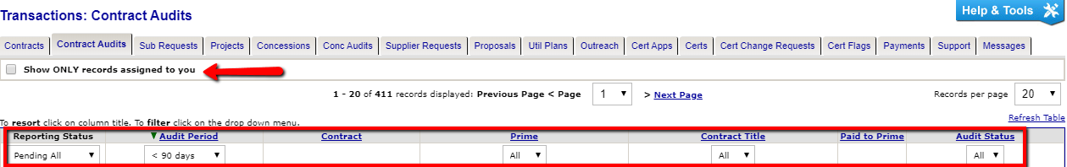

- Research why the vendor has been unresponsive and correct for the future
  - Contact vendor and confirm system contact information, update any wrong contact information. (Page 2‐9)
  - Add new contact for a vendor. (Page 2‐8)
  - Send user login and password. From the ‘User Information’ page > “User Administration” button > “Send Password Reminder” button
  - Update the contact person on contracts, so the correct contact person is notified of the audit. From the ‘Contract Management: Subcontractor List’ page > Actions > Edit Sub / Edit Prime > change the “Vendor Compliance Contact”
  - Extend reporting deadline (Page 3-58)
- Manage Discrepancies
  - Find Discrepancies
    - Run “Reported Discrepancies” Report
    - Use the Dashboard > Contract Audits > Discrepancies

Run “Reported Discrepancies” Report

Step One
From the Navigation Menu select reporting > full list

Step Two
Select reporting category > Contracts

Step Three
Select the report titled “Reported Discrepancies”. By clicking on “Add to favorites” will allow for this report to be added to your favorite report list on the dashboard.

Step Four
Enter in the date range of the Audit Period you seek to review. The status will default to Open, however you can also review resolved discrepancies by making that selection> View Report. The results of the report will populate where you can export to Excel, PDF, Word etc.
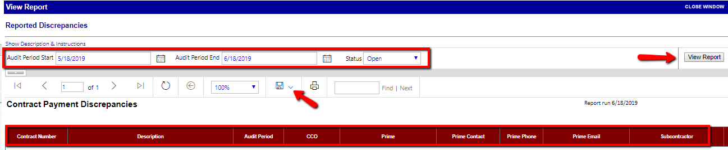

Use the Dashboard > Discrepancies
Step One
From the dashboard under the Contract Audits you can select all Discrepancies, or narrow the results to review those who are greater than or less than 90 days simply by clicking on the number.

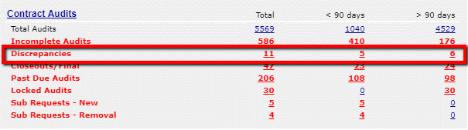

Step Two
Once you have selected “Discrepancies” from the Dashboard the following page will appear. There is an option to view the discrepancies assigned to you or throughout the system. You can also filter the results based on Reporting Status / Audit period / Prime Name etc.
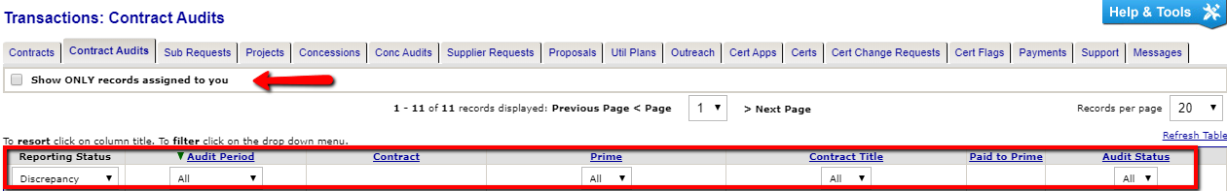

- Send Not Meeting Goal Notices
  - Find Contracts that are NOT meeting goal
    - Run ‘Active Contracts (Include Prime Payments and Participation) [Individual COO]’ report
    - **each COO will get a report of only the contracts assigned to them
    - Use report as a starting point and review contracts that are not meeting goal **Based on knowledge of the contract, contract progress, missing goal amount and organization policies NOT all contracts that are missing goal will be sent a notice
  - Sending Notices
    - Send not meeting goal notices to any new Primes. From the ‘Contract Audit: Audit Summary for Total Contract’ page (Compliance Audit Summary Tab)> “Not Meeting Goal Letter” > complete the ‘Contract Management: Print Not Meeting Goal Letter’ page and then click “Print Letter” / “Save Letter” or “Email”

Run “Active Contracts with Prime Payments” Report
Step One
From the Navigation Menu select reporting > full list

Step Two
Select reporting category > Contracts

Step Three
Select the report titled “Active Contracts with Prime Payments”. By clicking on “Add to favorites” will allow for this report to be added to your favorite report list on the dashboard.

Step Four
Once you click on the report title, the report will automatically generate. The results of the report will populate where you can export to Excel, PDF, Word etc. Here you will be able to identify how the contracts are trending as it relates to the contract goal / payments.

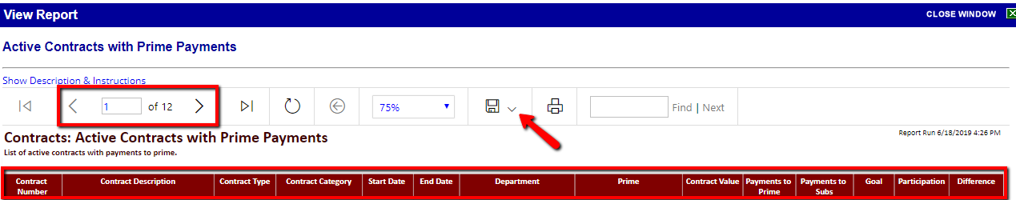

Sending Notices for Primes Not Meeting Goal

Step One
If you have determined that a Not Meeting Goal letter is warranted, locate the specific contract and click on the Compliance Audit Summary Tab.
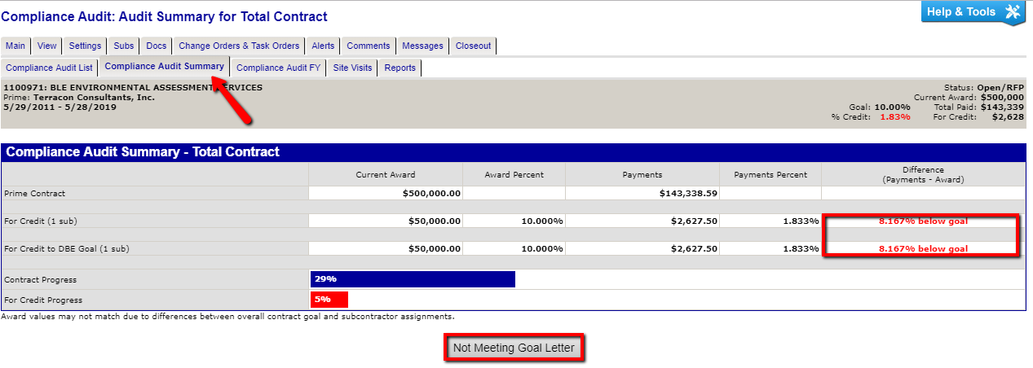
Step Two
Here you will see the Compliance Audit Summary which indicates this Prime is falling below the contract goal. From this page you can click on “Not Meeting Goal Letter”

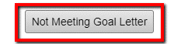

Step Three
The next screen will appear where you will review the contact information in which the notice is being sent.
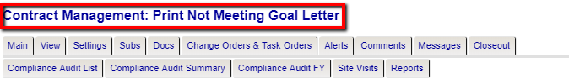

Step Four
By clicking “Send Email” – an email notice will be sent to the Prime indicating they are below goal.
*** A Not Meeting Goal Template can be added upon request by City of Charlotte***

***Sample of Email Notification sent when using this feature***

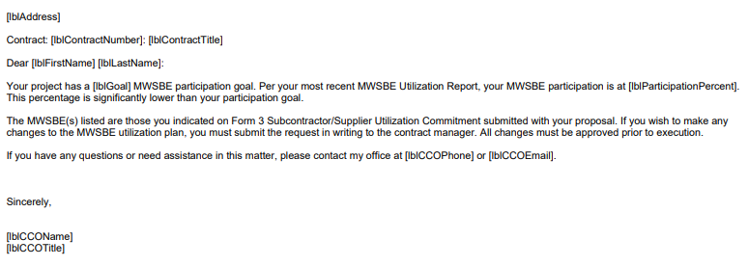
- Unlock Contracts
To understand the contract “lock-in” process be sure to follow these steps:
- From the dashboard click on “Contracts” or from the left-hand navigation panel click on “View” then “contracts”.
- From the Transaction: Contracts page sort the contracts by “New Contract” under Actions. Be mindful that if the check box is checked you will only see contracts that are assigned to you. Uncheck it to see all.

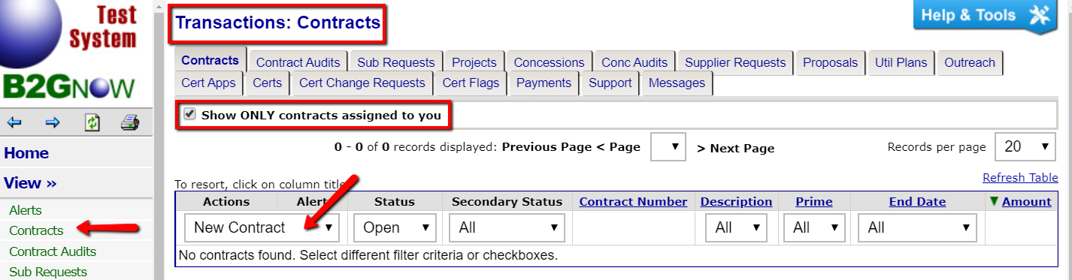
- To begin the lock-in process click “View” to the left of the contract you wish to lock-in.

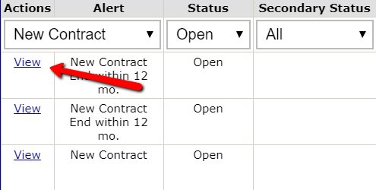

- From the Main page for the contract click “Review”. This opens the contract compose page.

- Review the information that came in via the interface, add any additional information that may be necessary, scroll to the bottom of the page, click “Review” and on the following page, scroll to the bottom and click “Save”.

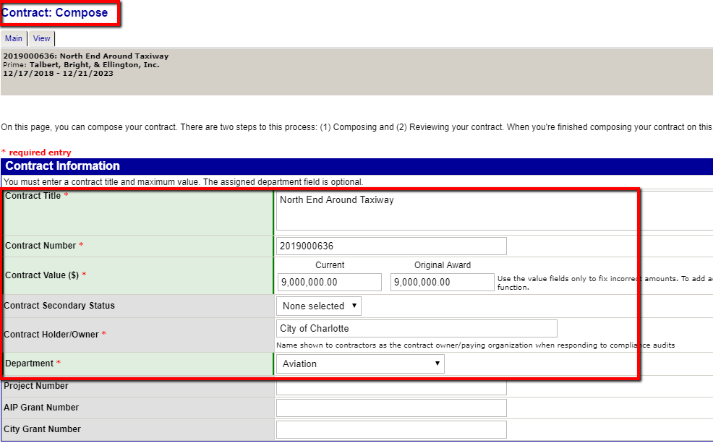

- Review and update the accurate Organizational Contacts from the drop-down menu. If additional contacts are applicable, they can be recorded here.

- Review and update the accurate Organizational Contacts from the drop-down menu. If additional contacts are applicable, they can be recorded here.

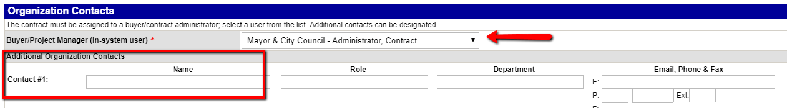

- To add Contract Goals to the contract, select “Click here to select goal types”

8.
The following screen will appear where you can select and add the applicable goal type(s) from the drop down, click on “Assign Goal” – you can add additional goal types and click return once complete.

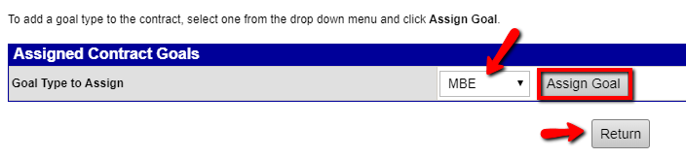

- Now that the Goal Type has been identified, enter in the applicable percentages.

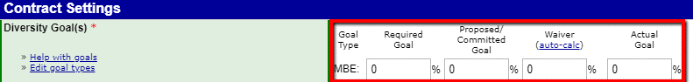

- If additional goals and/or funding information is known this can be reported here.

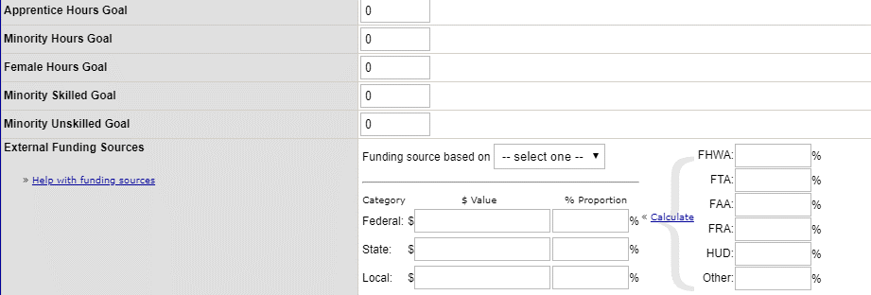

- Review and update the Contract Type and Category. Many of the settings are already defaulted to the selections City of Charlotte has identified.

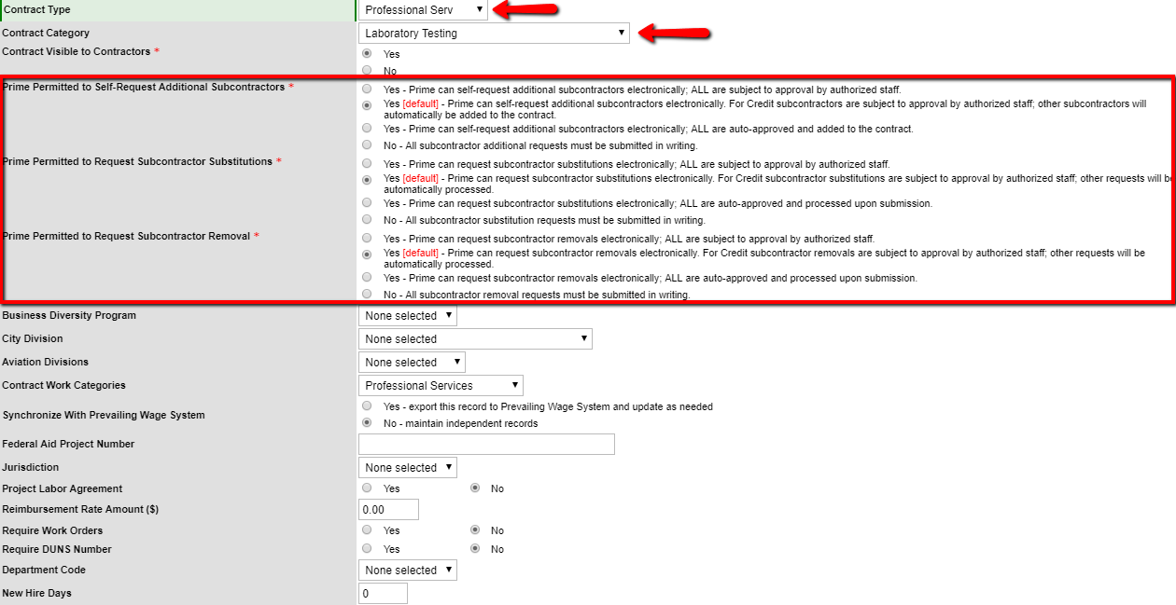

- Review the default audit settings
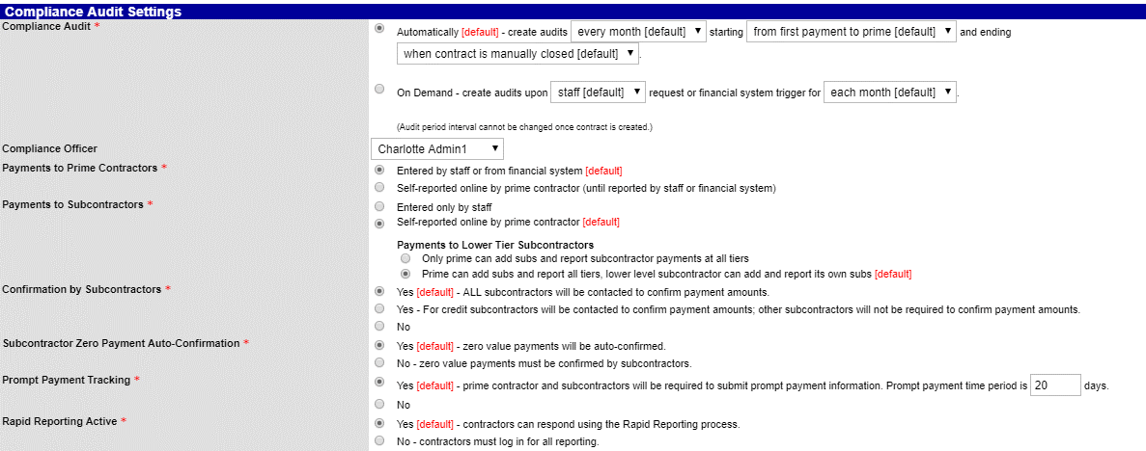

- The option to add commodity codes as well as Contract Documentation can be done as well. Once complete, click Review.

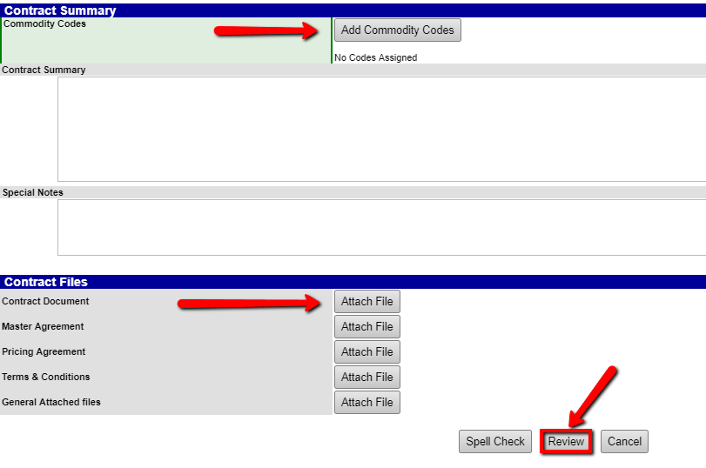
- A summary of the contract will appear. You will have an opportunity to Edit if needed or click Save to complete the Contract Lock-In
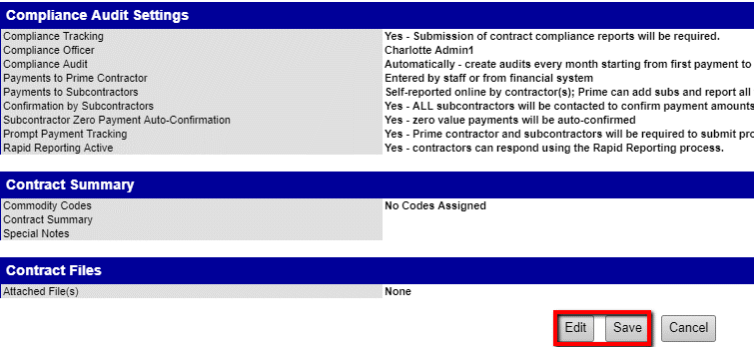

The contract is now saved and ready to have payments matched as well as subcontractors added to the contract.

7. Contracts Missing information
Step One
From the navigation Menu select reporting > Full list
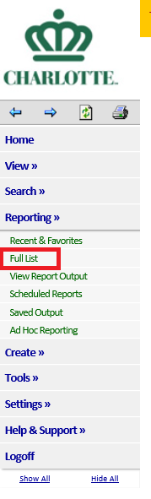
Step Two
Select reporting category > Contracts Maintenance
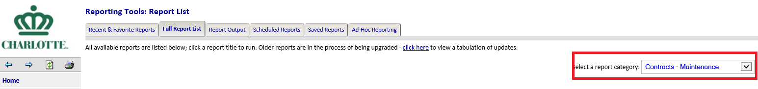

Step Three
Select > Missing Information on contracts

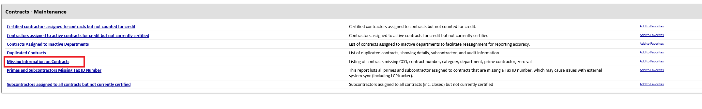
8. Rejected contracts
From the contract missing information report Find Rejected Contracts run Missing Contract Report

