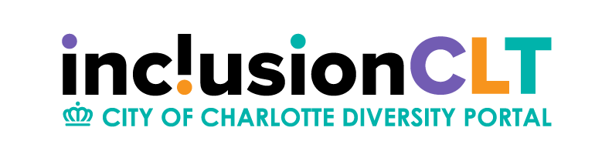

Contract Compliance Audit Management

The following is a checklist and “How-To Guide” for typical monthly Compliance Officers tasks in InclusionCLT for existing contracts. This may not be wholly inclusive, as the responsibility of Compliance Officers differs at every organization. However, completion of this checklist will help ensure quality reporting at the individual contract and overall program levels.

- Manage Incomplete Audits
  - Run “Unresponsive Vendors” report to find vendors that have not completed audits
  - Check the Dashboard for “Incomplete Audits” (provides incomplete prime and sub audits for all user/system contracts), determine why vendors have been unresponsive, and take appropriate action to resolve incomplete audits
- Manage Discrepancies
  - Run “Reported Discrepancies” report to view a list of all open and/or resolved payment discrepancies
  - Check the Dashboard for “Discrepancies” and complete appropriate actions to resolve open discrepancies
- Find Contracts that are NOT meeting goals and send a “Not Meeting Goal Letter,” when appropriate
  - Run “Active Contracts with Prime Payments” Report
  - Send “Not Meeting Goal Letter” to Primes
- “Lock-in” Contracts
- Manage Contracts with Missing Information
- Manage Rejected Contracts (contracts that could not be verified by the system)

TASK 1: Manage Incomplete Audits
TASK 1.a. Run “Unresponsive Vendors” report to find vendors that have not completed audits

Step 1: From the Navigation Menu, select “Reporting,” then “Full List.”
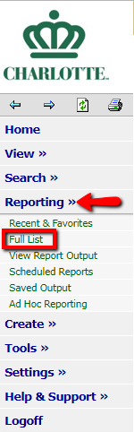

Step 2: In the “Select a report category” dropdown menu, choose “Contracts.”
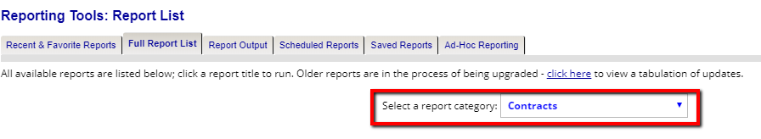

Step 3: Select the report titled “Unresponsive Vendors.” To add this report to your favorite report list on the dashboard, click “Add to Favorites.”

Step 4: Enter the date range of the reporting period you wish to view, then click “View Report.” Click on the “Export” icon to export the report to Excel, PDF, Word, etc.

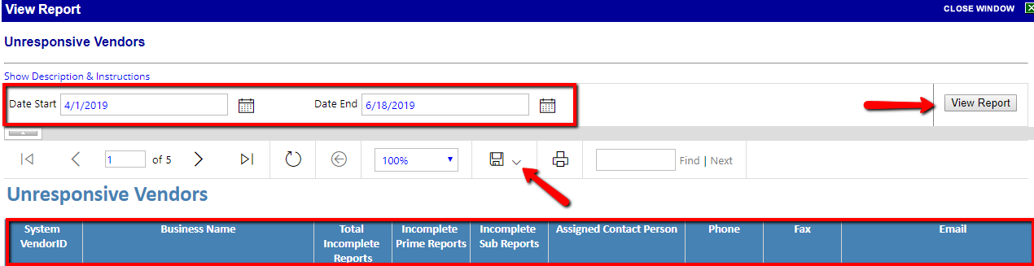

TASK 1.b. Check the Dashboard for “Incomplete Audits” (provides incomplete prime and sub audits for all user/system contracts), determine why vendors have been unresponsive, and take appropriate action to resolve incomplete audits

Step 1: In the Contract Audits section of the Dashboard, you can select all of the incomplete audits or narrow the results to review those that are greater than or less than 90 days. Click on the underlined number of the audits you would like to review.

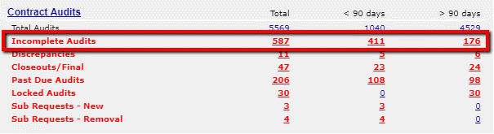

Step 2: By selecting or deselecting the checkbox next to “Show ONLY records assigned to you,” you can view incomplete audits assigned only to you or ALL incomplete audits in the system. You can also filter the results based on Reporting Status, Audit Period, Prime Name, etc.

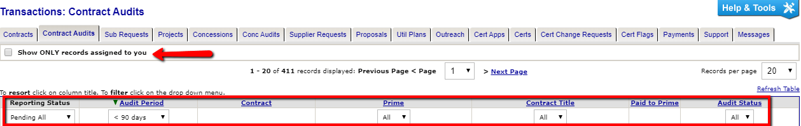

Step 3: Select an incomplete audit record to view and determine why the vendor has been unresponsive. Actions that might need to be taken to resolve the incomplete audit include:
- Contacting the vendor to confirm/update the system contact information (Page 2‐9);

- Adding new contact for the vendor (Page 2‐8);
- Sending the vendor their user login and reset their password (from the “User Information” page > “User Administration” button > “Send Password Reminder” button);
- Updating the “Vendor Compliance Contact” so the correct person is notified of the audit. From the “Contract Management: Subcontractor List” page > Actions > Edit Sub / Edit Prime > change the “Vendor Compliance Contact”; or
- Extending the reporting deadline (Page 3-58).

TASK 2: Manage Discrepancies

TASK 2.a. Run “Reported Discrepancies” report to view a list of all open and resolved payment discrepancies

Step 1: From the Navigation Menu, select “Reporting,” then “Full List.”

Step 2: In the “Select a report category” dropdown menu, choose Contracts.
Step 3: Select the report titled “Reported Discrepancies.” To add this report to your favorite report list on the Dashboard, click “Add to Favorites.”

Step 4: Enter the date range of the reporting period your wish to view. The “Status” field defaults to “Open,” however you can also review resolved discrepancies by selecting “Resolved” from the dropdown menu. Click “View Report.” Click on the “Export” icon to export the report to Excel, PDF, Word, etc.

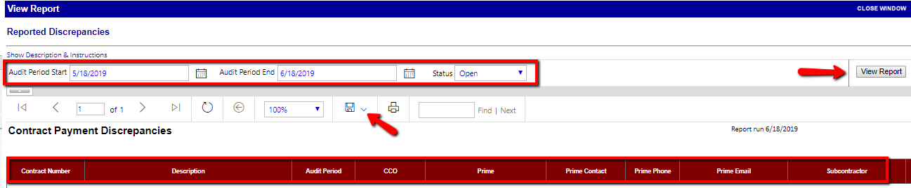

TASK 2.b. Check the Dashboard for “Discrepancies” and complete appropriate actions to resolve open discrepancies

Step 1: In the Contract Audits section of the Dashboard, you can select all of the open Discrepancies or narrow the results to review those that are greater than or less than 90 days. Click on the underlined number of the Discrepancies you would like to review.

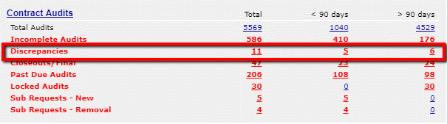

Step 2: By selecting or deselecting the checkbox next to “Show ONLY records assigned to you,” you can view discrepancies assigned only to you or ALL incomplete audits in the system. You can also filter the results based on Reporting Status, Audit Period, Prime Name, etc.
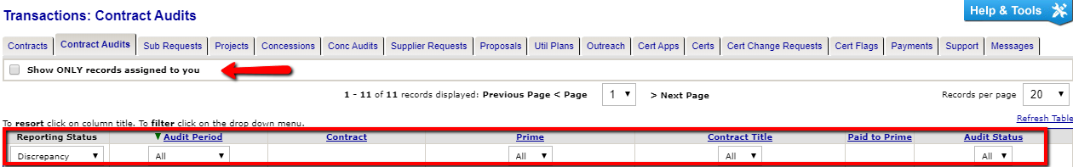

Step 3: Select a discrepancy record to view and determine appropriate actions to take to resolve the discrepancy.

TASK 3: Find Contracts that are NOT meeting goals and send a “Not Meeting Goal Letter,” when appropriate

TASK 3.a. Run “Active Contracts with Prime Payments” Report

Step 1: From the Navigation Menu, select “Reporting,” then “Full List.”

Step 2: In the “Select a report category” dropdown menu, choose Contracts

Step 3: Select the report titled “Active Contracts with Prime Payments.” To add this report to your favorite report list on the Dashboard, click “Add to Favorites.”

Step 4: Review the generated report to determine which contracts are not meeting their goals and require a “Not Meeting Goal Letter.” Based on your knowledge of the contract, contract progress, missing goal amount, and organization policies, NOT all contracts missing their goals will require notice.

Click on the “Export” icon to export the report to Excel, PDF, Word, etc.

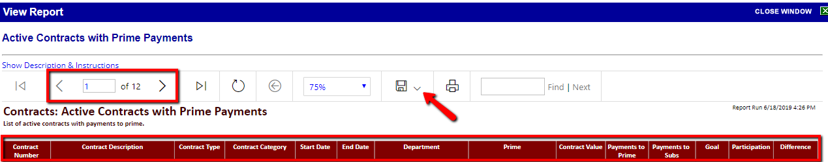

TASK 3.b. Send “Not Meeting Goal Letter” to primes

Step 1: If you have determined that a “Not Meeting Goal Letter” is warranted, locate the specific contract and click on the Compliance Audit Summary Tab. This will show the PPrime’s progress in meeting the goal. Click on the “Not Meeting Goal Letter.”

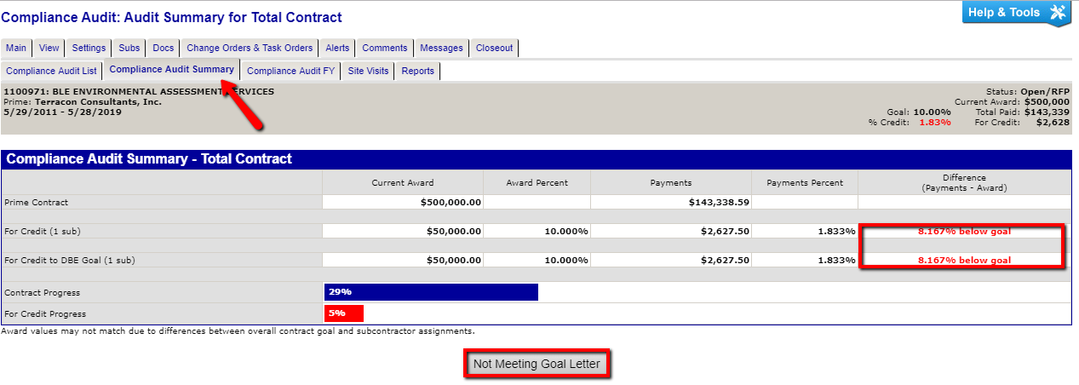

Step 2: Review and update, if necessary, the contact information of the vendor to whom the notice will be sent.

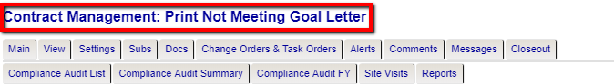

Step 3: By clicking “Send Email,” email notification will be sent to Prime, indicating they are below their goal.

*** A Not Meeting Goal Template can be added upon request by the City of Charlotte***

***Sample of Email Notification sent when using this feature***

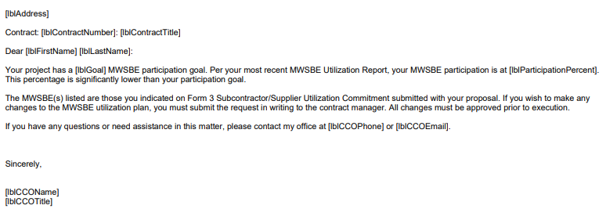

TASK 4: “Lock-in” Contracts

Step 1: From the Dashboard, click on “Contracts” or from the left-hand navigation panel, click on “View” then “Contracts.”

ADD SCREENSHOT SHOWING BOTH OPTIONS

Step 2: Sort the contracts by “New Contract” under Actions. Be mindful that if the checkbox is checked, you will only see contracts that are assigned to you. Uncheck it to see all new contracts in the system.

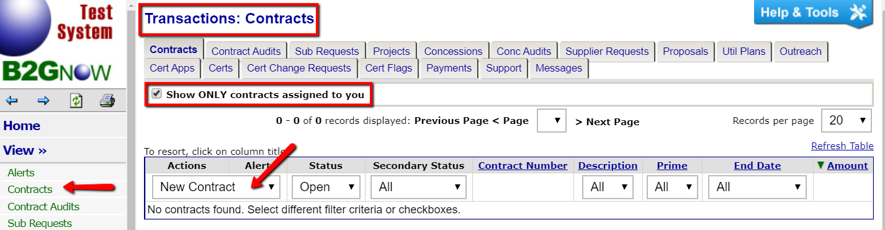

Step 3: To begin the lock-in process, click “View” to the left of the contract you wish to lock-in.

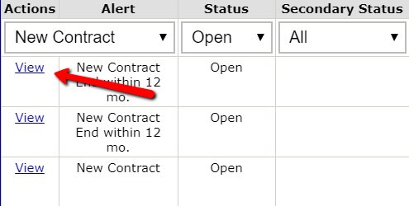

Step 4: On the “Main” tab of the contract record, click “review contract” (in the “Contract Alerts” section). This opens the contract compose page.

Step 5: Review the information that came in via the interface and add any additional information that may be necessary by following Steps 6 through 17. Fields with a red asterisk are required by the system; fields highlighted green are required by the City of Charlotte to support its Disparity Study.

Step 6: Review the “Contract Information” section for accuracy. “Contract Holder/Owner” must always be “City of Charlotte.”

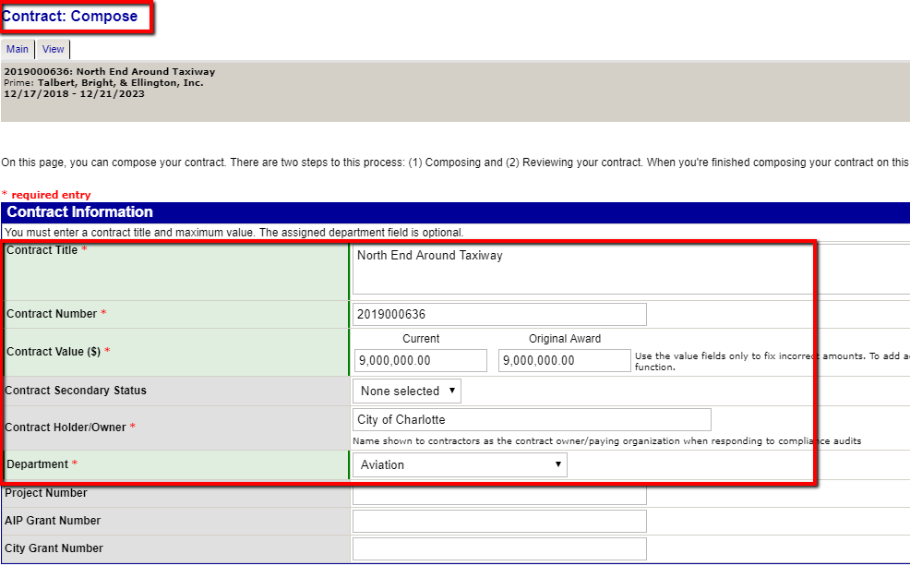

Step 7: Review the “Contract Dates” section for accuracy.

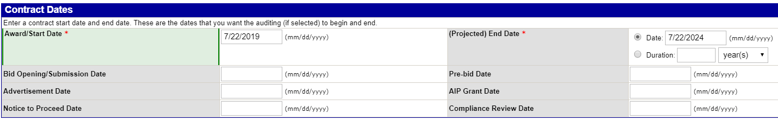

Step 8: Review the “Prime Contractor Information” section for accuracy. If either of the contact or the address is incorrect and the correct information is not listed in the dropdown menu, click “QuickAdd” to add a new contact or address.

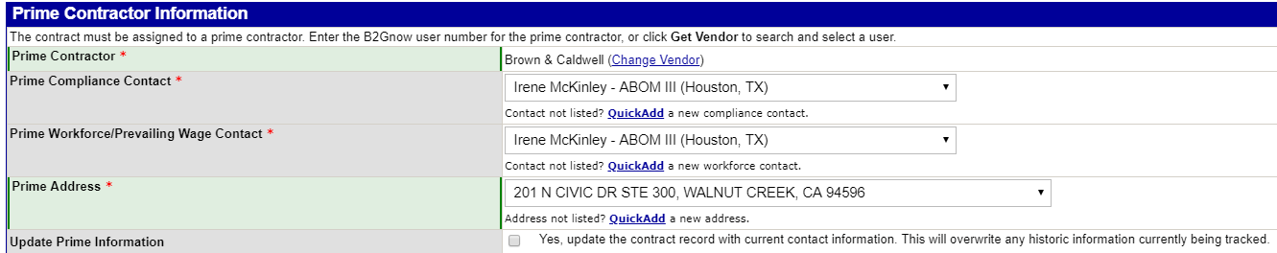

Step 9: Review the “Organization Contacts” section for accuracy. If the department listed in the “Buyer/Project Manager” field is not correct, choose the correct department from the dropdown menu. Add any project contacts, as applicable.

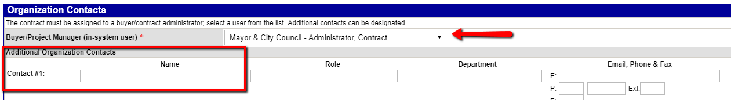

Step 10: The “Contract Settings” section is where you will add the goals to the contract record. In the “Diversity Goal(s)” field, click on “Click here to select goal types.”

Step 11: The following screen will appear. Select the applicable goal type(s) from the dropdown menu and click “Assign Goal.” After adding all goal types, click “Return” to go back to the “Main” tab of the contract record.

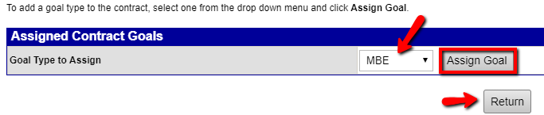

Step 12: Now that the goal type(s) has been identified, enter the applicable percentages. For assistance in filling out the goal percentages, click on the “Help with goals” link.

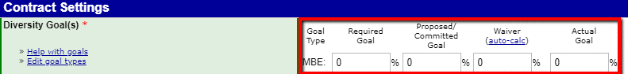

Step 13: Additional goals and/or funding information can be added in the fields below the “Diversity Goal(s)” field.

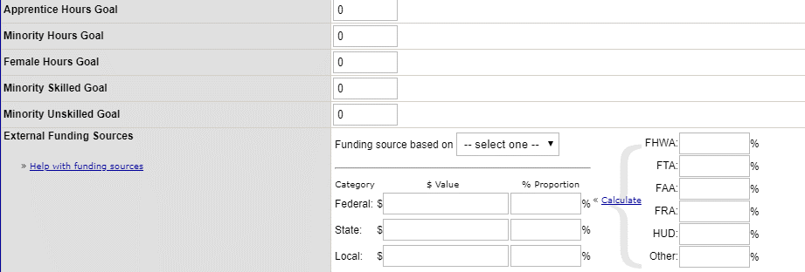

Step 14: Review the remaining fields of the “Contract Settings” section for accuracy, including “Contract Type” and “Contract Category.” Many of the fields already default to the settings the City of Charlotte has selected.

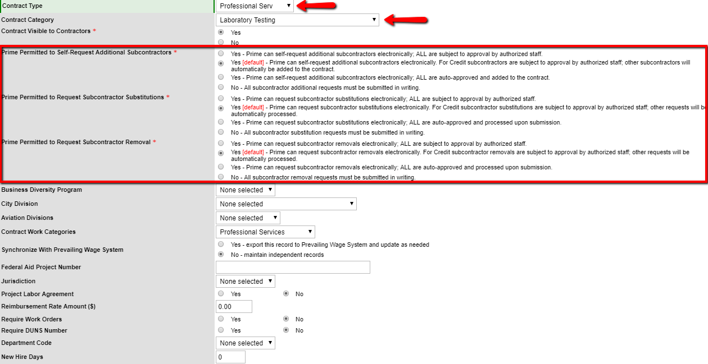

Step 15: Review the “Compliance Audit Settings” section for accuracy. Select the appropriate “Compliance Officer” from the dropdown menu. Many of the fields are already defaulted to the settings the City of Charlotte has selected.

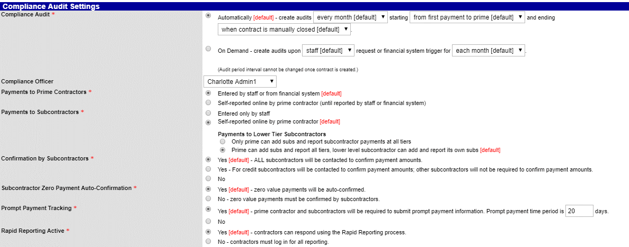

Step 16: Click “Add Commodity Codes” in the “Contract Summary” section to add the commodity codes used in the solicitation of this contract. This field is required by the City of Charlotte.

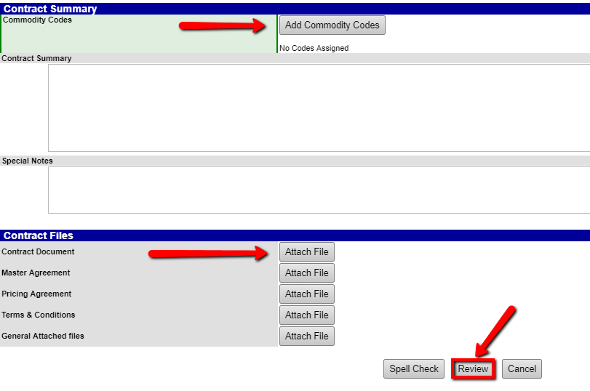

Step 17: Any documents related to the contract can be added to the “Contract Files” section. Once the contract record is complete, click “Review.”

Step 18: A summary of the contract will appear. You will have an opportunity to “Edit,” if needed, or click Save to complete the Contract Lock-In. The contract is now saved and ready to have payments matched, and subcontractors added to the contract.

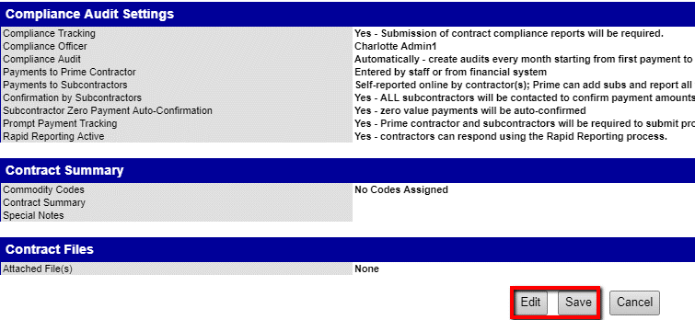

TASK 5: Manage Contracts with Missing Information

Step 1: From the Navigation Menu, select “Reporting,” then “Full List.”

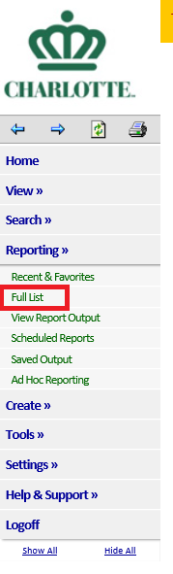
Step 2: In the “Select a report category” dropdown menu, choose “Contracts Maintenance.”

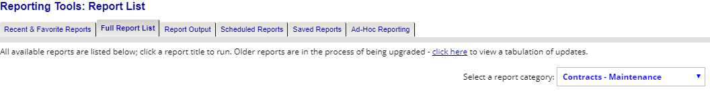

Step 3: Select the report titled “Missing Information on Contracts.” To add this report to your favorite report list on the Dashboard, click “Add to Favorites.”

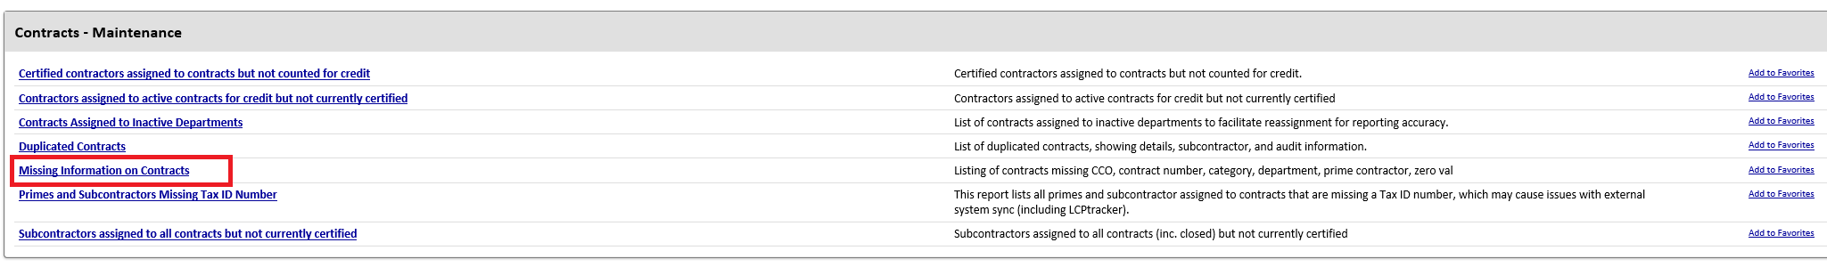

Step 4: Review the generated report to determine which, if any, of your contracts are missing information.

Step 5: Update the contract record(s) to add any information that is missing.

TASK 6: Manage Rejected Contracts (contracts that could not be verified by the system)

Step 1: From the Navigation Menu, select “Tools,” then “Data Management,” then “Contracts.”

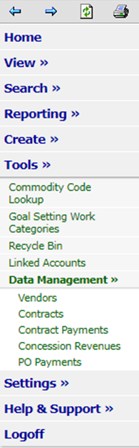

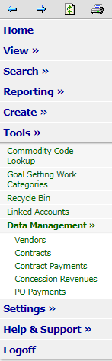

Step 2: Click “View Rejected Records.”

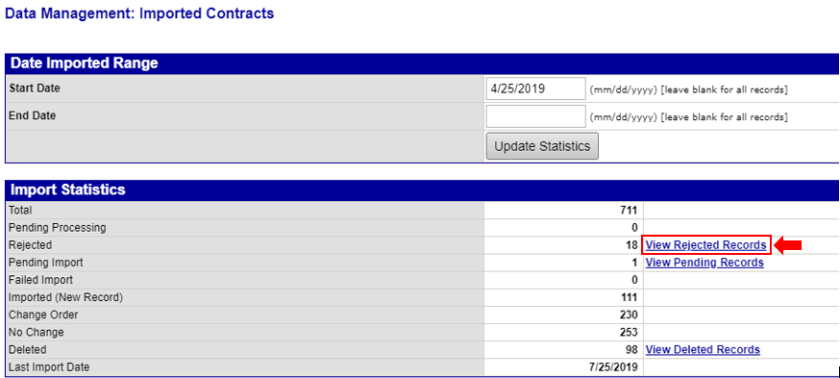

Step 3: Click “View” for the rejected contract record you wish to review.

Step 4: Review “Record Status” in the “Record Summary” section and the “Errors” section to determine what information is needed to resolve the rejected status.

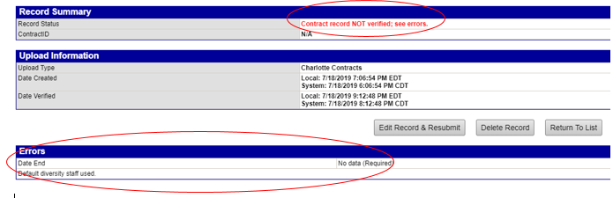

Step 5: Click “Edit Record & Resubmit”

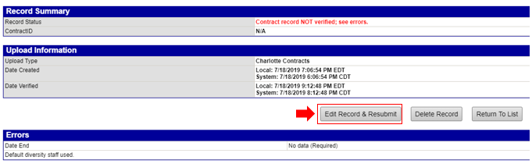

Step 6: Correct the error listed in the “Errors” section.

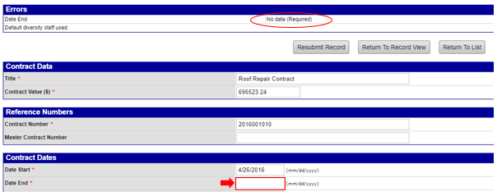

Step 7: Once all errors have been resolved, click “Resubmit Record.”

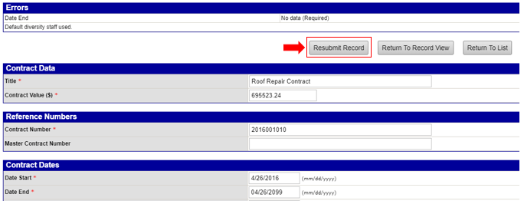

Step 8: Click “OK” on the window that pops up.

