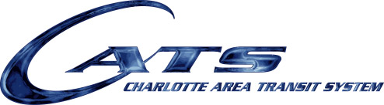

TRANSIT SERVICES ADVISORY COMMITTEE

AGENDA

Thursday, January 10, 2019

4:00- 5:30 pm

CMGC, Conference Room 278 (second floor)

1. Call to Order 4:00-4:07 Chairman

Approval of December Summary

1. Public Comment on Agenda Items 4:07-4:10

1. Information Items:
2. Unified Design Ordinance 4:10-4:30 Alan Goodwin
3. Security Update 4:30-4:50 Ken Chapman

BJ Johnson

1. NBA Service Impacts 4:50-5:10 Reggie Arrington

Brad Thomas

Krystel Green

1. Chairman’s Report 5:10-5:15 Sam Grundman
2. Service Issues 5:15-5:25 All

VII. Operation Planning Report 5:25-5:30 Larry Kopf

*Next Month’s TSAC Meeting is FEBRUARY 14, 2019*